VALLEY SWEAT BOOK – CONDENSED NOTES
MODULE 1
Cell and General Physiology (pg. 1-11)
- Large water soluble molecules & ions DO NOT diffuse through lipid bilayers (DO NOT cross placenta, BBB)
- Models of exocytosis: pinocytosis (cell drinking—proteins absorbed in PCT of kidney) & phagocytosis (cell ingestion—bacteria)
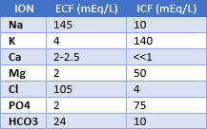
- Clathrin provides mechanism to form vesicles (endocytosis)

Receptor Types
Ionotropic: ligand-gated ion channel (5HT3, GABA, glutamate)
Metabotropic: GPCR (adrenergic, muscarninic ACh)
Catalytic: when activated, these are enzymes or become a part of enzyme complexes (insulin, epo, ANP, growth factor)
Nuclear: link extracellular signals to gene transcription (steroid hormones)
- Common 2nd messengers: cAMP, cGMP, Ca, calmodulin, inositol triphosphate (IP3)
- cAMP (cyclic adenosine monophosphate): when activated, ↑contractility in cardiac muscle, but ↑relaxation in bronchial muscle
- Na-K-ATPase: 3 Na out, 2 K in; stimulated by insulin, β2 agonists
- Hyperkalemia = depolarized cell (K out more slowly d/t gradient); hypokalemia = hyperpolarized cell (K out more quickly)
- Normal resting potential of a neuron is -70mV; K efflux (via leak channels) is most responsible for resting membrane potential
- Diffusion of Na inward is responsible for depolarization; diffusion of K outward is responsible for repolarization
- VG Na channels: found principally in axon and are concentrated in Nodes of Ranvier
- Action potential basics: depol to threshold➔fast VG Na channels open➔inside becomes (+) and outside becomes (-)➔VG K channels open➔repolarization occurs… Na-K-ATPase returns balance
- Absolute refractory period: fast VG Na channels are in the inactivated state, thus another AP cannot be fired
Clinical examples: cardioplegia (high K content locks Na channels open), Sux & local anesthetics also lock channels
- Axon Hillock: initial segment of axon to which AP first spreads
Hemostasis (pg. 165-181)
- Summary of primary hemostasis: adhesion of plt to damaged wall (vWF), activation of plt (thrombin), aggregation of plt (ADP, thromboxane A2), production of fibrin (extrinsic/intrinsic/final pathways)
- Life of plt = 8-12 days; normal plt count = 150k-400k; 33% is sequestered in spleen
- Adhesion: vWF anchors plt to subendothelial collagen (via GP1B receptor, aka glycoprotein plt surface receptor)
vWF is made from & released by endothelial cells
vW Disease: most common inherited coagulation defect; ↑bleeding times despite normal plt count & clot retraction
  - DDAVP is 1st treatment; causes release of endogenous stores (80% effective); works in 30min, duration of 4-6hrs
    - SE = hyponatremia in kids; causes thrombocytopenia with Type 2B vW disease
  - Cryo (FVIII, XIII, Fibrinogen, vWF) and FVIII concentrate are alternative treatments
- Activation: thrombin (FIIa) combines with thrombin receptor on plt surface to activate; plate changes shape & releases ADP &
thromboxane A2 (& other stuff)
- Aggregation: ADP & TA2 bind to receptors on plt to activate signal transduction (make cap pop off so fibrinogen can hold on)
Plt plug: fibrinogen (FI) connect = white clot (RBCs haven’t arrived yet); GPIIb/IIIa = fibrinogen receptor
  - DIC = “uncapped” fibrinogen receptor runs into fibrinogen in bloodstream
- Fibrin production: involves all clotting factors
Fibrin is woven (cross linked) into plt making it insoluble to H2O (now red clot); cross-linking requires FXIIIa
Extrinsic path (“can buy for $.37”): damaged outside of cell➔release of FIII➔activates VII➔activates X (with help of Ca, III)
  - Coumadin (PT, INR) acts on extrinsic path
Intrinsic path (“if you can’t buy for $12, can for $11.98”): trauma to blood itself or exposure to collagen activates XII➔activates XI➔activates IX➔IX with VIII:C (& Ca) activate X
  - Heparin (PTT, ACT) acts on intrinsic; “You give heparin inside the hospital (intrinsic) & Coumadin outside (extrinsic)”
Final common path (“purchased at 5 & dime for $2 or $1 on 13th of the month”): activated X (w/V & Ca) converts II➔converts I➔Ia with XIII = cross linking

Coagulation disorders
vW Disease: see above
Hemophilia A: FVIII:C deficiency; recessive trait carried by female almost exclusively seen in males; 2nd most common
  - FFP or Cryo (both have FVIII) to treat; could also give FVIII concentrate
Hemophilia B (“Christmas Factor Disease”): FIX deficiency; heat-treated FIX concentrate to treat

Miscellaneous Facts
Plts in blood are inactive after 1-2 days (must give plts w/massive transfusion)
All procoagulants are in FFP (except plts)
1 unit PRBCs will ↑Hct 1g/dL or 3-4%
1 pack of plts will ↑plt count by 5-10K/mm³

Massive transfusion = 1 complete blood volume transfused in 24hrs
- Antithrombin: attaches to thrombin (FIIa) & Xa (also IX, XI, XII) & removes them from circulation = anticoagulates blood
Heparin ↑effectiveness of antithrombin by 1,000x or more; binds to AT III
  - Pts with AT deficiency will not be as responsive to heparin (cirrhosis, nephrotic syndrome)
  - FFP contains AT (give to ↑ACT if heparin not working well)
  - Protamine: its (+) charge combines with heparin’s (-) charge = neutralization rxn
  - Heparinization is adequate if ACT > 400-450 sec (Barash states > 480 sec)
Hirudin, Ximelagatran, & Argatroban are direct thrombin inhibitors (can be used as alternatives to heparin)
- Finrinolyis (“clot busting”): plasminogen is incorporated as clot is made; tPA (tissue type plasminogen activator) & uPA (urokinase type) convert plasminogen to plasmin = plasmin destroys clot (breaks down fibrin = fibrin split products)
uPA is most commonly used thrombolytic for grafts; streptokinase also converts plasminogen to plasmin
Aprotinin: inhibits plasmin; removed from shelf d/t risk of MI, renal dysfxn
Aminocaproic acid (Amicar) & tranexamic acid: displace plasmin from fibrin = slow clot breakdown (= ↓bleeding)

Complex coagulation disorders
DIC (disseminated intravascular coagulation): caused by underlying dz; essentially overactive (or overconsumption of)
clotting factors (↓plt, fibrinogen, FII, V, VII, XIII) with ↑fibrinolysis = many small clots + bleeding
  - No lab test to diagnose; shock, ischemia, & infarction are most commonly associated
Liver dz: most common cause of isolated ↑PT; causes defects in plt plug formation & fibrin clot formation, ↑fibrinolysis
  - Give FFP, cryo, Vit K prn
Uremia-related problems: plt dysfxn but giving plts is ineffective b/c they too become quickly abnormal
  - Treat with dialysis (uremia = kidney probs), cryo, DDAVP, ↑Hct
Massive transfusion problems: may bleed b/c PRBCs are deficient in plts, FVII, XIII
  - 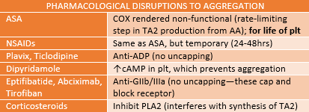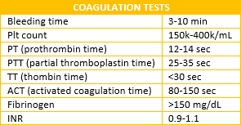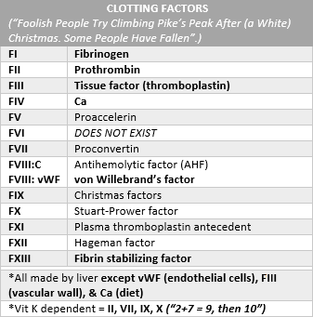Give FFP, cryo, plts

MODULE 2
Neuromuscular Physiology (pg. 12-30)
- Motor neurons (somatic, efferents): originate in ventral horn; these are Aα (largest, most myelinated = fastest conduction)
- Sensory neurons (afferents): exit via dorsal horn

Neuromuscular Jxn (myoneural jxn)
Presynaptic terminal releases ACH to motor end plate
  - AP➔VG Ca channels open presynaptically➔Ca influx➔ACh vesicles dump into cleft
    - Presynaptic nACh-R respond to ACh by ↑ACh synthesis & mobilizing ACh vesicles (positive feedback)
    - Postsynaptic nACh-R respond (only when two ACh occupy both α subunits) by opening ion channel
Na & Ca influx with K efflux = AP and eventual contraction of skeletal muscle (excitation-contraction coupling)

Note: presynaptic release of ACh is dependent on Ca
    - Hypo-Ca = ↓ACh release; hyper-Ca = ↑release (Mg antagonizes Ca, so ↑Mg = ↓ACh release, ↓Mg = ↑release)
Acetylcholinesterase are found near nACh-R and extend into cleft to metabolize ACh

  - AChE also degrades LAs, neostigmine, edrophonium, remifentanil, & esmolol
- Non-depolarizing block (Phase II): act by competitive inhibition at nerve terminal; ACh cannot attach when NDNMB are bound
- Depolarizing block (Phase I): mimic axn of ACh; when bound to nACh-R, contraction occurs; however, b/c Sux is not metabolized by AChE, VG Na channels get stuck in the inactivated state (= absolute refractory period) & no additional AP can occur

Definitions
Potency: relationship b/w twitch depression & dose; ED95 = 95% block of single twitch compared to control twitch
Onset time: time to max blockade
Duration of axn: from injection to 90% recovery
Recovery index: b/w 25% & 75% twitch height

NEUROMUSCULAR BLOCKERS
Name | Onset  (min) | Duration | Min to 25%  recovery | Elimination | CV Effects
Sux | 0.-1.5 | Ultrashort | 6-8 | Metabolized | Tachy-c, brady-c (in kids), ↓BP
Atracurium | 3-4 | Intermediate | 35-45 | 2/3 hydrolysis, 1/3 Hofmann | Minimal effects
Cisatracurium | 5-7 | Intermediate | 35-45 | Hofmann | Minimal effects
Vecuronium | 3-4 | Intermediate | 35-45 | Biliary (60%), renal (40%) | Minimal effects
Rocuronium | 1-1.5 | Intermediate | 35-45 | Biliary (80%), renal (20%) | Minimal effects
Pancuronium | 2-4 | Long | 60-120 | Renal (85%), biliary (15%) | ↑BP
Histamine release—Sux; dose-dependent histamine release—mivacurium, atracurium, d-Tubocurarine, Metocurine
Autonomic ganglionic blockade—d-Tubocurarine, metocurine
Tachycardia—Sux, atracurium, d-tubocuranine, metocurine, pancuronium, gallamine
↑BP—pancuronium, gallamine
↓BP—Sux, d-tubocurarine, metocurine
- AminOsteroids = “Onium”; benzylisoquinolines = “curium”
- All NMBs are 100% ionized at physiologic pH (do NOT cross BBB, placenta)
- SE of Sux: ↑K (0.5mEq/L, 5-10mEq/L w/burns/trauma/head injury), myalgia (24-48hrs post), tachy-c/brady-c (kids), ↑IOP (5- 15mmHg), ↑ICP, MH, myoglobinuria, prolonged resp paralysis (w/atypical plasma cholinesterase), ↑intragastric pressure
- Proliferation of extra-jxn receptors: burns, SC transection, trauma, head injury/CVA/Parkinson’s, prolonged immobility
- MH (hyperpyrexia): rapid ↑EtCO2 (first, most sensitive sign), fever, tachy-c (SNS hyperactivity), masseter muscle rigidity (trismus, aka lockjaw), whole body rigidity; associated electrolytes—↑H, K, Ca, CO2 & ↓O2
Caused by mutation of RYR1 (ryanodine receptor) in sarcoplasmic reticulum = excessive Ca release
Dantrolene to treat (2.5mg/kg)—causes ↓release of Ca from SR
Triggers: Sux, halogenated IA (Iso, Des, Enf, Sevo, Halo)
Cardiac muscle is NOT directly involved b/c it has the RYR2 receptor
- Factors that ↓NDNMB activity: chronic anticonvulsants, burns (manifests at 10days, peaks at 40days, declines after 60days)
- Factors that ↓Sux activity: NDNMBs, myasthenia gravis
Note: only memorize these; if anything else is in the question, then it must ↑activity of neuromuscular blockade
- Train of Four (TOF): 4 stimuli Q 0.5sec (= 2Hz); fade w/NDNMBs
- Double Burst Stimulation: short bursts of 50Hz separated by 750ms with 0.2ms duration for each; fade w/NDNMBs
- Tetany: 50Hz for 5sec; w/NDNMBs there is post-tetanic fasciculations & twitches after tetany are larger than before; w/Sux there are NO post-tetanic fasciculations & twitches after tetany are smaller than before
- Phase I to Phase II block: w/high or repeat dose of Sux , it acts like NDNMBs (fade, post-tetanic fasciculations)

RECEPTOR BLOCKADE AND TOF
99-100% | Complete paralysis
95% | Diaphragm moves; NO twitches
90% | 1 twitch; adequate for abd procedures
75-80% | Single twitch as strong as baseline; VT returns to normal
70-75% | NO fade in TOF
70% | Sustained tetany
60-70% | NO fade in DBS
50% | Extubation criteria met (head lift, hand grasp, sustained bite)
Peripheral Nervous System (pg. 31-64)
- Somatic: motor (efferent) impulses to skeletal muscle & sensory (afferent) signals to brain (touch, pressure, temp, pain)

Autonomic
Sympathetic: preganglionic nerves are short & postganglionic nerves are long
Parasympathetic: preganglionic nerves are long & postganglionic nerves are short

- ACh is the predominant NT in the periphery; released from somatic motor nerves, preganglionic sympathetic nerves, preganglionic parasympathetic nerves, & postganglionic parasympathetic nerves
NE is released from all sympathetic postganglionic nerves (except sweat glands—ACh is released there)
Adrenal medulla is innervated by sympathetic preganglionic neurons; ACh elicits NE & epi release
- Nicotinic receptors are found at autonomic ganglia, adrenal medulla, & at motor end plate of skeletal muscle
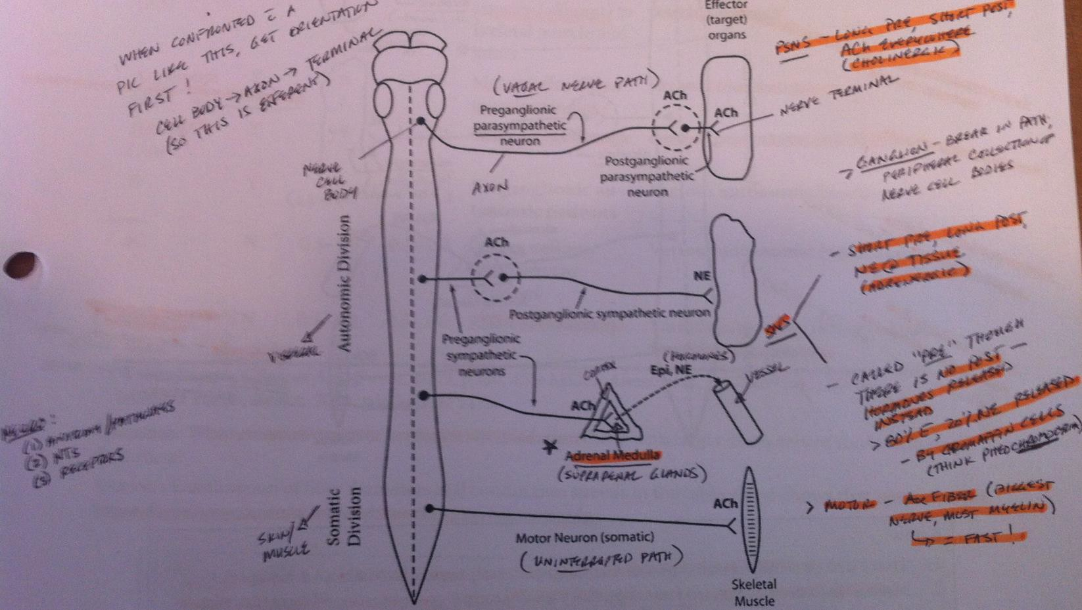
- Adrenergic receptors are found on tissue innervated by SNS (except sweat glands)
NERVE FIBERS
Type | Myelination | Size | Speed | Function | Transmission
Aα | Y | LARGE  SMALL | FAST  SLOW | Motor (efferent) & sensory (afferent)  to skeletal muscles/joints | Muscle length/force, proprioception, somatic  motor neurons
Aβ | Y | LARGE  SMALL | FAST  SLOW | Motor (efferent) & sensory (afferent)  to skeletal muscles/joints | Proprioception, touch, pressure
Aγ | Y | LARGE  SMALL | FAST  SLOW | Motor (efferent) to muscle spindles | Muscle tone
Aδ | Y | LARGE  SMALL | FAST  SLOW | Sensory (afferent) | Pain, temp, touch
B | Y | LARGE  SMALL | FAST  SLOW | Preganlionic autonomic neurons | Various
sC | N | LARGE  SMALL | FAST  SLOW | Postganlionic sympathetic neurons | Various
dC | N | LARGE  SMALL | FAST  SLOW | Sensory (afferent) | Pain, temp, touch
- Summary of chart
Aα efferents adjust skeletal muscle force & length
Aα & Aβ sensory fibers transmit proprioception (position sense)
dC fibers transmit throbbing pain & temp
Aδ fibers transmit sharp, prickling pain & temp
Sympathetic & parasympathetic preganglionic fibers are B fibers
Myelinated are faster than non-myelinated; larger are faster than smaller

The sympathetic (thoracolumbar) nervous system arises from T1-L3
Cardioaccelerators arise from T1-T4 (get brady-c w/high spinal b/c these are blocked)
Stellate ganglion is fromed by inferior cervical & 1st thoracic ganglia; Horner’s syndrome (ipsilateral miosis, ptosis, enophthalmos, ↑temp, anhydrosis, nasal congestion, flushing) is d/t stellate ganglion blockade
All sympathetic preganglionic fibers pass through white rami, but only some pass through gray rami
  - White rami are distributed to spinal nerves arising from T1-L2
  - Gray rami are distributed to all spinal nerves from the ganglia; these allow coordinated, mass discharge of the SNS
After passing through white rami, sympathetic preganglionic fibers have 3 fates:

  - Some synapse in paravertebral ganglia w/sympathetic postganglionic neurons
  - Some ascend or descend in paravertebral ganglia before synapsing w/postganglionic neurons
  - Some pass through paravertebral ganglia without synapsing (these synapse w/postganglionic neurons in the periphery)

Events in Sympathetic Neurotransmission
Synthesis of NE: tyrosine into nerve terminal from blood➔L-dopa➔dopamine➔NE➔epi
  - NE stored in presynaptic vesicles (in adrenal medulla, NE converted to epi—NE = 20%, epi = 80% of the NE/epi pool)
Release of NE: AP travels along sympathetic neuron➔depol opens VG Ca channels➔Ca unites w/calmodulin leading to exocytosis➔NE diffuses into synaptic cleft➔NE diffuses down concentration gradient to postsynaptic membrane receptors
Tissue response to NE: NE combines w/adrenergic-R & activates adenylate cyclase➔intracellular production of cAMP
  - Tissue-specific axn—arterial SM contracts, HR↑, contractility↑
Termination of NE axn: diffusion away from receptors is 1st step➔80% reuptake (active transport) in presynaptic terminal
  - Small amounts are metabolized in cleft by monoamine oxidase (found on surface of mitochondria)
  - Small amounts diffuse into blood; metabolized in vascular compartment by catechol-O-methyl transferase (COMT)

Drugs associated
Ephedrine works by: (1) indirectly displacing NE from nerve terminal; (2) directly stimulating adrenergic-R
MAO-I’s: avoid ephedrine & meperidine—these may cause excess amounts of NE = HTN crisis
- Functions of SNS: fight-or-flight; ↑HR/CO/BP/glucose concentration, dilate bronchial tree, shunt blood to skeletal muscle
ADRENERGIC RECEPTORS
Receptor | Location | Action when Stimulated
α-1 | Peripheral tissue (vascular SM, glands) | Arterial/venous constriction (↑VR/SV/CO/BP), mydriasis
α-2 | Presynaptic nerve terminals of sympathetic postganglionic neurons; postsynaptic  membranes in brainstem/periphery | Inhibits NE synthesis/release, promotes analgesia
β-1 | Heart, kidneys, adipose tissue | ↑inotropy/chronotropy/dromotropy/CO/BP, ↑renin release
β-2 | SM & glandular tissue | Bronchodilation, relaxation of uterus, ↑blood glucose levels, mild  vasodilation (↓SVR), stimulation of Na-K-ATPase, ↑secretions
- β-2 stimulation promotes hyperglycemia & hypokalemia (SE of ritodrine, a β-2 agonist)
- Renin-Angio-Aldo System: 85% of resting BP is controlled by renin (enzyme from juxtaglomerular cells of afferent arteriole)
Renin released d/t ↓BP (or ↑SNS activity, Cl)➔angioteninsogen converted to ang I➔ACE converts ang I to ang II➔ang II promotes vaso-c & aldo release➔aldo ↑K secretion (& excretion) & ↑Na reabsorption = volume expansion

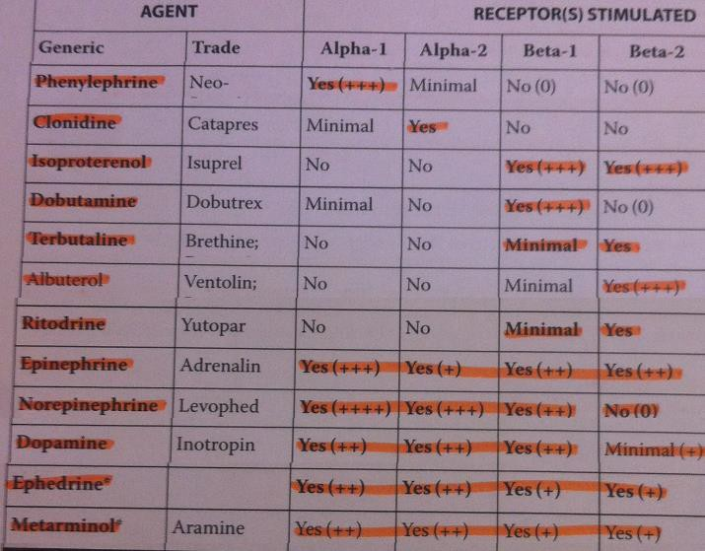2 important stimuli for aldo release: ang II & ↑serum K Clinical use of catecholamines
Epinephrine: ↓systemic absorption of LAs, treat allergic rxns,
cardiopulmonary resuscitation, ↑myocardial contractility
Dopamine: ↑CO; unique in that it simultaneously
↑contractility, RBF, GFR, Na excretion, & urine output
Isoproterenol: treat complete heart block
Dobutamine: ↑CO (in CHF)

Clinical use of synthetic noncatecholamines
Ephedrine: treat hypo-t, treat bronchial asthma, as a decongestant nasal spray
Neosynephrine: treat hypo-t, as a topical nasal decongestant, to prolong duration of spinal anesthesia

Adrenergic agonists & BP
NE: ↑SBP/DBP/MAP, ↓HR
Epi: ↑SBP/HR, ↓DBP (β-2 mediated), variant MAP
Isoproterenol: ↑SBP/HR, ↓DBP (β-2 mediated), ↓MAP
  - Note: DBP & SVR move in the same direction (that is, ↓DBP = ↓SVR, & vice versa)

Clinical use of selective β-2 agonists
Bronchospasm: terbutaline, albuterol (metaproterenol, isoetharine, salmeterol)
↓uterine contractions: ritodrine, terbutaline
  - SE of β-2 agonists: tachy-c, hypo-K, hyperglycemia, tremor, pulm edema (note: ritodrine crosses placenta)
- Central-acting SNS agonists (α-methyldopa, clonidine, dexmed): inhibit SNS by stimulating postsynaptic α-2 receptors in brain
Used to treat HTN (clonidine also promotes analgesia, sedation, & ↓anxiety)

- Associated with chart
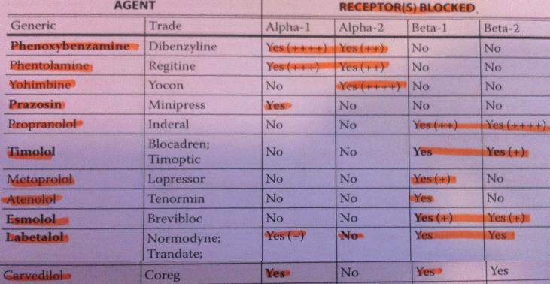
Phentolamine is a non-selective α-adrenergic antagonist
Prazosin lowers BP without ↑the release of NE from postganglionic SNS terminals b/c it doesn’t block α-2 receptors
Esmolol is very short acting b/c it is metabolized by non- selective esterases in plasma; used to treat HTN, SVT
Labetalol competitively antagonizes α-1, β-1, β-2 receptors;
used to treat HTN emergencies; ↓HR/contractility/SVR

Clinical use of α antagonists
Phenoxybenzamine & Prazosin: chronic BP control w/pheochromocytoma
Phentolamine: HTN emergencies, intraop pheochromocytoma mgmt, ANS hyperreflexia, reversal of LA
Yohimbine: impotence & idiopathic orthostatic hypo-t

Clinical use of β antagonists
HTN: ↓BP secondary to ↓HR/CO & ↓renin secretion
Mgmt of angina: ↓myocardial requirements
Suppression of arrhythmias: ↓rate of spontaneous phase 4 depolarization of ectopic cardiac pacemakers
Blunt SNS response (w/intubation, IHSS, pheochromocytoma, tetralogy of Fallot, anxiety, reflex tachy-c)
- SE of β antagonists: brady-c, ↓contractility (heart failure), bronchoconstriction, hypoglycemia (↓glycogenolysis), hyper-K (depresses Na-K-ATPase), fatigue/lethargy, withdrawal hypersensitivity (up-regulation of β receptors)
- Treat excess myocardial depression from β antagonists: atropine, dobutamine (NOT dopamine), CaCl, glucagon, pacemaker
- Least to most favorable interaction w/β blocker: Ketamine➔Enflurane➔Halothane➔Opioids➔Isoflurane
- Downregulation of β receptors occurs in response to chronic β agonist administration (↓# of receptors); happens w/CHF
Upregulation occurs in response to chronic β blocker administration (↑# of receptors); this explains withdrawal symptoms
of tachy-c & ↑contractility when β blocker is stopped—could lead to MI
- PSNS (craniosacral) arises from midbrain (CNIII), pons (CNVII), & medulla (CNIX, X) of the brainstem & sacral cord (S2-S4)
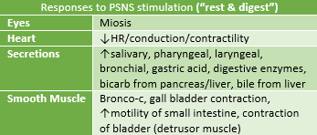
Vagus nerve (CNX) transmits 3/4 of PSNS traffic
- Parasympathomimetics (cholinergic agonists): methacholine, carbachol, bethanechol, pilocarpine, muscarine, arecoline
Actions: mimic ACh at muscarinic-R (activate PSNS)
Used to treat glaucoma, ileus, &urinary retention
- Cholinesterase inhibitors: edrophonium, neostigmine, pyridostigmine, physostigmine, echothiophate
Mechanism: inhibit both true & plasma cholinesterase = accumulation of ACh
Actions at muscarinic-R: brady-c, ↑gastric secretion, hyperperistaliss, miosis, salivation
Actions at nicotinic-R: stimulation of autonomic ganglia & neuromuscular jxn
Uses: reversal of NDNMBs, treat glaucoma, ileus, atonic bladder, myasthenia gravis, anticholinergic syndrome, Alzheimer’s
Disease, postop shivering
These prolong the action of Sux (& mivacurium)
Echothiophate is much longer-acting than the others; mainly used to treat glaucoma (NOT to reverse NDNMBs)
Cholinergic crisis: physostigmine (organic insecticides) can produce S/S of excessive ACh in brain (miosis, salivation, bronchoconstriction, brady-c, abd cramps, muscle weakness, dysphoria, seizure, coma)
  - Treat with atropine, pralidoxime (reactivates AChE), diazepam (for seizures)
- Anticholinergic: antagonize transmission of neural impulses at any site where ACh is the NT (antagonize ACh)
- Antimuscarinic: antagonize transmission at sites w/muscarinic-R (competitively antagonize ACh); atropine, scopolamine, robinul
Sites of action: tissues innervated by parasympathetic postganglionic nerves
  - Atropine & scopolamine cross the BBB (= sedation, amnesia); glycopyrrolate does much less (quaternary amine)
Actions: mydriasis, blurred vision, tachy-c, ↑AV conduction, ↓secretions, bronchodilation, ↓LES/bladder tone
Anticholinergic syndrome: in response to high dose of atropine, scopolamine = restlessness, hallucinations, excitation, agitation, motor incoordination; treated w/physostigmine (readily crosses BBB)
Esophageal relux: ↓LES tone may promote reflux
- Bronchial smooth muscle is influenced by 3 second messenger systems & 4 second messengers
cAMP formation from ATP in response to β-2 stimulation leads to bronchodilation (cAMP stimulate protein kinase A)
Phosphodiesterase inhibitors block breakdown of cAMP = bronchodilation; NO activates cGMP = bronchodilation
IP3 formation (from conversion of PIP2 by phospholipase C) in response to muscarinic-3 stimulation
  - IP3 stimulates the release of Ca = bronchoconstriction

Pharmacology of Respiratory System
Adrenergic agonists: bronchodilation via stimulation of β-2 (tachy-c & HTN may occur d/t β-1 effects)
Xanthines: bronchodilation via non-specific inhibition of phosphodiesterase (theophylline, aminophylline)
Antimuscarinics: bronchodilation via antagonism of ACh (less IP3 is produced, so Ca is less available)
Volatile anesthestics: potent bronchodilation
Mast cell inhibitors (cromolyn sodium): prevents histamine release (=prevents bronchoconstriction)
Steroids: reduce inflammation & cause bronchial muscle relaxation
Respiratory stimulants (doxapram): CNS stimulant; ↑alveolar ventilation; used to reverse resp depression
Leukotriene antagonists (montelukast, zafirlukast, zileuton): impairs conversion of AA to leukotrienes = ↓bronchospasm,
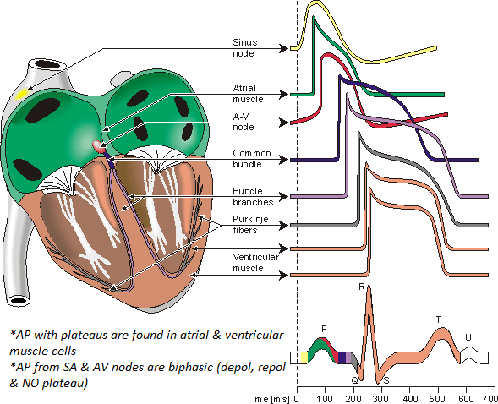
vasoconstriction, eosinophil recruitment

MODULE 3
Cardiovascular (pg. 102-164)
- ECG (each mm = 0.04sec on ECG strip)
P wave: atrial depolarization
PRI: atrial systole & AV nodal delay; normal is 0.12-0.2sec
QRS: ventricular depol (& atrial repol); normal is ≤0.12
  - R waves are always above baseline; a 2nd R wave is R’
  - Q & S waves are always below baseline
T wave: ventricular repolarization
U wave: precise activity unknown (not always present)
- Resting potential of cardiac muscle = -90mV

Phases of ventricular AP
0: rapid depolarization (Na influx)
  - VG Na channel opens (cell goes from -90mV to +30mV)
1: transient repolarization (Cl influx, K efflux)
2: plateau (Ca influx)
  - Na channel in inactivated state (absolute refractory period); Ca channel open
3: repolarization (K efflux)
  - VG K channel open (when enough Ca has accumulated); Ca channel closed; Na channel resets
    - Note: with hypo-Ca the duration of the plateau is prolonged (Ca moving slower); with hyper-Ca it is shortened
4: resting membrane potential; diastole
  - K leak channel open (K most responsible for RMP), Na-K-ATPase restores balance; all other channels closed

Phases of SA node AP
0: slow depolarization (Ca & Na influx)
3: repolarization (K efflux)
4: diastole (spontaneous depol occurs when threshold is reached; K efflux ↓ progressively & Na influx ↑ progressively
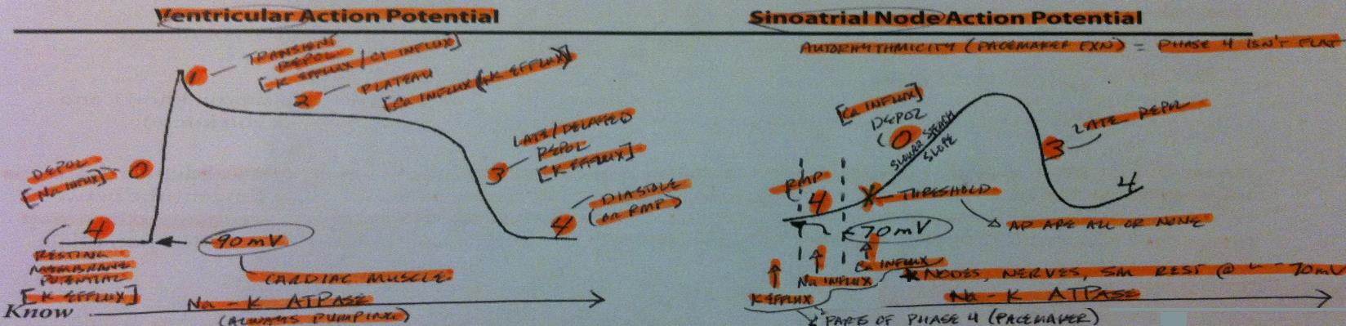
  - AV node AP has a slower phase 4, but is otherwise the same as the SA node AP
- Mechanisms for altering HR: changing the slope of phase 4 causes HR to change; when phase 4 is slowed (ACh), it takes longer
to reach threshold = ↓HR; when phase 4 is accelerated (NE), threshold is reached more quickly = ↑HR
- Random facts (from Q & As, pg. 105)
Digitalis & CC blockers slow HR by slowing the phase 4 depolarization in SA & AV nodes
  - CC blockers work on phase 2 of the ventricular AP = ↓contractility (not clinically significant, though)
Lidocaine & Phenytoin control ventricular dysrhythmias by suppressing spontaneous phase 4 depol (Na channel blockers)

Ventricular conduction disturbances
RBBB: look in leads V1-V6; V1 shows rSR’ (“rabbit ears”)

LBBB: look in leads V1-V6; abnormally long QRS; loss of normal septal R wave in V1; notched R waves in V1, V5, V6
1st degree heart block: PRI > 0.20; consistent beat-to-beat
2nd degree, Mobitz Type I: progressive ↑in PRI until a beat (QRS) is dropped; associated w/progressive ↓in RR interval
2nd degree, Mobitz Type II: rarer/more serious; sudden appearance of non-conducted P wave (normal P waves, but not all are followed by QRS complexes); PR and RR intervals are constant
3rd degree (complete): dissociated P & QRS waves (no fixed relationship b/w the two)
Sinus arrhythmia: ↑HR w/inspiration d/t ↓intrathoracic pressure/VR—R atrium stretches & reflexively ↑HR (Bainbridge)

Supraventricular Dysrhythmias
  - Premature atrial contractions: can be conducted or non-conducted (P wave could occur so early it falls on the T)
  - Subendocardial ischemia/injury: both produce ST segment depression of >1mm
    - Transmural ischemia = symmetrically inverted T waves; transmural injury = ST elevation
Calcium disturbances: hyper-Ca = shortened QT (plateau phase); hypo-ca = prolonged QT
Potassium disturbances: hyper-K = peaked T waves; hypo-K = prominent U waves
Paroxysmal atrial tachy-c: 150-250bpm; treat w/vagal maneuvers, verapamil, esmolol, propranolol, edrophonium, phenylephrine (if pt is hypo-t), rapid overdrive pacing, cardioversion
Premature ventricular contractions: no P wave w/PVC; wide QRS; treat by correcting underlying abnormality (low K, low PaO2); also treat w/lidocaine (or esmolol, propranolol, procainamide, quinidine, verapamil, atropine, overdrive pacing)
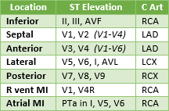
Wolff-Parkinson White: normal P wave w/PRI <0.12; HR <100bpm; avoid digoxin & verapamil (it ↑conduction through bundle of Kent & ↓AV node conduction, so v-fib can occur)

Determinants of CO & systemic BP
Mean BP is determined by 2 factors: CO & SVR
  - SVR = [(MAP – CVP) / CO] * 80
CO is determined by 2 factors: HR & SV (CO = HR * SV)
SV is determined by 3 factors: preload, afterload, & contractility
  - EF = SV / EDV OR EF = (EDV – ESV) / EDV; normal is ≥ 60%
Preload is determined by 2 factors: intravascular volume & venous tone
  - PL is the tension (force) in wall of L ventricle at end-diastole; ↑PL = ↑SV (Starling)
Afterload is determined by SVR; AL is the tension (force) in wall of heart at time aortic valve opens
Contractility is determined by the chemical environment of the cardiac cell
  - Contractility is the ability of the heart to generate a force for a given preload & afterload
Intravascular volume is determined primarily by amount of Na (controlled by aldosterone)

Myocardial Hypertrophy
Concentric hypertrophy: pressure overload; caused by chronically ↑AL (untreated HTN, AS, coarctation of aorta); L wall thickens & chamber size remains the same
Eccentric hypertrophy: volume overload; caused by chronic requirement to pump lg volume of blood (AR, MR, obesity); L ventricle dilates causing pumping chamber to enlarge (r/t Law of LaPlace… tension = (pressure * radius) / thickness

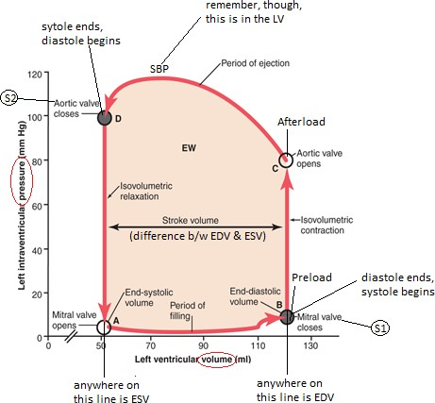Left ventricular pressure volume loops
If a loop gets taller/shorter = pressure change
If a loop gets wider/skinnier = volume change

Acute changes in preload
↑PL (fluids) = ↑EDV/SV/BP, unchanged ESV
  - HR & SVR may ↓ w/↑BP (baroreceptor reflex)
  - Loop should get wider (& modestly taller)
↓PL (diuretic, NTG) = ↓EDV/SV/BP, unchanged ESV
  - HR & SVR may ↑ w/↓BP (baroreceptor reflex)
  - Loop should get skinnier (& modestly shorter)
Though filling changes, the ventricle continues emptying to the same ESV, so SV changes w/PL

Acute changes in afterload
↑AL (neo) = ↑EDV/ESV/BP, ↓SV
  - HR may ↓reflexively
  - Loop should get taller & skinnier & shift right
↓AL (nipride) = ↓EDV/ESV/BP, ↑SV
  - Loop should get shorter & wider & shift left
  - HR may ↑reflexively
Based on AL, the LV empties more or less completely

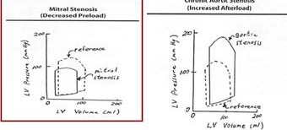
Acute changes in contractility
↑contractility (digoxin) = ↓EDV/ESV, ↑SV/BP
  - BP↑ (d/t ↑SV) & HR may ↓reflexively
  - Loop should get taller & wider & shift left
↓contractility (CHF) = ↑EDV/ESV, ↓SV/BP
  - BP↓ (d/t ↓SV) HR may ↑reflexively
  - Loop should get shorter & skinnier & shift right
- IHSS (idiopathic hypertrophic subaortic stenosis)
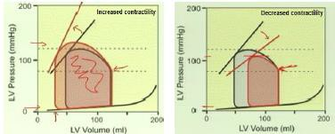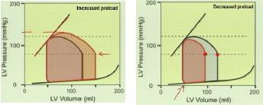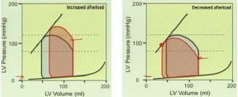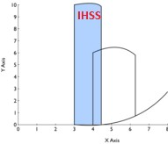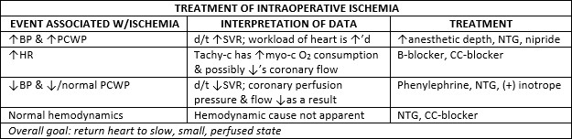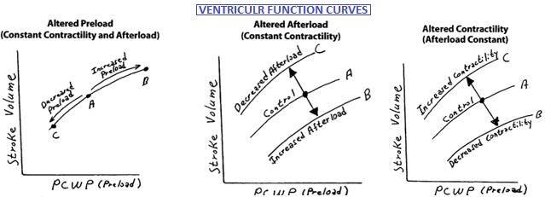 Loop gets skinnier & taller & shift left (*just memorize—looks like an “I”)

Valvular Lesions & LV volume loops
Aortic stenosis: loop shifts upward
Mitral stenosis: loop shifts left & becomes smaller (looks like tamponade or NTG/lasix)
Aortic insufficiency: isovolumetric relaxation is NOT isovolumetric
  - Acute: loop is shorter & shifts right
  - Chronic: loop is taller & larger (LV dilates w/time—eccentric hypertrophy) & shifts right
Mitral insufficiency: isovolumetric contraction is NOT isovolumetric
  - Acute: loop is shorter & shifts right
  - Chronic: loop is shorter & larger (LV dilates w/time— eccentric hypertrophy)
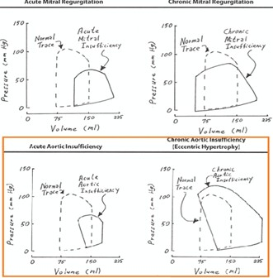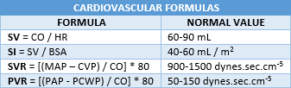

- Control of BP—baroreceptor reflex: ↑arterial BP➔↑stretch of baro-R in carotid sinus & aortic arch➔↑APs in afferent vagus (from aortic arch) & Hering’s nerve, a branch of glossopharyngeal, (from carotid sinus) to CV center in medulla➔ this causes…
↑APs in vagus efferent (to SA node in heart) = ↓HR/CO
↓APs in sympathetic nerves to heart (↓contractility/SV/CO), venous vessels (↓VR), arterial vessels (↓SVR)
  - Result is a ↓ in arterial BP (note: opposite process will occur in response to ↓arterial BP)
- Nitric oxide (NO): gaseous substance produced by numerous tissues in the body; produced by endothelial cells of vascular wall
Nitric oxide synthase (enzyme) converts arginine (amino acid) to NO, which is a potent vasodilator
Three forms of nitric oxide synthase:
  - Constitutive form (eNOS) is present & working at all times; regulated by Ca
  - Inducible form (iNOS) is generally dormant; produced in response to immunologic stimuli
  - Neuronal form (nNOS) is confined to neural tissues; regulated by Ca
NO from endothelial cells diffuses into smooth muscle layer of vascular wall & activates soluble guanylyl cyclase (sGC), an enzyme that triggers production of 2nd messenger cyclic guanosine monophosphate (cGMP) = smooth muscle relaxation
Nitroprusside, NTG, & dinitrates (isosorbide) “donate” NO at vascular wall = vasodilation (& some bronchodilation)
  - Nitroprusside has NO in its configuration; metabolism of NTG leads to generation of NO molecule
  - 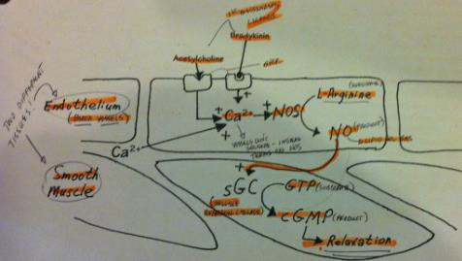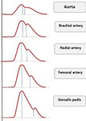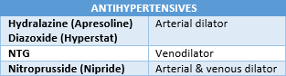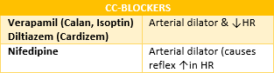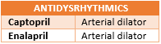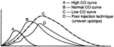NO generating system for NTG is found in venous vasculature, whereas the NO generating system for nitroprusside is found in both the arterial & venous vasculature
NO has also approved for persistent pulmonary HTN of neonate
- Measuring CO by thermodilution: CO is inversely proportional to the area under the curve

Mechanisms of edema formation
↑plasma hydrostatic pressure—
R heart failure = systemic edema & L failure = pulmonary edema
↓plasma oncotic pressure—hypoalbuminemia

Lymphatic obstruction
- Bainbridge reflex example: with this reflex, the SVC dilates & venous
pressure falls, but VR↑… how? B/C the pressure gradient across the
system ↑, which = VR ↑ (think of venous pressure as venous resistance to arterial flow)
- Arterial pressure wave forms: pulse pressure ↑s as wave form moves to more peripheral locations (d/t
↑SBP & ↓DBP—superimposition principle)
- MAP: most accurate measure of BP is taken from area under aortic pressure curve

Area under curve ÷ time = MAP
- Non-adrenergic CV drugs (see tables also)

Phosphodiasterase (PDE) inhibitors
  - Inamrinone (Ionocor) & milrinone (Primacor) block breakdown of cAMP = ↑contractility &↓SVR
Adenosine (antidysrhythmic): endogenous nucleotide occurring in all cells of body; can be given to…
  - Slow conduction of impulses through AV node
  - Interrupt re-entry pathways through AV node
  - Restores NSR w/paroxysmal SVT (including associated Wolff-Parkinson-White)
    - Dose is 6-12mg IV (slam it); elimination half-time is <10sec (rapid metabolism)
- Hypertrophic cardiomyopathy (w or w/o ventricular outflow obstruction): #1 cause of cardiac death in peds/young adults
Diastolic dysfunction is d/t abnormally hypertrophied septal muscle below aortic valve, which blocks outflow w/systole
  - This dysfunction is reflected by ↑LVEDP
Also, subaortic area is narrowed, contributing to obstruction as well
Venturi effect draws leaflet out as blood rushes by (Bernoulli’s Law)
Left ventricular hypertrophy w/o obvious cause & deep, broad Q waves
Obstruction is worsened by ↑contractility (digoxin, epi), ↓preload (hypovolemia, vasodilators), ↓afterload (hypo-t)
Obstruction made better with β-blocker/CC-blocker/anesthetics (↓contractility), hypervolemia/brady-c (↑PL), neo (↑AL)
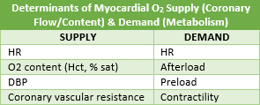
Mitral valve regurg will also be present (has a dysfunctional anterior leaflet w/stenotic & regurgitant elements)
S/S: dyspnea on exertion, angina, fatigue/syncope (classic triad); also tachydysrhythmias, heart failure
Diagnosis: ECG—notched P waves (MR), ST abnormalities, Q waves; cardiac cath

Anesthetic considerations
  - Arterial wave form may be bifid (bisferiens pulse, or rabbit ears)
  - NO nerve blocks—regional anesthesia will ↓PL & AL
  - Neo instead of ephedrine (ephedrine will ↑HR, which ↓PL)

Management of valvular lesions
Aortic regurg: (fast, forward, full) ↑HR (which ↓time for regurg), keep NSR, maintain PL, ↓AL, maintain contractility
  - Congenital or d/t rheumatic fever; leads to eccentric hypertrophy over time (volume overload)
  - Pts often asymptomatic (as long as 20yrs); initial S/S = severe dyspnea, hypo-t, weakness
    - Acute regurg represents CV collapse = diastolic murmur (L sternal border), ↓DBP, wide pulse pressure, MR
  - Angina can occur in absence of coronary dz d/t (1) ↑myo-c O2 demand & (2) ↓O2 supply d/t ↓diastolic aorta pressures
  - Pulmonary congestion can occur w/progressively ↑LVEDP & EDV
  - Other: spinals/epidurals okay; ephedrine over neo (which ↑AL)
Mitral regurg: (fast, forward, full) ↑HR, keep NSR, maintain PL, ↓AL, maintain contractility
  - Characterized by ↓in forward SV & CO associated w/↑ left atrial pressure (low impedance)
  - Etiologies: myo-c ischemia, infarction (chordae tendinae), infective endocarditis, rheumatic fever, chest trauma
  - As much as 50% of SV may regurg; LV compensates by dilating & ↑EDV—leads to eccentric hypertrophy
    - <30% regurg = mild, 30-60% = moderate, >60% = severe
  - Murmur best heart at apex, with radiation to axilla
  - Other: spinals/epidurals okay; ephedrine over neo (which ↑AL)
Aortic stenosis: (keep at baseline) slow HR, keep NSR, maintain PL & AL (coronary perfusion), maintain contractility
  - Most common cause is Ca deposits on cusp preventing normal opening; bicuspid valve = ↑risk
  - Obstruction is gradual; leads to concentric hypertrophy
  - Normal valve area = 2.5-3.5 cm²; stenosis is severe when 0.8-1.0 cm² & critical when 0.5-0.8 cm²
  - May experience angina w/o coronary dz d/t ↓O2 supply to subendocardium by ↓ventricular diastolic compliance
  - ↓atrial kick will ↓ventricular filling & may lead to a 40% reduction in CO; ST also ↓diastolic filling
  - Significant S/S do not develop until 30-60yrs old; classic S/S = syncope, angina, dyspnea on exertion (“SAD”)
  - Systolic murmur at right 2nd intercostal space w/transmission to neck (over aortic arch)
  - Other: may tolerate spinal/epidural if mild to moderate, but NOT for severe
Mitral stenosis: (keep at baseline) slow HR, keep NSR, maintain PL, AL, & contractility
  - Delayed complication of acute rheumatic fever; S/S develop in 20-30yrs; may have coexisting MR & aortic valve probs
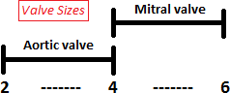
  - Normal mitral orifice = 4-6 cm²; opening reduced to <2cm²
  - Enlarged L atrium may apply pressure to L recurrent laryngeal nerve = hoarseness
  - 90% present w/CHF & a-fib; 10-15% develop chest pain
  - Rumbling diastolic murmur at apex or in axilla
  - 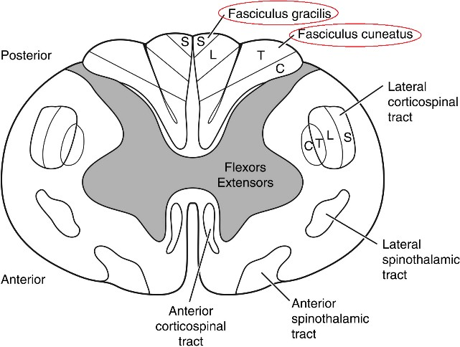Other: epidural > spinal (d/t gradual onset)

Heart valve lesion summary points
  - Regurgitant valves have ↑HR; stenotic valves have ↓HR
  - NSR is always preferred
  - PL & contractility are always maintained
  - AL must be understood for each lesion

Murmur master
  - ARDS (aortic regurg, diastolic, sternal border)
  - MSDA (mitral stenosis, diastolic, apex)
  - MRSA (mitral regurg, systolic, apex)
  - ASS Arch (aortic stenosis, systolic, aortic arch)

MODULE 5
Evoked Potentials, Pain Paths, CNS (pg. 65-101)
- Cuneatus & Gracilis tracts of the dorsal-lemniscal system are located in the posterior cord & carry sensations of touch, pressure, & vibration on ipsilateral side of SC (remember “SAD” = sensory/afferent/dorsal)
SSEPs assess integrity of these tracts, which are the most direct route to sensory cortex for touch, pressure, & vibration
  - w/posterior cord or brain ischemia, transmission of APs through the SC & brain is diminished & SSEPs are altered
- Reticular activating system (RAS): in addition the direct route to the primary sensory cortex, sensory info is also transmitted into the RAS where it percolates upward & spreads throughout the cerebral cortex; this is a secondary, indirect route
RAS functions to maintain the awake/alert state & shuts off when we go to sleep (GA depresses the RAS)
- Anatomical pathways for evoking cortical potentials: tibial, median, & ulnar nerves may be stimulated, usually bilaterally to elicit SSEPs, which are recorded from the scalp (stimulating electrodes are placed peripherally, detecting placed centrally)

Homunculus: representation of primary sensory cortex; note that the ankle is located centrally on the homunculus, which is why the critical electrode for detecting SSEPs must be placed at the midline of the scalp (over the primary sensory cortex)
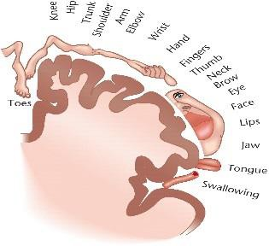
Path of AP from tibial nerve to central cortex: R tibial to SC via dorsal horn➔R (ipsilateral) SC (cuneatus/gracilis tracts)➔L cerebral cortex➔evoked potential recorded near midline (over longitudinal fissure)

Components of SSEPs
Early peak = APs carried directly by cuneatus/gracilis tracts
Late peak = APs that traversed RAS; has larger magnitude, longer duration
Latency: time for AP to traverse peripheral nerves, SC, & inner brain b/f arriving at cerebral cortex
Amplitude: magnitude (size) of evoked potential

↑latency and/or ↓amplitude suggests damage is occurring along pathway
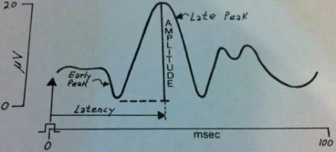
    - Changes in temp, hypo-t, & changes in PaCO2/PO2 also may effect SSEPs
- Applications for SSEPs: spinal surgery, thoracic & thoracocolumbar aortic reconstruction, CEA

Types of evoked potentials
SSEP (somatosensory): monitor fxn of dosal spinal cord or brain
BAEP (brainstem auditory): elicited by auditory clicks; useful in surgeries involving CN VIII
VEP (visual): elicited by flashes of light; useful in surgeries near CN II
  - VEP most sensitive to anesthetic agents (“very”), then SEEP (“somewhat”), then BAEP (“barely”)

Peripheral afferents (sensory) conducting pain (& temp)
A-δ: free nerve endings, myelinated, 1-4μm in diameter, transmit fast/1st pain (sharp, pricking)
C-fibers: free nerve endings, unmyelinated, smaller (0.4-1.2μm in diameter), transmit slow/2nd pain (dull, throbbing)
- Pain classifications: somatic, superficial (cutaneous), deep (muscles, tendons, joints), visceral (parietal peritoneum or viscera)
- Dual pain pathways: fast & slow paths are activated in periphery when nerve endings are damaged
Cell bodies of A-δ & C-fibers are found in dorsal root ganglion
These fibers enter dorsal cord, divide, & ascend/descend 1-3 segments in the Tract of Lissauer

Transmission of pain impulses through dorsal horn
Fast/Sharp pain: after leaving Tract of Lissauer, A-δ enter dorsal horn➔terminate in Rexed’s Lamina I & V
  - 2nd order neurons leave lamina I, V & cross to contralateral lateral spinothalamic tract & ascend to brain
    - LST is an ascending sensory tract carrying pain & temp; part of anterolateral system
    - Another part of anterolateral system is dorsolateral tract, which is descending & modulates pain
  - Major NT from A-δ is glutamate, which binds to AMPA & NMDA receptors on postsynaptic membrane
Slow/Chronic pain: C-fibers terminate in lamina II, III➔interneurons transmit to lamina V
  - Neurons leaving lamina V cross immediately to contralateral lateral spinothalamic tract & ascend to brain
  - Major NT from C-fibers is substance P, which binds to NK-1 receptors on postsynaptic membrane
- Reminder of dermatome landmarks: clavicle (C4), nipples (T4), xiphoid (T6), umbilicus (T10), tibia (L4-5), perineum (S2-5)
- Substantia Gelatinosa: lamina II (or II & III, depending on the source); site where pain impulses are attenuated
1st neuron of slow/chronic path synapses in SG➔releases substance P➔enkephalin-releasing interneurons synapse on substance P-releasing nerve terminal➔release of substance P is decreased (↓APs = ↓pain)
  - Enkephalin is an endogenous opioid that acts primarily on μ2 in SC (though all opioid-R are present in the SC)
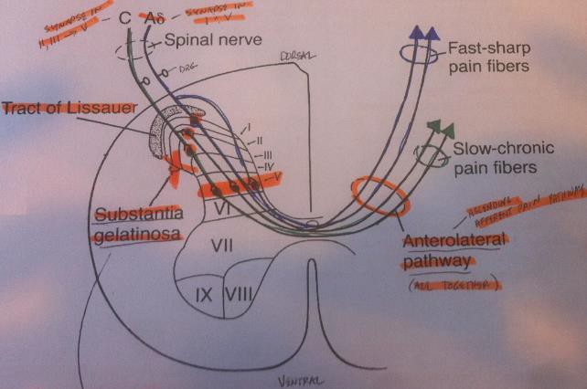
  - Opioids (fentanyl, morphine) stimulate the same receptors to ↓pain
- Neuraxial Opioids (spinal analgesia)
Hydrophilic Opioids (morphine)
  - Intrathecal: onset is slow, duration is long; early resp depression
doesn’t occur (happens late, at 6-12hrs)
  - Epidural: onset is slow, duration is long; resp depression within 2hrs d/t >systemic uptake
Lipophilic Opioids (fentanyl)
  - Intrathecal/Epidural: onset is rapid, duration is short (diffusion out of CSF is fast); early resp depression
SE: pruritis, neonatal morbidity, nausea, urinary retention, resp depression, CNS excitation, sedation, GI dysfxn
- Spinal analgesia: when transmission of pain impulses through SG is suppressed; pt’s perception of pain in diminished
Note: even if opioids are working in brain (at periaqueductal gray), if the net action is at SC, then it is spinal analgesia
- Supraspinal analgesia: when opioids act in the brain (& activity stays in the brain) in lymbic system, hypothalamus, thalamus
“I feel the pain, but I don’t care”
- Brain control of SG: descending neurons in periventricular/periaqueductal gray terminate in SG
Impulses arising at P/P gray go through Raphe Magnus Nucleus (pons) to SG via dorsolateral funiculus➔APs activate enkephalin neurons = ↓substance P = ↓pain
  - Also, descending APs in dorsolateral funiculus hyperpolarize cell bodies of 2nd neurons in pain path, thereby ↓APs in
ascending lateral spinothalamic tract (in other words, the descending dorsolateral tract modulates pain)

    - IV opioids produce analgesia in part by initiating APs in the dorsolateral funiculus (supraspinal, mediated by μ1)

Summary of afferent pain paths
Afferent paths are 3-neuron pathways; primary neuron originates in periphery & terminates in dorsal column (Rexed’s)
Secondary neurons immediately crosses over, then ascends the anterolateral system
  - There are dual ascending paths in the anterolateral system—lateral spinothalamic & anterior spinothalamic
Secondary neurons terminate in thalamus, specifically the ventro-posterior thalamus
From there, third order neurons project to the somatosensory cortex (in postcentral gyrus)
- Cross talk: b/w ascending paths & descending paths that modulate pain; accomplished by interneurons in periaqueductal gray
OPIOID RECEPTORS
μ-1 | μ-2 | κ | δ
Spinal analgesia  Supraspinal analgesia | Spinal analgesia | Spinal analgesia (κ-1)  Supraspinal analgesia (κ-3) | Spinal analgesia (δ-1, 2)  Supraspinal analgesia (δ-1, 2)
 | Respiratory depression
↓HR  Euphoria  Low abuse potential Urinary retention Pruritis | Physical dependence Constipation (marked) | Dysphoria, sedation Diuresis | Physical dependence Constipation (minimal)

Additional opioid facts
Most currently used opioid agonists are highly specific for μ-R
Spinal analgesia is mediated by all opioid-R, but primarily by μ-2
Supraspinal analgesia is mediated primarily by μ-1
Remifentanil is unique b/c it is metabolized by non-specific plasma esterases & appears to lack κ & δ activity
- Competitive opioid antagonists (naloxone, naltrexone, nalmefene): all opioid-R are blocked by these
Naltrexone is often used to treat opioid & alcohol addiction
SE of naloxone: analgesia reversal, excitement/dysphoria, tachy-c, HTN, dysrhythmias, pulmonary edema
- Opioid agonist-antagonists (nalbuphine, butorphanol, buprenorphine, dezocine, nalophine, pentazocine): either weak agonists
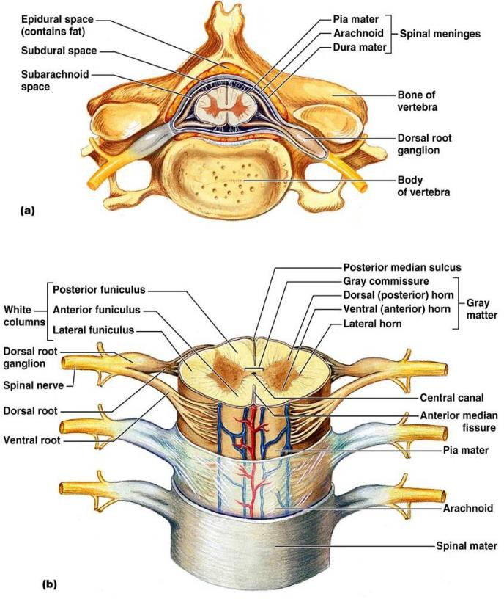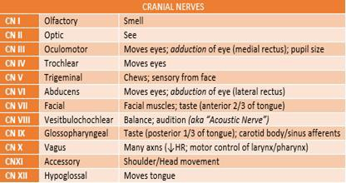or antagonists for μ, & κ/δ agonists; these maintain analgesia without producing severe resp depression
- Neuroanatomy of SC—summary
Afferent (sensory) nerves enter dorsal SC
Efferent (motor) nerves exit from ventral SC
Spinal nerve root is connected to paravertebral sympathetic ganglia by communicating channels called white/gray rami
White rami carry myelinated sympathetic preganglionic neurons & gray carry unmyelinated (C-fibers)
Motor nerves to skeletal muscle arise from anterior horn
Preganglionic sympathetic nerves arise from intermediolateral horn
2 divisions of PNS: somatic (motor & sensory for pain, temp, touch, pressure) & autonomic
- Cranial Nerves (“O O O To Touch & Feel Virgin Girl’s Vagina & Hymen”)
- CSF Circulation Route (“Christie Leann Martin Takes A Fall; Must Lose Some Brain Activity”)

Choroid plexux➔Lateral ventricles➔Foramina of Munro➔Third ventricle➔Aqueduct of Silvus➔Fourth Ventricle➔Foramina of Lushka/Foramen of Magendie➔Subarachnoid space of SC➔Brain➔Arachnoid villi
CSF is made in choroid plexus of lateral, third, & fourth ventricles

CSF is reabsorbed in arachnoid villi (smaller) & arachnoid granulations (larger); both are a part of arachnoid membrane
- Circle of Willis: permits collateral flow in event that major vessel becomes occluded
Major vessels supplying circle of Willis are R/L internal carotids & basilar artery (supplied by R/L vertebral arteries)
All vessels in CoW are paired except basilar & anterior communicating arteries
Stump pressures measure pressure transmitted through CoW back to carotid (indicates brain perfusion); want >40mmHg

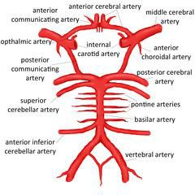Effects of GA on cerebral flow & O2 consumption
Volatiles ↑cerebral flow & ↓CMRO2; halothane ↑flow most & iso the least
N2O alone ↑both cerebral flow & CMRO2 d/t sympathetic axns
Except Ketamine, all IV anesthetics ↓both cerebral flow & CMRO2 (Ketamine ↑both)

Blood supply of SC
1 anterior spinal artery (75%), 2 posterior spinal arteries (25%) supply SC
  - Also, small segmental arteries (from intercostal/lumbar arteries) augment flow
  - Usually there are 8 radicular (segmental) branches, including at least 1 cervical, 2 throacic, & 1 upper lumbar
  - Largest of these is the Great Radicular Artery (of Adamkiewicz)—enters vertebral canal from L side (in most pts) in lower thoracic region; NOT bilat
    - Likely major source of flow to lower 2/3 of SC; blocked = paraplegia
    - In 75% of cases, Artery of Adamkiewicz joins anterior spinal artery b/w T8-T12 (10% b/w L1-L2)
    - SC ischemia w/aortic cross clamping occurs in 1-11% of distal descending thoracic artery repairs
- Coma: condition of non-arousal d/t damage of reticular activating system (RAS)
- Decorticate rigidity: damage to brain above cerebellum & brainstem (supratentorial); UE flexion, LE extension
- Decerebrate rigidity: damage to brainstem or cerebral lesions that compress thalams/brainstem; UE/LE extension
Mechanical ventilation required for this pt b/c brainstem (center for resp control) is damaged
- Intracranial pressure: normal is <15mmHg
S/S of ↑ICP: ↑MAP, ↓HR, irregular respirations (Cushing’s Triad); think of the opposite of shock S/S (↓BP, ↑HR/Resp)
Focal ischemia occurs around >20mmHg; global around >50mmHg
- Cerebral steal (Luxury perfusion): in ischemic brain regions, vessels are max dilated; in non-ischemic, vessels have tone
W/vasodilator or hypoventilation, vessels in non-ischemic region dilate = flow ↑to non-ischemic, ↓to ischemic
Inverse steal (Robin Hood): w/hyperventilation, vessels in non-ischemic constrict & blood is diverted to ischemic
  - Bottom line: hyperventilation (↑PaCO2) improves flow to ischemic areas of the brain

Bones of the skull & cranial fossa
Frontal lobes rest in anterior cranial fossa; temporal lobes rest in middle; brainstem & cerebellum rest in posterior
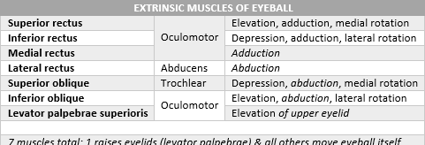
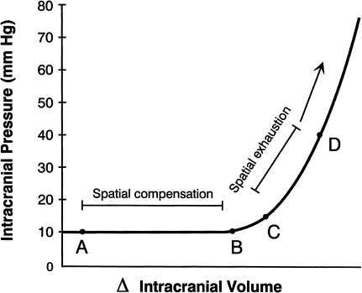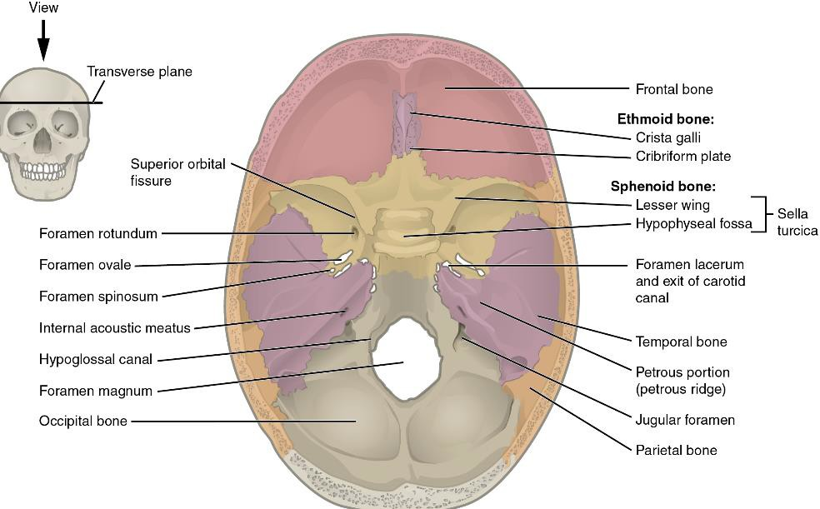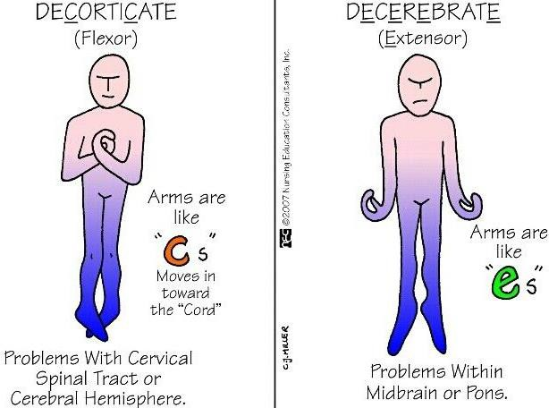

- Withdrawing entrained air during craniotomy: multi-orifice catheter must be positioned high in R atrium, 2cm below SVC-atrial jxn b/c that is where air tends to localize (tip of single-orifice cath should be in R atrium, 3cm above SVC-atrial jxn)

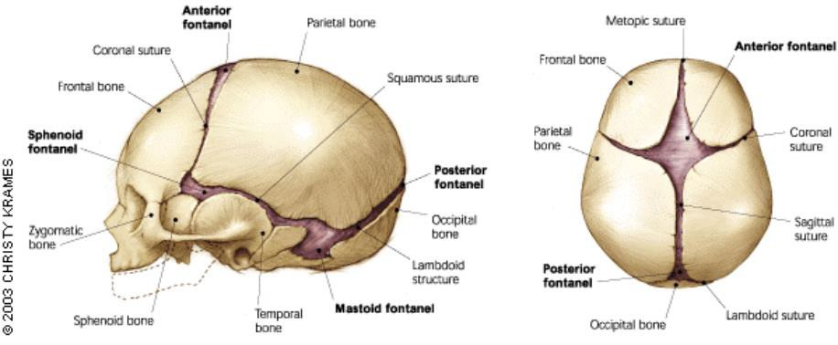
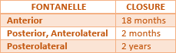
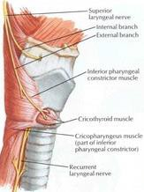
Fontanelles

MODULE 6
Respiratory System (pg. 184-223)

Anatomy of larynx
Motor innervation
  - External branch of superior laryngeal nerve innervates cricothyroid muscle
  - Recurrent laryngeal nerve supplies all other intrinsic muscles of larynx

Sensory innervation
  - Internal branch of SLN is major sensory nerve of larynx; supplies tissue from vocal cords up (including VC)
  - Recurrent laryngeal supplies sensory innervation to laryngeal mucosa inferior to VC
4 pieces of cartilage: 3 large—epiglottis, cricoid, throid; 3 smaller pairs—arytenoids, cuneiforms, cuniculates

Laryngeal nerve damage
Damage to external SLN = VC cannot be tensed (cricothyroid is paralyzed)
Unilateral R RLN damage = hoarseness & paralyzed cord that assumes intermediate position (post subtotal thyroidectomy)
Bilat RLN damage = aphonia & paralyzed VC; results in airway obstruction; extremely rare
  - Stridor after thyroidectomy may result from bilat RLN damage OR hypocalcemia (parathyroid involvement)
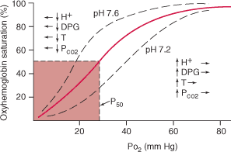
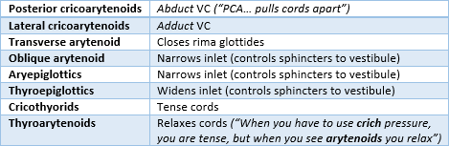
Unilateral vagus damage: hoarseness
- Oxyhemoglobin dissociation curve: upsloap is unloading (desaturated) region & plateau is loading (saturated) region
“For PO2 of 40, 50, 60 you get SATs of 70, 80, 90”; 40mmHg (70% O2) = mixed venous blood; 60mmHg (90%) = arterial
P50 (O2 at which Hgb is 50% saturated) is normally 26-28mmHg
  - P50 ↑ w/right shift & ↓ w/left shift
Left shift represents an ↑binding/affinity; right shift represents ↑unloading
  - Left shift (↑O2 carried by Hgb): ↓H/DPG/Temp/CO2, fetal Hgb, carboxy-Hgb, meth-Hgb
  - Right shift (↓O2 carried by Hgb): ↑ H/DPG/Temp/CO2, maternal Hgb, sickle cell (HbS)
    - Example: opioids would shift curve right (d/t ↓respirations, which would ↑CO2)
Bohr effect: refers to shift in oxy-Hgb curve in response to an ↑ or ↓ in PCO2
Systemic circulation: blood travels through capillaries➔CO2/acids diffuse in blood (& temp↑ w/metabolism) = O2 unloads
Pulmonary circulation: blood through pulm capillaries➔CO2 diffuses to alveoli = O2 loads

Calculating O2:
Hgb-bound O2 = (max carrying capacity) * (concentration of Hgb) * (% SAT)
  - For SAT of 90%... (1.34 mL O2/g Hb) * (15 g Hb/100mL blood) * (0.9) = 18.1 mL O2/dL
Dissolved O2 = 0.003 * PO2 (units are mL O2/100mL blood OR O2/dL at 37°C)
Total O2 = Hgb-bound + dissolved

Other O2 carriage facts
O2 is carried in two forms: Hgb-bound (chemical form) & dissolved (physical form)
Max O2 carrying capacity in young, healthy person breathing RA = 20.4 mL O2/100mL (20.1 w/Hgb, 0.3 dissolved)
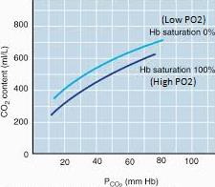
Hypoxia is defined as PaO2 < 60 mmHg (when curve slopes steeply)
Henry’s Law: dissolved gas in liquid = dissolved gas * solubility

Amount of CO2 dissolved in blood = PCO2 * 0.067
- CO2 blood dissociation curve
Haldane Effect: change in PO2 influences blood CO2 dissociation curve
  - ↑PO2 = CO2 curve shifts downward & right
  - ↓PO2 = CO2 curve shifts upward & left
Systemic circulation: O2 diffuses out of blood to cells = CO2 curve shifts left = loading of CO2 into blood (blood will carry more CO2 when PO2↓)
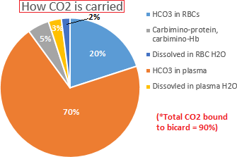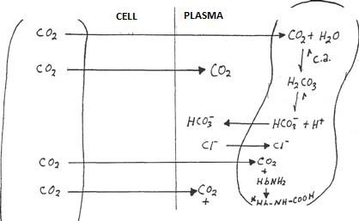 Pulmonary circulation: O2 diffuses to blood from alveoli = CO2 curve shifts right = unloading of CO2 from blood (blood will carry less CO2 when PO2↑)

Conversion of CO2 to bicarb
Cl shift (Hamburger Shift) in non-pulm capillaries (see pic)
  - CO2 diffuses from tissue cell to vascular compartment
  - Converted to HCO3 via carbonic acid
  - Reacts w/H2O via carbonic anhydrase = carbonic acid (H2CO3)
  - HCO3 diffuses out of RBC down concentration gradient
  - Cl diffuses into RBC as HCO3 diffuses out (maintains electroneutrality)

Cl shift (Hamburger Shift) in pulm capillaries
  - CO2 diffuses from plasma to alveoli
  - Co2 diffuses from RBC to plasma
  - HCO3 diffuses into RBC
  - Cl diffuses out of RBC as HCO3 diffuses in

Control of Ventilation
Pneumotaxic Center (Pontine Resp Group): 2° resp center high in pons; shuts off inspiration
Apneustic Center: 2° resp center lower in pons; site of normal inspiratory cutoff
  - These two centers probably work together to control rate & depth of breathing
Dorsal Resp Group (in medulla): inspiratory pacemaker, vital center, controls diaphragm & ext intercostals
  - Sends motor signals via phrenic (C3-5) to diaphragm; via ext/int intercostal nerves to ext/int intercostal muscles
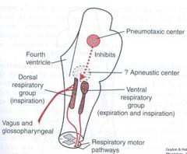
    - Diaphragm accounts for 50-75% of quiet, spontaneous breathing
  - Receives sensory signals via vagus to stretch receptors in lungs
  - Receives glossopharyngeal nerve from peripheral chemo-R in carotid bifurcation
Ventral Resp Group: controls int intercostals; influence both inspiration & expiration
  - Comes into play when high levels of ventilation are required
Stretch Receptors: in smooth muscle of bronchi or bronchioles; reflexively inhibits inspiration when stretched
  - Hering Breuer Reflex: NOT important until VT exceeds 1.5L; protective mechanism to prevent excess lung ventilation
Central chemo-R are stimulated by ↑H+ (↑CSF CO2 automatically = ↑H+)
Peripheral chemo-R: found in carotid bodies (mostly) & aortic bodies; stimulated by ↑PCO2, ↓pH, ↓PaO2
  - Glossopharyngeal carries sensory impulses from carotid bodies, vagus from aortic bodies & lung stretch receptors
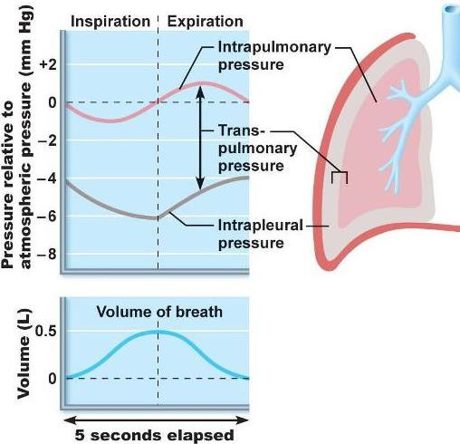
CO2 drives normal resp (even though O2 is the strongest driver of resp)

Pulmonary mechanics
Intrapleural space: potential space b/w parietal pleura of internal chest wall & visceral pleura covering lungs
The pleural membranes couple the lungs to the chest wall
Intrapleural pressure is negative (subatmospheric) b/c the lungs recoil inward & chest wall recoils outward
  - These forces come to equilibrium at end expiration

Normal tidal breathing
During normal inspiration, intrapleural pressure becomes more (-)
Intrapulmonary pressure (was 0 at end expiration) becomes (-) w/inspiration
Air enters lungs b/c intrapulmonary pressure is < atmospheric pressure

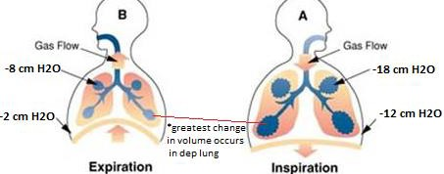
At end inspiration, intrapulmonary pressure is 0
During expiration, intrapleural pressure becomes less (-) & intrapulmonary pressure becomes (+)
Air is exhaled b/c intrapulmonary pressure is > atmospheric
  - Intrapleural pressure is always (-) during normal tidal volume breathing; it becomes (+) w/forced expiration or Valsalva

Distribution of ventilation
- V/Q: ratio of ventilation to perfusion; normal = 0.8
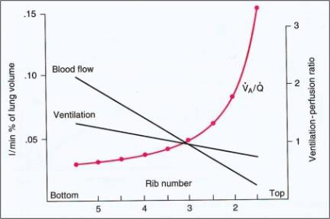
(4 L/min ventilation) / (5 L/min CO) = 0.8

Regional distribution of ventilation/perfusion
In apex, delivery of O2 is 3.5x better than removal (V/Q = 3.5)
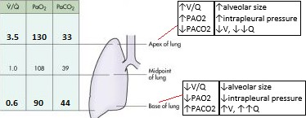
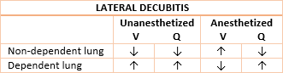
There is dead space (↑V/Q ) in apex, shunt in base (↓V/Q)
- Lateral decubitis anesthetized & paralyzed: a V/Q mismatch develops when anesthetized & paralyzed; ventilation is non-
dependent lung ↑ (dependent lung is difficult to inflate), but distribution of blood flow does not change
Non-dependent = dead space (well ventilated, poorly perfused); dependent = shunt (well perfused, poorly ventilated)
- 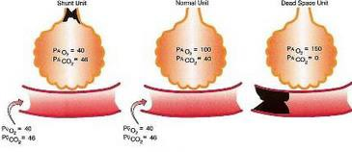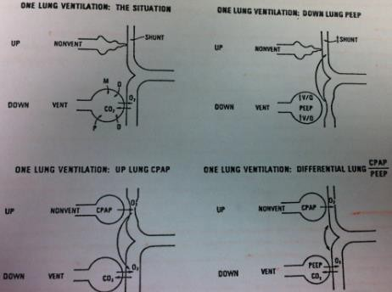V:Q disturbances: PaO2 always ↓ when there is a V/Q mismatch
↓PaO2 may be accompanied by hypocapnia, normocapnia, or hypercapnia
If breathing RA, a V/Q mismatch leads to hypoxia
B/C low PaO2 can be caused by V/Q mismatch AND hypoventilation (or low inspired O2), the alveolar-arterial blood gradient must be calculated to determine if a V/Q mismatch is present
  - Normal PAO2 – PaO2 gradient = 5-15 mmHg
    - This ↑as inspired O2 ↑ (could = 100 mmHg on 100% FiO2)
  - Normal PaCO2 – PACO2 gradient = 2-10 mmHg
    - Note: EtCO2 = average PACO2
  - If pt is hypoxemic (PaO2<60 mmHg) AND one of these gradients is grossly abnormal, there is a V/Q mismatch
- One-lung anesthesia—strategies for maintaining arterial blood oxygenation
Dependent lung is ventilated but compressed by wt of mediastinum, the diaphragm, & positioning effects of rolls, etc.
  - Non-dep lung is non-ventilated, & flow through this lung is shunt flow
With down lung PEEP, V/Q is improved in dep lung, but vascular resistance is
↑ there, shunting more to non-dep lung
CPAP to non-dep lung permits O2 uptake there, which greatly ↑PaO2; blood is diverted to dep lung, but that’s ok b/c gas
exchange is actively taking place there
With CPAP to non-dep AND PEEP to dep, it doesn’t matter where blood flows since both lungs participate in O2 uptake

Summary: V/Q
Dependency is d/t effects of both gravity & support at base of dependent structure
In any position, dep (lower) regions are better perfused & ventilated than non-dep (upper) regions (awake pt)
Blood flow is affected to a greater degree by dependence than ventilation (changes in perfusion are greater than changes in ventilation in the vertical direction; that is, V/Q is normally smaller in dep region & larger in non-dep region)
Normal V/Q mismatch implies PaO2 is 5-15mmHg < PAO2, & PCO2 is 2-10 mmHg > PACO2 (on room air)
With obstructive dz (emphysema, asthma), large mismatches may occur (↓PaO2, ↑PCO2); ↑ventilation has little effect on
PaO2 but may lower PCO2 levels if dz is not in severe stage
With a substantial defect in ventilation & perfusion, there will be hypoxemia w/hypocarbia, normocarbia, or hypercarbia
↑FiO2 may do little to ↑O2 carrying capacity if the problem is R➔L shunt; if pt is deadspacing, ↑FiO2 will help

Four Zones of the Lung (West’s Zones)
Zone 1 (PA > Ppa > Ppv): alveolar pressure exceeds artery pressure, so capillaries in alveolar wall collapse (no flow)
  - Zone 1 is not normally present; it is a pathological zone that develops w/pulm hypotension

Zone 2 (Ppa > PA > Ppv): pulm artery pressure exceeds alveolar pressure; blow flow is proportional to Pa-PA gradient
  - Known as “waterfall zone” b/c after flow passes through alveoli it falls into pulmonary venous system
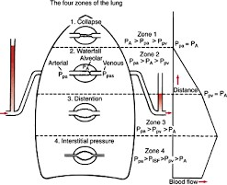
Zone 3 (Ppa > Ppv > PA): flow is proportional to Pa-Pv grandient
  - Tip of Swan-Ganz cath should be in Zone 3
Zone 4 (Ppa > Pisf > Ppv > PA): flow is proportional to Pa-Pisf gradient
  - Also not normally present; pathological—develops w/pulm edema
Remember, these zones are not anatomically fixed; in lateral position, most non-dep region is where Zone 1 would occur

Preoxygenation/Denitrogenation
Normally, FRC has ~415mL O2 & total O2 in blood is ~856 mL
With 100% FiO2, FRC ↑6x (2526 mL) & total O2 ↑slightly
Preoxygenation for 5min w/100% can furnish up to 10min of O2 reserve
  - Normal VO2 (O2 consumption) = 250 mL/min, so it would take 10min to use all O2 in FRC if expanded to 2500mL w/preoxygenation
Most common reason for poor preoxygenation is a loose-fitting mask
- Hypoxic pulmonary vasoconstriction: in response to hypoxia, alveolar arteries constrict to ↓flow to unventilated area (↓shunt)
Direct acting vasodilators & volatile anesthetics (at >1MAC) inhibit HPV, thereby ↑shunt & ↓PaO2

Pulmonary function tests (PFTs)
Two types of ventilatory dz: obstructive (COPD, asthma) & restrictive (generally difficult to reverse)
↓FEV1/FVC on spirometry is characteristic of airflow obstruction (should be performed when COPD is suspected)
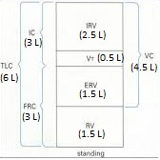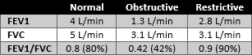 Lung volumes from spirometry: all (VT, VC, IC, IRV, ERV) except FRC, RV, TLC
Methods for measuring FRC: He dilution, N2 washout, body plethsmography (Boyle’s Law)
FEV1: forced expiratory volume in 1 sec
FVC: forced VC; volume that can be exhaled during a forced expiratory maneuver
FEV1/FVC: ratio useful in distinguishing restrictive vs. obstructive
FEF25-75: rate of flow in a forced expiration from point where 25% to 75% of FVC has been exhaled; best test for assessing small airway dz
- Obstructive dz: asthma, COPD (chronic bronchitis, emphysema)
- Restrictive dz: pulmonary fibrosis, pneumo, chest wall dz (scoliosis), neuromuscular dz
If FEV1 <2 L/min & FEV1/FVC <40%, more sophisticated tests should be run
- Flow volume loop: normal looks like a guitar pic
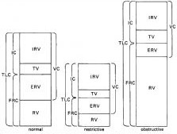
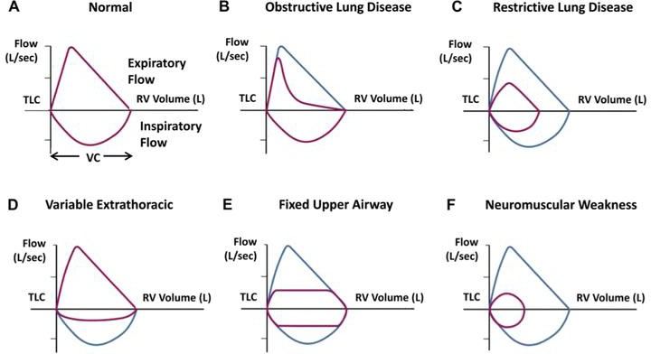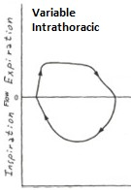
Lung volumes are greater with obstructive dz, and lesser with restrictive dz
With Extrathoric, Expiration is normal (impaired inspiration); with Intrathoracic, Inspiration is normal (impaired expiration)
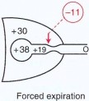
- Airway closure: as fluid/gas flows through a tube, pressure falls (pressure ↓along bronchioles) = airway closure
During forced expiration, intrapleural pressure becomes (+); as air flows along airway, the pressure falls
  - At some point, intrapleural pressure sufficiently exceeds airway pressure & airway closes

Closing volume/capacity
Closing volume: air that can still be forced out after 1st airway closes; closing capacity = CV + RV
In young, healthy adults airway closure occurs at low volumes (at ~10% of VC)
The volume at which airway closure occurs ↑w/age; CC becomes equal to FRC in upright 66yr old

Also w/age, lung becomes more compliant (less elastic), chest wall becomes less compliant, & FRC ↑slightly
CV is also ↑w/obstructive pulmonary dz
  - Emphysema: loss of collagen/elastin = radial traction holding airways open ↓

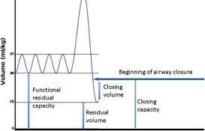
  - Chronic bronchitis/asthma: airways narrower & pressure↓ along airways is greater
  - Other: smoking, bronchospasm, airway secretions, fluid retention, anesthesia/surgery

MODULE 7
Equipment; Monitoring (pg. 472-511)
- DISS (Diameter Index Safety System): back of machine; connections indexed for a specific gas
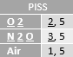
- O2 from wall supply (50psig) opens check valve in pipeline inlet; this valve prevents O2 cylinder gas from escaping the machine & going into the hospital wall
- Hanger yoke has pins for E cylinders to fit (see chart➔); prevent a full cylinder from emptying into empty cylinder or wall O2 entering a cylinder (PISS = pin index safety system… “PISS is the DISS for cylinders”)
- Bourdon gauge: shows O2 cylinder pressure
- Pressure regulator: 1st & 2nd stage regulators are diaphragm valve & only reduce pressure (this is their only fxn)
1st stage regulator: high➔intermediate pressure; cylinder pressure is ↓to 45psig (slightly less than pipeline)
2nd stage regulator: intermediate➔low pressure; reduces wall pressure (or cylinder) from 50psig to 16psig
- O2 flush valve: ball-and-spring valve; O2 at 35-75 L/min, pressurized at 40-50psig; possible barotrauma if this goes to the pt
- Pressure sensor shut-off valve (“fail safe”): cannot deliver N2O w/o adequate O2 pressure (O2 must be at least 25psig)
- O2 flow meter & flow control valve: read ball float in middle of ball, read arrow float at top of float to determine flow rate
Thorpe tube is gas specific & tapered w/largest diameter at top (annular space b/w floats & sides)
O2 knob differences: green, fluted, larger, always on right, sticks out further
- Check valve b/w vaporizer outlet & common gas outlet: closes & stops vaporizer flow when excessive back-pressure develops
- Inspiratory/Expiratory check valves: flutter valves; unidirectional
If inspiratory valve sticks open—EtCO2 will ↑as pt begins rebreathing mixed gas
If expiratory valve sticks open—inspired volume will not enter ETT, but leave expiratory side (d/t path of least resistance)
- APL (Adjustable Pressure Limiting): aka “pop off”; adjusts pressure in pt circuit & bag; attached to exhalation check valve
- Absorber: on inspiration, gas (from CGO & rebreathing bag) flows through inhalation check valve & soda lime
On expiration, gas flows through exhalation check valve to APL/rebreathing bag
- Scavenging system: receives gas from APL & ventilator & allows it to escape to OR (or wall) if pressure builds up
- 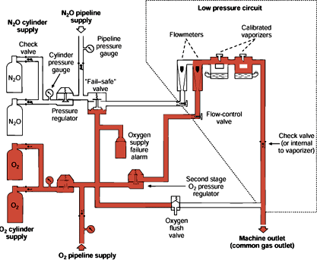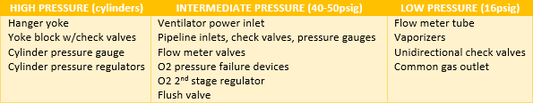Vaporizers: if tipped, liquid vapor will get into the vaporizer chamber = more will be given to pt; must be recalibrated
* 3 main valve types
Free-floating: moves air in the direction it is being pushed; prevents gas leak (DISS, dual hanger yoke)
Ball-and-spring: permits gas flow after connection is made; you
supply the energy; “all or none” (O2 flush)
Diaphragm: pressure regulators
* Complications r/t gas machine management
Hypoxia: empty O2 cylinder, incorrect cylinder on O2 yoke, close O2 cylinder valve, O2 flow meter off, O2 leak within machine or flow meter, faulty unidirectional valves, breathing circuit leak, inadequate ventilation
Hypercarbia: (overlap w/above, plus…) exhausted soda lime, ↑dead space in apparatus, inadequate fresh gas flow
  - Pt causes: resp depression, muscle relaxants, airway obstruction, severe intrapulmonary shunting
- Compressed gas cylinders: “any material or mixture having either an absolute pressure exceeding 40lb/in² or 130° F, or both
All cylinders are constructed according to Interstate Commerce Commission specifications
Anesthetic/Medical gases each have a specification number of ICC3S—must be on each cylinder
Other cylinder characteristics: entirely steel or chrome, walls 3/8’’ thick, tested to 1.66 their service pressure, must have
some tensile strength not to exceed 10%, subject to test every 5yrs, has a given pressure (called the service pressure)
- Cylinder pressure & capacity: O2 = 2000psi, 660L; N2O = 745psi, 1590L; Air = 1900psi, 625L
O2 is gas in a cylinder b/c it has a critical temp < room temp; N2O is a liquid at room temp
- Cylinder standards: Federal Food, Drug, & Cosmetic Act regulates gases; potency & purity are set by US Pharmacopeia
Dept of Transportation: requirements for design, construction, testing, labeling, storage, handling, transportation
Compressed Gas Assc./National Fire Prevention Assc.: standards for safe practice; basis for JCAHO accreditation
American National Standards Institute: safety/performance requirements for anesthesia machines
National Institute of Occupational Safety/Health (& Occupational Safety/Health Act, 1970): health/safety standards

Food & Drug Administration: standards for medical devices/gases
American Society for Testing Materials: assesses technology & revises standards
Joint Commission on Accreditation of Hospitals: voluntary accrediting agency
National Formulary: purity specifications for medical gases (like Pharmacopeia of US)
- Cylinder markings (7 required): regulatory body (DOT), serial #, purchaser/user/manufacturer, manufacturer’s manual, manufacturer’s identifying symbol, retest date/retester/ID symbol/110%filling/10yr test interval, neck ring owner’s ID
- Withdrawing cylinder contents: crack cylinder first (open slightly for a moment to clear outlet of dust)
Opening compressed contents into small space generates heat & could cause combustion

Breathing systems
Open—no mask on face: no dead space, no rebreathing/reservoir, no valves; not used much today
Semi-open—mask on face: pt spontaneously breathes inhaling anesthetic & RA (open drop technique)
  - Reservoir bag, no rebreathing, high gas flow, room pollution
Semi-closed—mask on face: anesthetic gas in system (no RA inspired); expired gas through scavenging system
  - Unidirectional valves, conserves moisture/heat, FGF can be < pt’s minute ventilation, has pop off & corrugated tubes
Closed—mask on face: anesthetic agents contained in system and are not vented (pop off closed)
  - Flow 150-500mL/min for physiological requirements (150-250mL/min under anesthesia); unknown gas concentrations
- Mapleson systems: all have common components—facemask, springloaded pop off, reservoir tubing, FGF inlet, reservoir bag

3 distinct Mapelson groups
  - A: FGF inlet & pop off valve at opposite ends
  - B, C: FGF inlet at mask end, next to pop off valve
  - D, E, F: FGF inlet at mask end & pop off valve at end away from mask (also called T-piece tubing)
Preventing rebreathing w/spontaneous ventilation: A > D F E > C B
During controlled ventilation: D F E > B C > A
- Laryngeal mask airway: max use for reusable is 40x; can be used w/NGT (pass b/f placing LMA)
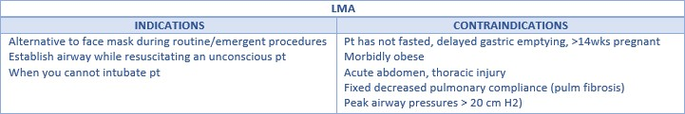
Concerns w/LMA: risk for aspiration, poor ventilation, sore throat, nerve injury (rare)
- 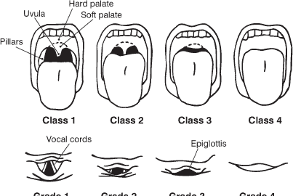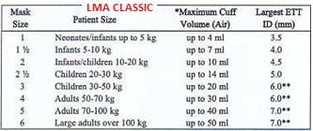LMA Fastrach: for tracheal intubation w/ETT; for difficult airway
One hand insertion, epiglottic elevating bar, 40x use
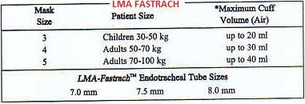
Cleaning detergent of choice is endozime

Mallampati scores
1: complete visualization of soft palate
2: complete visualization of uvula
3: visualization of only base of uvula
4: soft palate not visible at all

Laryngoscopy grades
I: most of glottis visible
II: only posterior extremity of glottis is visible
III: no glottis visible, but larynx can be located
IV: no glottis visible and larynx cannot be located
- Bispectral Index Monitoring (BIS): measures depth of anesthesia

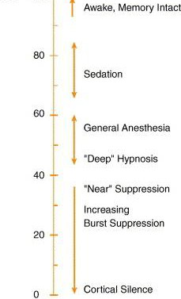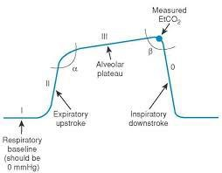 Sudden ↑ or higher than expected BIS: getting lighter, narcs needed, check vaporizer, check patency of IVs, check twitches, check mechanical devices w/high frequency in close range
Sudden ↓ or lower than expected BIS: ↓surgical stimulation, recent NMB, high level of IA,
hypothermia, ↓BP, BIS leads not properfly placed
- Pulse oximetry: based on Beer-Lambert Law; red light absorbed by deoxy-Hgb (660 nm) & infrared red light absorbed by oxy-Hgb (940 nm)
POX will detect early signs of hypoxia, may predict PaO2, accurately detects SaO2
Conditions affecting accuracy: anemia, blood dye (methylene blue, indigo carmine), hypothermia, hypotension, thick scars/nail polish/burns
- Capnography: assesses CO2; numbers are capnometry, wave form is capnography

Analyzing capnography wave forms
Look at y-axis first to determine the CO2 scale (normal or abnormal?)
Obstructive capnogram appears to have a crushed top corner (“shark fin”)
Wave form off x-axis (not touching bottom) = expiratory valve problem (or soda lime)
If wave form begins on x-axis, but then “takes off” = incompetent inspiratory valve
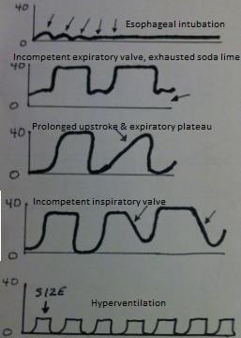
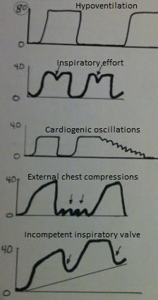
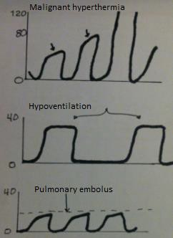
Always check the respiratory rate—this may help deduce the correct answer
- Central venous pressure (CVP): measures right heart filling pressure (fluid status)
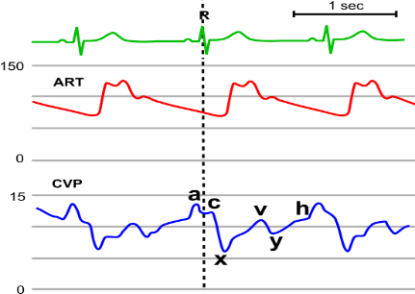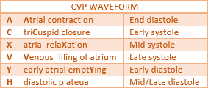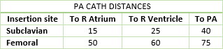 Contraindications: tumor in right atrium, anticoagulation, ipsilateral CEA
  - Pts on PEEP will read high (need to disconnect 10-15sec & reconnect)

Wave form abnormalities
  - Absent A wave = atrial fib
  - Large A wave = tricuspid/pulmonic stenosis, pulm HTN, ↓RV compliance
  - Large V wave = tricuspid regurg, pericarditis, tamponade, R ventricular papillary muscle ischemia
- Pulm Artery Cath (Swan Ganz): used to assess LV fxn
Length = 60 cm—child & 110 cm—adult (marks every 10 cm); size = 4.0-7.5 French

Pressure tracings
  - R atrium: 1-8 mmHg (RAP = CVP = RVEDP)
  - R ventricle: 15-25 / 1-8 mmHg
  - PA: 15-25 / 10-20 mmHg (RVS = PAS)
    - ↑pressure w/vol overload, LV failure, mitral stenosis, tamponade
    - ↓pressure w/hypovolemia
  - PCWP: 6-12 mmHg (max wedge time = 15 sec)
    - PCWP is never higher than PA diastolic pressure
PA complications: dysrhythmias, pneumo, air embolism, vessel damage, clotting, balloon rupture

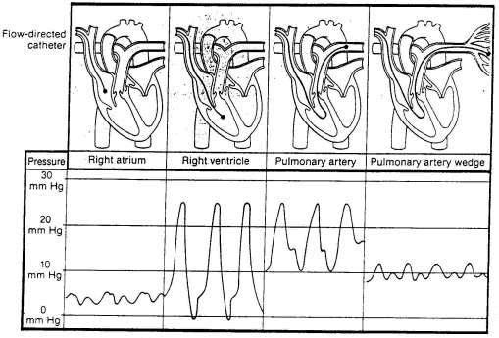
- 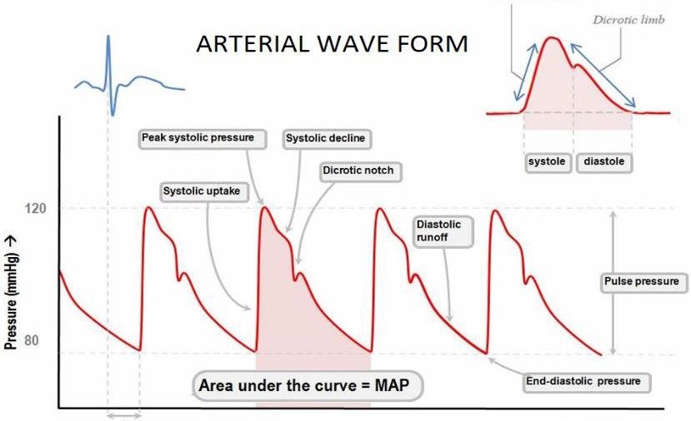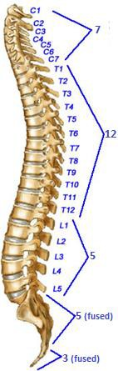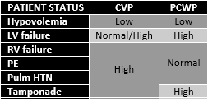Arterial monitoring: shows trends in vol status, contractility, SVR
Anacrotic limb (ORS complex): velocity of ejected blood
Dicrotic limb (T wave): ↓BP/flow to periphery
Dicrotic notch (end of T wave): closure of aortic valve
- Arterial cannulation: radial artery is most common; dorsalis pedis can also be used
Sites w/greater risk: femoral, brachial, ulnar, axillary
Invasive BP is usually 20 mmHg higher than noninvasive

Noninvasive BP monitoring
Cuff too large = lower BP; cuff too small = higher BP
Deflate BP cuff at rate of 2-3 mmHg per beat
Karotkoff sounds identify the onset of systole

MODULE 9
Regional (pg. 341-378)
- Spinal cord: extends from foramen magnum to L1 (adults; 42-45cm long)) or L3 (newborn—24mo to ↑to L1)
SC terminates at conus medularis and filum terminale extends down and anchors in lower sacral region
33 vertebrae (7C, 12T, 5L, 5S, 4C); 31 pairs of spinal nerves (8C, 12T, 5L, 5S, 1C); C1 = atlas, C2 = axis
High points = C3, L3; low points = T6, S2

Definitions
Cauda equina: nerve group in lower dural sac (L2-S3)
Supraspinous ligament: strong fibrous cord from sacrum to C7; thickest & broadest in lumbar region
Interspinous ligament: thin; runs full length of column
Ligamentum flavum: elastic (yellow) tissue b/w spinous processes (joins vertebral arches); strongest of posterior ligaments
Epidural space: surrounds spinal meninges from foramen magnum to sacral hiatus; widest at L2; narrowest at C5
Neuraxial anesthesia: spinal, epidural, or caudal block
- Layers: epidural space➔dura mater➔arachnoid mater➔subarachnoid space➔pia mater➔SC
CSF is contained b/w pia & subarachnoid layers; 100-150cc total volume, 25-35 cc in subarachnoid space

500cc produced daily in choroid plexus (3rd-4th ventricles); normal CSF pressure = 10-20 cmH2O
- Blood supply to SC is from a single anterior spinal artery & 2 posterior spinal arteries
- Spinal block summary: the principle site of action for neuraxial anesthesia is the nerve root
Vasocontrictors: prolong duration of block by ↓absorption
Factors w/proven effects on distribution: site of injection, anatomical shape (scoliosis, kyphosis), pt ht, angulation of needle, volume of CSF, characteristics of LA (density, specific gravity, baracity), dose, pt position
  - Hyperbaric = heavier SG, sinks; isobaric = same SG; hypobaric = lighter SG, rises; normal SG = 1.004-1.009 (think “007”)
  - Advantage of spinal over epidural is controlling the spread by controlling the SG of the solution
Uptake of LA is greatest where concentration of LA is greatest; uptake occurs by diffusion down a concentration gradient
Elimination: rate determines duration of block; occurs by vascular absorption via subarachnoid/epidural vessels
- CV effects of sympathetic blockade: predominant action is venodilation (75% of EBV on venous side)
If T1-T4 are blocked (cardioaccelerators), unopposed vagal stimulation will produce brady-c
  - High spinal = anything above T4; total spinal = all the way
Best means for treating hypo-t is physiologic, not pharmacologic; fluids first, then ephedrine/neo if normotensive
  - No glucose in fluids b/c glucose acts as a diuretic and worsens the situation
If C2-C3 are blocked, phrenic nerve paralysis occurs = loss of accessory muscles for ventilation = hypoxia

  - Otherwise, pulm alterations are usually of little clinical significance (unless pt is very young/old or chronically ill)
- Spinal needles: cutting needles have a “k” (Quinke, Pitkin); non-cutting are the rest (Greene, Whitacre, Sprotte)
Always keep bevel of cutting needles parallel to dural fibers (L or R when sitting)—worried about damaging dural layer
- Anticoagulants/Antiplatelet agents: NSAIDs, ASA may receive neuraxial anesthesia regardless of last dose
SubQ minidose heparin—neuraxial okay; IV heparin—NO neuraxial until normal PTT is documented
Warfarin—still controversial; check INR—neuraxial ok if <1.5 (and don’t remove epidural cath until <1.5)
Fibrinolytics/Thrombolytics: wait 10 days
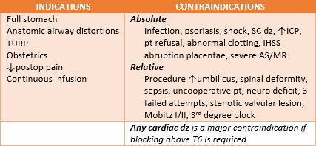
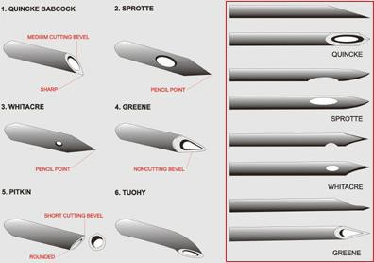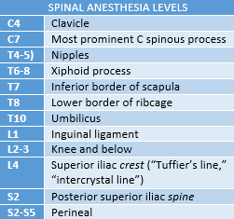 Ticlodipine, clopidogrel, abciximab, eptifibatide, tirofiban: evidence is lacking; usually wait 7-10 days
- Distribution of LA: spreads to nerves of cauda equina & laterally to nerve roots/rootlets; may also diffuse into SC
- Pathway of needle: skin➔subQ ➔supraspinous➔interspinous➔ligamentum flavum➔epidural space➔dura➔arachnoid
Lateral approach will NOT pass through supraspinous/interspinous

Complications
Infection: factors are advanced age, DM, alcoholism, CA, AIDS
  - S/S: high fever, nuchal rigidity, severe HA
  - Streptococci common in meningitis; staph aureus in epidural abscess
Respiratory: N/V are considered signs of hypoxia until proven otherwise
Backache: most common complication
HA: 2nd most common; 12-72 hrs after dural puncture; lasts ~10 days
  - Bifrontal & occipital; worse in upright position & w/coughing
  - S/S: nausea, diplopia, photophobia, tinnitus, loss of appetite
  - Caused by ↓CSF = medulla/brainstem drops into foramen magnum
  - Blood patch of 10-30cc to treat (90% effective); blood will put pressure on subarachnoid space, lifting brainstem
- Epidural: space extends from base of skull to sacrococcygeal membrane; not as voluminous as subarachnoid space;
In adults, 1-2cc of LA per segment to be blocked (to block T4 from L4-5, 12-24cc will be needed)
Two mechanisms of axn: directly acting on nerve roots/rootlets & diffusing through CSF into SC
4-6 cm to epidural space in average adult (obese up to 8 cm, thin person ~3 cm)
Alcohol swab to assess loss of temp sensation is the best indicator of onset of sensory block
Complications: penetration of blood vessel, epidural hematoma, dural puncture, back pain, air embolism, infection, hypo-t, resp depression, brady-c, total spinal, trigeminal nerve palsy, Horner’s syndrome (ptosis, miosis, ↓sweating, enophthalmos)
Test dose: 3cc 1.5% Lidocaine w/epi 1:200k; to detect both subarachnoid & intravascular injection
- Differential blockade: β-fibers➔C, Aδ➔Aγ, Aβ, Aα… this is b/c of anatomy, NOT sensitivity (B-fibers outermost in nerve)
Sensitivity (“LSU”): large myelinated, small myelinated, unmyelinated
- Caudal: most common regional in peds; considered epidural; needle insertion through sacrococcygeal membrane
CSF, air, blood should NOT be aspirated & there should be no local pain on injection
Volume of LA = 25-35 cc to get sensory at T10-T12
Compared to lumbar epidural, there are high plasma levels & longer distribution times w/caudal
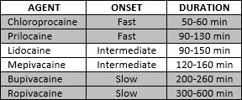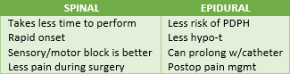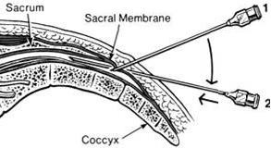 Complications: infection, urinary retention, injection site pain, ineffective block (most common)
Doses: adult = 15-25cc (S5-L2), 35cc (S5-T10); peds 0.5-1cc/kg 0.125-0.25% bupivacaine

- Ultrasound guided peripheral nerve blocks: advantage is ability to see tip of needle, anatomy, spread of LA, more precise
Ultrasound: high frequency sound waves through tissues (1-50MHz, well above human hearing of 15-20KHz)
  - Lower frequencies penetrate deeper; higher frequencies penetrate more shallow (good for <4cm under skin)
  - As sound moves it is absorbed, reflected, or allowed to pass through
    - Anechoic (echolucent): sound passes through; appears black on image (liquids)
    - Hyperechoic: sound reflected almost entirely; appears bright white on image (bone, fascia)
    - 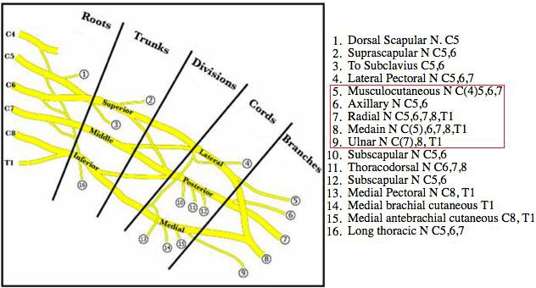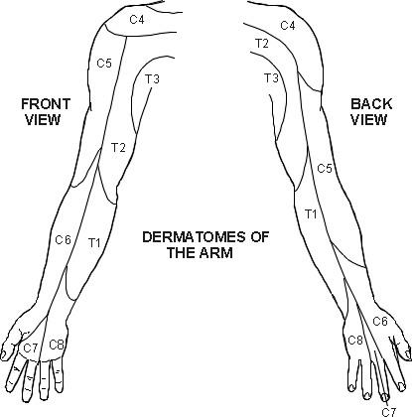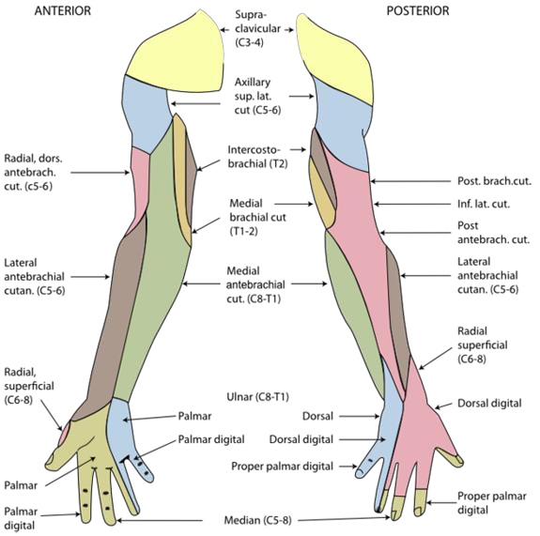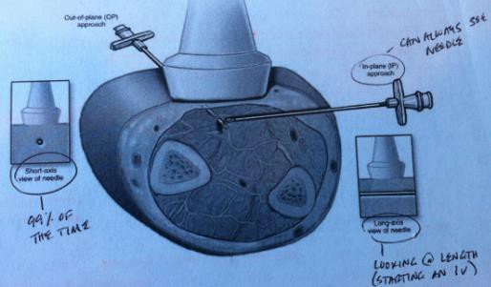Hypoechoic: sound is modestly reflected; appears gray on image
  - Arteries appear pulsatile & are NOT compressible; veins are compressible
Short-axis: cross sectional view of object; most common
Long-axis: longitudinal view; most helpful when following path of an object
In-plane approach: full visualization of needle tip
Out-of-plane approach: shows only tip of needle as it intersects ultrasound path
Common reason for poor visualization is insufficient gel at skin probe surface
- Cervical plexus: C1-C5; phrenic nerve C3-C5 (with C4 making up 70% of contribution)
- Brachial plexus: C5-T1

- Movements in response to stimulation
Radial nerve: extension of elbow/wrist/finger, supination of FA
Median nerve: pronation of FA, flexion of wrist, opposition of middle finger, forefinger, thumb & flexion of later 3 fingers
Ulnar nerve: flexion of wrist, adduction of fingers, felxion & opposition of medial 2 fingers toward thumb
Musculocutaneous nerve: flexion of elbow
- Cervical plexus block: for unilateral procedures (CEA); adjunct for interscalene
Pt’s head to opposite side, draw line from tip of mastoid process of temporal
bone to anterior tubercle of transverse process of C6—4cc at each level
Complications: phrenic block (hiccups), Horner’s, hoarseness

Interscalene block: for shoulder surgery
Pt’s head to opposite side, palpate sternocleidomastoid, roll fingers off posteriorly, intersection at C6 (cricoid cartilate)—40cc
Complications: unintentional spinal/epidural, puncture of vertebral artery (toxicity), phrenic nerve block
- Supraclavicular block: most homogeneous block of brachial plexus; arm can be in any position
Point of entry is above clavicle, 2cm medial from midpoint—40cc
Complications: pneumo (contraindicated w/severe resp dz)
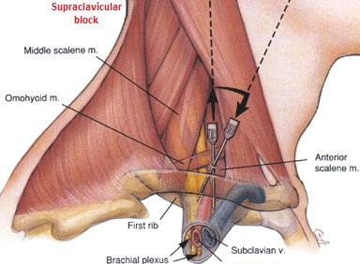
- Infraclavicular block: nerves frequently missed w/axillary are blocked
Point of entry is the same as SC but 2cm caudal to clavicle—40cc
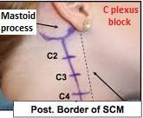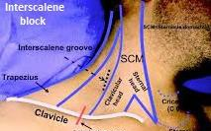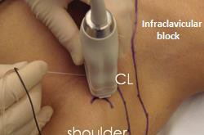 Complications: pneumo

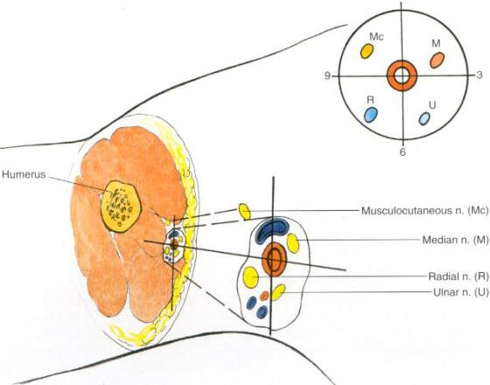
- Axillary block: most popular block for arm (FA, wrist) d/t minimal complications
Musculocutaneous outside bundle (requires separate block)
NOT for shoulder surgery
Pt’s head to opposite side, arm abducted (90° out & up), palpate brachial artery, follow pulse as far as possible toward axilla, inject b/f & after artery—40cc
Complications: intravascular injection, hematoma
- Ulnar block at elbow: flex elbow 90°, point of entry b/w medial condyle of humerus & olecranon process of ulna—4cc
Complication: intraneural injection (“arm is on fire”)
- Median & Radial blocks at elbow
Median: draw line from medial to lateral condyles of humerus on anterior surface, point of entry is medial to brachial artery—4cc
Radial: point of entry is groove b/w brachioradialis muscle & biceps brachii muscle—4cc
- Ulnar & Median blocks at wrist
Ulnar: point of entry is medial to flexor carpi tendon, just adjacent to ulnar artery—3cc

Median: point of entry is b/w long palmar muscle & radial flexor muscle—3cc
- Radial block at wrist: inject subQ ring of LA starting at radial flexor muscle & extending to dorsal surface of ulnar styloid—6cc
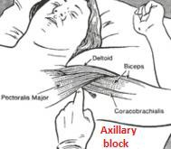
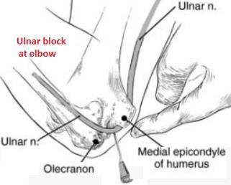
- 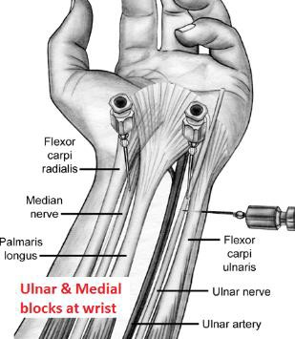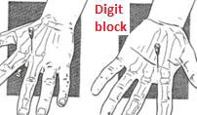Digit block: epi-containing solutions should NOT be used; inject up to 2cc on each side of digit; caution w/Raynaud’s
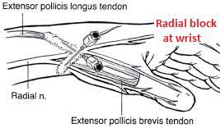
- Nerve avenues of leg: two major nerves are femoral & sciatic 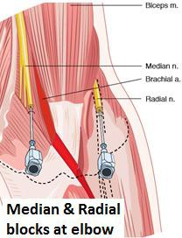
Femoral nerve continues as saphenous distal to knee
Sciatic bifurcates into common peroneal & tibial in proximity of knee
  - Common peroneal bifurcates into superficial peroneal & deep peroneal
  - Tibial gives rise to sural just about at the middle of the leg
- Femoral block (“3-in-1”): for anterior thigh, knee, & small part of medial foot
Point of entry is 1.5-2cm lateral to femoral pulse, 2cm inferior to a line b/w pubic symphysis &
anterior superior iliac spine (line is essentially the inguinal ligament)—30cc
Blocks femoral, obturator, & lateral femoral cutaneous; to get back side of knee, block sciatic also
- Sciatic block: nerve originates from lumbosacral trunk, composed of roots L4-5, S1-3
Sensory to post hip capsule, knee, & LE distal to knee (except anteromedial aspect—saphenous)
Motor to hamstrings & all LE muscles distal to knee
Identify inguinal ligament & divide into thirds, point of entry is at jxn of middle & medial third draw a perpendicular line that intersects greater tronchanter—20cc
- Ankle block: 5 nerves—posterior tibial, sural, saphenous, deep peroneal, superficial peroneal (most superficial start w/”S”)
Tibial: largest division of sciatic; from L4-S3; sensation to heel & medial sole of foot
Superficial peroneal: branch of common peroneal; sensation to dorsum of foot & adjacent sides of 1st-5th toes
Saphenous: largest branch of femoral; from L3-4; sensation to medial legs, ankle, & onto foot
Sural: branch of posterior tibial; sensation to posterior later aspect of lower calf & lateral side of foot & 5th toe
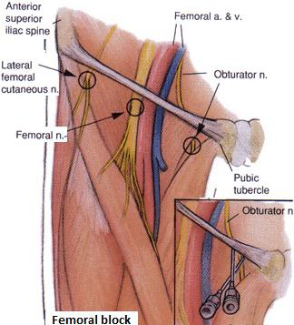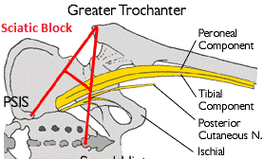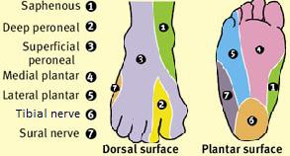 Deep Peroneal: runs in anterior compartment of leg as continuation of common peroneal; innervates toe extensors & sensation to medial half of dorsal foot, especially 1st-2nd digits
- Popliteal block: 7-10cm above posterior knee
- Intercostal block: primary rami T1-T11
Walk off each rib—2-5cc at 15-20°angle
Complications: pneumo, toxicity, nerve injruy, total spinal
- Ilioinguinal & Iliohypogastric blocks: inguinal hernia surgery
8-10cc; pt discomfort is most common complication

Retrobulbar block
Complications: retrobulbar injection, hemorrhage, intra- arterial injection (most common)
Watch for oculocardiac reflex (brady-c)
- Bier block: IV regional technique

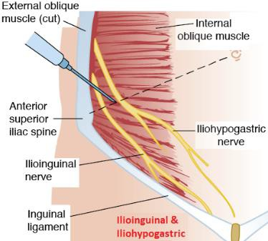
IV LA into vein distal to tourniquet (250-300 mmHg arm, 350-400 mmHg leg); 40-50cc—arm, 100cc—leg (0.25% lidocaine)
Tourniquet time should NOT exceed 2hrs; vasoconstrictor should NOT be used
Contraindications: infection, poor circulation, hx of seizure disorder, heart block

MODULE 10
Nerve Injuries; Positioning (pg. 380-387)
- Ulnar nerve: most common postop peripheral injury; stretched when pronating arm
Compression b/w medial epicondyle of humerus & sharp edge of table
Injury = inability to abduct or poose 5th finger; ↓sensation over medial 1½ fingers; claw hand
- Brachial plexus: 2nd most common; injured when neck is extended & head is turned away
Compression b/w clavicle & 1st rib w/improperly placed shoulder brace or sternal spreading

Radial nerve: results in wrist drop, inability to extend metacarpophalangeal joints, weakness in abduction of thumb
- Median nerve: may occur during IV start (unlikely w/positioning); results in inability to oppose 1st & 5th digits
- Musculocutaneous nerve: rarely injured; results in inability to flex arm, ↓sensation over ventral FA
- Axillary nerve: results in inability to abduct arm
- Sciatic nerve: compression as serve passes under piriformis muscle or by stretching (nerve fixed b/w sciatic notch & femur)
Most likely to occur in lithotomy position
IM injections should be in upper outer quadrant to avoid sciatic

Results in weakening of all muscles below knee, ↓sensation of lateral leg & almost all of the foot
- Common peroneal: most frequently damaged in LE; mostly from lithotomy

Results in foot drop, loss of dorsal extension of toes, inability to evert foot
- Anterior tibial: caused by plantar flexion of feet for extended periods; results in foot drop
- Femoral: mostly from lithotomy (compression at pelvic brim)

Results in ↓knee jerk, loss of hip flexion & extension of knee, ↓sensation over superior, medial, anteromedial leg
- Saphenous: mostly in lithotomy (compression against medial tibial condyle w/suspended foot)

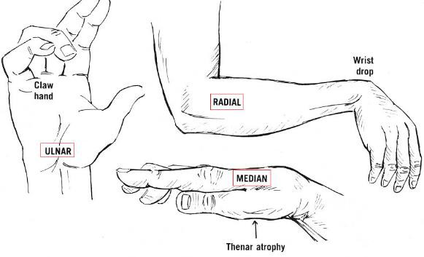
Results in parathesias along medial & anteromedial side of calf
- Obturator: from difficult forceps delivery or excession flexion of thigh to groin
Results in inability to adduct leg & ↓sensation over medial thight
- Buccal branch of facial nerve: results in paresis of orbicularis oris muscle
- Supraorbital nerve: results in ↓sensation over forhead & pain in the eye

MODULE 13

VALLEY SWEAT BOOK – CONDENSED NOTES
Part II

Renal; Electrolytes; Acid-Base; GI (pg. 224-262)
- Renal functions: kidneys have a major influence on BP; filters/excretes metabolic end-products to prevent accumulation

Maintains ECF composition
  - Regulates ionic composition: electrolyte balance (Na, K, Ca, Mg, Cl) & acid-base balance (H & HCO3)
  - Regulates osmolarity: sodium salts are 90% of total osmolality; normal osmolality = 300 mOsm/kg
  - Conserves non-ionic components of plasma: glucose, amino acids, proteins, vitamins, H2O
  - Excretes non-volatile end products: HPO4²⁻, urea, uric acid, SO4²⁻, creatinine, lactic acid
Maintains ECF volume: by controlling NaCl & H2O exretion
Endocrine functions (“RED”):
  - Renin-angio system: enzyme-hormone system that participates in BP regulation, K excretion, Na reabsorption
  - Erythropoeitin: renal hormone that acts on bone marrow to stimulate RBC production; deficient w/CRF (= anemia)
  - Vit D: converts Vit D (w/liver) to 1, 25 dihydroxycholecalciferol (active form); ↓Ca w/CRF (↓reabsorption w/↓Vit D)

Regulation of arterial BP
- Renal blood flow: 25% of CO (1.25L/min) passes through kidneys; ECF is “re-worked” every 2hrs (dialysis “re-works” every 8hrs)
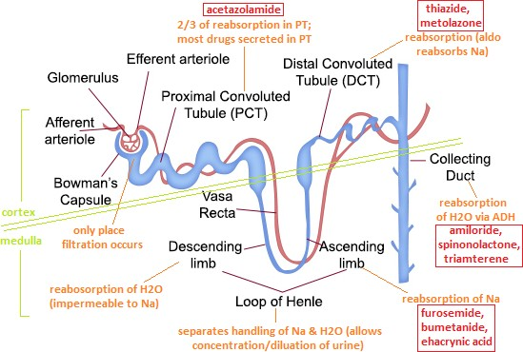 Efferent arteriole branches into peritubular capillaries, which engulf the tubule
Substances can be transported from capillary to
tuble (secretion) or vice versa (reabsorption)
- Nephron: functional unit of kidney

Two types
  - Cortical: short loops; glomeruli near surface
  - Juxtamedullary: long loops; glomeruli deep in cortex
Juxtaglomerular apparatus: BP control via renin; where DT overlaps AA
Glomeruli, PT, DT, are in cortex
  - L of H, CD are in medullar
Inner stripe of outer medulla: most vulernable to ischemia (secondary, for example, to HTN)
- Glomerular filtration: movement, under hydrostatic pressure, of plasma H2O & dissolved constituents from glomerulus to BC
- Proximal tubule: reabsorbs bulk of filtered fluid (67%); coarse control mechanisms for regulation of ECF volume/composition
- Loop of Henle: establishes/maintains osmotic gradient in medulla; fluid leaving loop is hypo-osmotic; countercurrent multiplier
TAL is impermeable to H2O & has high concentration of Na transporters (NKCC2) = Na reabsorbed, but H2O cannot follow
Vasa recta: peritubular capillaries of L of H; countercurrent exchanger which maintains osmotic gradient
Deposition of Na into medullary interstitium by TAL can ↑interstitial osmolality to 600 mOsm/kg; combined w/urea, that makes a total osmolality as high as 1200-1500 mOsm/kg (this gradient is required for making urine concentrated or dilute)
Urea: freely filtered & partially reabsorbed in PT; secreted into tubules in TAL; ↑urea concentration as fluid moves through
CD drives reabsorption into medullary interstitium (in other words, urea is recycled b/w tubules & medullary interstitium)
- Distal tubule & collecting duct: make final adjustments on urine pH, osmolality, ionic composition
Reabsorption of H2O occurs via ADH; reabsorption of Na & secretion of K via aldosterone
- Renal handling of glucose: PT has a max capacity for reabsorbing glucose (transport maximum, or Tm); normally all glucose
filtered is reabsorbed; in untreated DM, however, the amount of glucose filtered exceeds the Tm = “sweet urine”
DM: inadequate amounts of insulin are produced by the pancreas; ↑in plasma glucose concentration is a consequence
  - When glucose is excreted, it ↑urine flow (d/t an osmotic diuresis)
- Renal control of H2O excretion: ↓vascular volume = ↑ADH (AVP, arginine vasopressin) release = ↑reabsorption of H2O
Note: any stress (trauma, hypo-t, emotional) will lead to ↑ADH release

5 S’s of vasopressin (ADH)
  - Synthesized in paraventricular & supraoptic nuclei of hypothalamus
    - ↓ECF osmolality = these cells swell & APs are inhibited; ↑ECF osmolality = these cells shrink & APs fire
    - A 2% ↑in osmolality (from 300 to 306 mOsm) is sufficient to stimulate release of large quantity of ADH

Stored in posterior pituitary (neurohypophysis)
  - Secreted into blood
  - Stimulus for ADH release is ↑ECF Na concentration (↑osmolality)
  - Site of action is kidney—ADH puts H2O channels into CD = reabsorption
    - 67% of filtered H2O is reabsorbed from PT & 13% from descending L of H (TAL is impermeable to H2O)

Since NaCl is reabsorbed from TAL, urine is dilute (100 mOsm) when it reaches DT
ADH ↑permeability of DT & CD to H2O = ↑H2O reabsorption
Bottom line: ↑ADH = a little concentrated urine (0.5 mL/kg/hr); ↓ADH = a lot of dilute urine (2-25 mL/kg/hr)
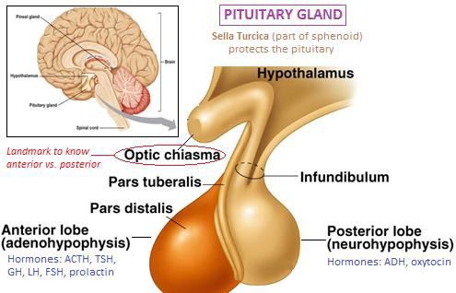
Diabetes Insipidus: failure of ADH synthesis or release
  - OR insensitivity of DT/CD to ADH (nephrogenic)
  - Results in lots of dilute urine
SIADH (Syndrome of Inappropriate ADH): inappropriate secretion of ADH; result of tumor, hypothyroidism, porphyria, small (Oat’s) cell carcinoma of lung
  - Results in ↑urine Na/osmolality w/hyponatremia &
↓plasma osmolality
- Na is major determinant in ECF volume
Aldosterone is the most important hormone for regulating ECF volume
Atrial natriuretic peptide (ANP) is released from right
atria & acts on kidney to ↑Na excretion
Na excretion ↑when GFR ↑ (and vice versa)
Mechanisms for ↑Na excretion: ↑GFR, ↓aldo, ↑ANP
Mechanisms for ↓Na excretion: ↓GFR, ↑aldo, ↓ANP
- Aldosterone is produced in zona glomerulosa of adrenal cortex & acts on late DT & CD
Aldo ↑rate of Na reabsorption in DT/CD (= ↓Na excretion)
Aldo ↑rate of K secretion into late DT/CD (= ↑K excretion)

Summary of body’s response to ↑ in body Na
When Na is high, ADH output ↑ to conserve existing H2O & thirst causes ingestion = normal osmolality & ↑volume
  - Major consequences of Na retention are ECF volume expansion & a tendency for arterial BP to ↑

Hypervolemia is corrected by ↑Na excretion via ↑GFR, ↓renin (= ↓aldo), ↑ANP release
    - Remember, ↓blood volume➔renin secretion➔angiotensinogen to ang I➔ACE converts ang I to ang II➔ang II stimulates release of aldo from ZG

Summary of body’s response to ↓ in body Na
When Na is low, ADH output ↓ & a lot of dilute urine is formed = normal osmolality & ↓volume
  - Major consequences of Na loss are hypovolemia & a tendency for arterial BP to ↓

Hypovolemia is corrected by ↓Na excretion via ↓GFR, ↑renin (=↑aldo), ↓ANP
- Renal control of K excretion: 67% of filtered K is reabsorbed in PT & 25% in TAL
In the presence of aldo, substantial quantities of K are secreted in DT (principle cells) & CD
  - Under normal conditions, circulating aldo is high with about 75% of excreted K derived from K secretion in DT/CD

Hyperkalemia = ↑aldo levels (and vice versa)
DT flow rate: K excretion is ↑ when flow through DT is ↑ (& vice versa); explains K loss w/most diuretics

HCO3 concentration: when HCO3 concentration in DT is ↑, K secretion rate is ↑ (& vice versa)
  - HCO3 is used in the treatment of hyperkalemia d/t this & its effect of alkalinizing blood (which pushes K into cells)

Diuretics
Loop diuretics (furosemide, bumetanide, ethacrynic acid, tosemide)
  - Na-K-2Cl symporter (protein channel) in TAL is responsible for establishing osmotic gradient in medulla
    - For each Na reabsorbed, (1) K & (2) Cl are reabsorbed

Loop diuretics bind to this symporter & inhibit reabsorption of these ions
B/C the osmotic gradient is diminished, the amount of H2O reabsorbed from CD is ↓ = ↑H2O excretion
Furosemide also causes release of PGs from kidney = venodilation (BP begins falling before UO↑)
  - SE: hypokalemia, hypovolemia, orthostatic hypo-t, reversible deafness (also N/V/diarrhea w/ethacrynic acid)
Thiazides (chlorothiazide, hydrochlorothiazide, chlorthalidone, metolazone): inhibit reabsorption of Na in early DT
  - SE: hypokalemia

K-sparing (spinonolactone, triamterene, amiloride)
  - Spironolactone competitively inhibits aldo = ↓Na reabsorption (&↓K excretion)
  - Triamterene, amiloride ↓Na reabsorption from late DT/CD
  - SE: hyperkalemia
Carbonic anhydrase inhibitors (acetazolamide): inhibition of carbonic anhydrase results in…
  - ↓HCO3 & Na reabsorption in PT = diuresis (also results in hyperchloremic metabolic acidosis)
  - ↓ rate of formation of aqueous humor = ↓IOP (one of its principle therapeutic actions)

Osmotic diuretics (mannitol): freely filtered into BC & remains trapped in renal tubule; this impermeable substance exerts an osmotic force & hinders the reabsorption of H2O
  - SE: hypokalemia (↑flow through tubule = ↑K excretion)
- Perioperative kidney injury: common complication; incidence of surgery-related ARF is 18-47%; 40-90% mortality
- Prerenal ARF: hypoperfusion resulting in deterioration of renal fxn & accumulation of nitrogenous waste (azotemia)
- 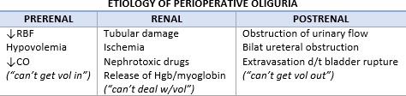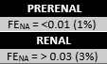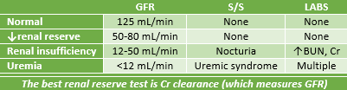Prerenal vs. renal failure: w/renal failure large amounts of Na are in urine (= ↑FENA, or fractional excretion of filtered sodium)
W/prerenal, filtered Na is reabsorbed b/c flow though the tubule is so slow = ↓Na in urine (=↓FENA)
FENA is 90% specific & sensitive (best test for distinguishing prerenal oliguria & acute tubular necrosis)

Chronic renal failure

Chronic anemia: Hgb of 5-8 g/dL caused by ↓erythropoetin production
  - Treat w/recombinant erythropoetin until Hct = 30-33% (SE = HTN)
Pruritis: often w/ESRD; erythropoietin administration ↓histamine concentration & may ↓pruritis
Coagulopathies: bleeding tendency despite normal PT, PTT, plt count (use bleeding time test instead)
  - Among recognized hemostatic abnormalities is release of defective vWF
  - Manifestations of uremic bleeding: GI tract (most common), epistaxis, hemorrhagic pericarditis, subdural hematoma
  - Treatment: dialysis, DDAVP or cryo, estrogen therapy, erythropoetin (shortens bleeding time)
Electrolyte disturbances: hyper-K, hypo-Ca, hyper-Mg, hyper-PO4
  - Hyper-K: most serious electrolyte abnormality; avoid elective surgery until K <5.5 mEq/L
    - ECG changes: peaked T waves, prolonged PRI, widened QRS, heart block, PVCs, v-fib
    - Avoid LR (contains 4 mEq/L K)
    - If surgery cannot be delayed, strategies may include…
IV Ca (protect the heart)
Hyperventilation (lowers K 0.5 mEq/L for every 10 mmHg PaCO2)
β-2 agonist, insulin (speed up Na-K-ATPase; give glucose w/insulin administration)

Loop diuretics, Kayexelate
Dialysis
  - Hypo-Ca: hyper-PO4 from ↓GFR leads to reciprocal ↓in plasma Ca; also ↓1, 25 dihydroxycholecalciferol results in
diminished interstitial absorption of Ca
    - Secondary hyperparathyroidism: hypo-Ca causes PTH release & Ca release from bones = vulnerable to fractures
  - Hyper-Mg: d/t mg retention; S/S—hypo-t, hypoventilation, coma
    - NDNMBs & Sux are potentiated by hyper-Mg
HTN: 80% of ESRD pts; risk factor for stroke, CHF, MI
Pericardial dz: pericardial effusion w/ or w/o tamponade; diagnosis w/cardiac ultrasonography
  - Treatment: hemodialysis or pericardiocentesis
Metabolic acidosis: d/t retention of acids
Nervous system abnormalities: encephalopathy (depression, sedation), seizures, neuropathies, ANS dysfxn
Infection: most serious problem facing renal pt (sepsis is the most common cause of death w/renal failure)
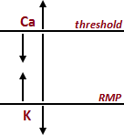
- Fluid & electrolyte disturbances—control of cell excitability by K & Ca
K effects excitability b/c it is the major determinant in resting membrane potential
  - RMP moves w/K
    - ↑K raises RMP (less negative), hypopolarizing the cell (more excitable)
    - ↓K lowers RMP (more negative), hyperpolarizing the cell (less excitable)
Ca effects excitability b/c it is a determinant of threshold potential
  - Threshold moves w/Ca
    - ↑Ca raises threshold (less negative), hyperpolarizing the cell (less excitable)
    - ↓Ca lowers threshold (more negative), hypopolarizing the cell (more excitable)
  - Two hormones control iCa: PTH, calcitonin (from thyroid, just “fine tuning”)
  - When parathyroid is removed, hypo-Ca develops & tetany can occur
  - Free iCa ↓w/alkalosis (iCa binds to more proteins, reducing free iCa = functional hypo-Ca)
    - Both H & Ca bind to plasma proteins, so there is more room for Ca to bind when H concentration ↓

Treating hyperkalemia
IV Ca: fastest (1-2min), but does not correct hyperkalemia

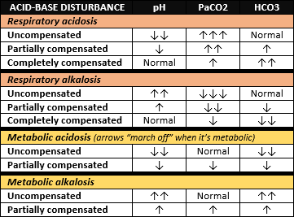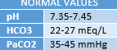 HCO3: 3-5min; H in plasma ↓ = H shifts out of cells to buffer alkalosis = K shifts into cells
Hyperventilate: 10-15min; same mechanism of action as HCO3
Insulin (w/glucose) & β2-agonist: 30 min; stimulates Na-K-ATPase pump, driving K into cells
Also, Kayexalate (hrs) & dialysis (hrs to days)
- Acid-base balance & disturbances—ABG interpretation
Determine alkalosis/acidosis from pH
Determine resp or metabolic from HCO3 & PaCO2
  - Resp if change in PaCO2 is compatible w/pH change
  - Met if change in HCO3 is compatible w/pH change
Determine if compensation has occurred from HCO3 & PaCO2

Role of kidneys in acid-base regulation
Na-H exchange is the fundamental event; specifically, Na-H exchange permits HCO3 to be reabsorbed & acids excreted
Bicarb reabsorption: 90% reabsorbed in PT (other 10% is reabsorbed later—HCO3 not typically excreted)
  - H is actively secreted into PT lumen in exchange for Na
  - Carbonic anhydrase catalyzes formation of CO2 & H2O
  - CO2 diffuses into tubular cell to resynthesize HCO3
  - HCO3 diffuses into peritubular capillaries from tubular cell; H is regenerated & available for use in another cycle
  - Elaborate mechanism is necessary b/c HCO3 slowly diffuses across luminal membrane (“ions don’t cross membranes”)
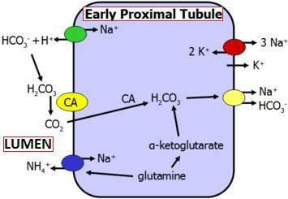
Excretion of H ions: titratable acids & ammonia (NH3) are acids excreted by kidney
  - NH3 enters tubular lumen & reacts w/H to form ammonium (NH4+), which very poorly penetrates membranes
    - Hence, NH4+ remains trapped & is excreted (diffusion trapping)
  - Ammonia production is stimulated by acidosis
- Anion gap: determined from measurements of plasma Na, Cl, & HCO3; normal = 10-12
AG = [Na+] – [Cl-] + [HCO3-]… therefore, [HCO3-] = [Na+] – [Cl-] AG
Unmeasured proteins include HPO4²⁻, SO4²⁻, etc.
  - Total concentration of unmeasured proteins = 12nM (normal AG)
When non-Cl ions are added, AG will ↑ b/c HCO3 that reacts w/H is replaced by unmeasured anion of the acid
  - When AG is 20-29 (elevated), 67% of the time metabolic acidosis is the diagnosis
When HCO3 is lost, Cl replaces the lost HCO3 so the AG does NOT ↓ (b/c of compensatory hyperchloremia)
- Pharmalogical control of gastric pH: normal is 1.6-2.2
H2-R antagonists (cimetidine, ranitidine, famotidine): inhibit hydrochloric acid production & raise gastric pH
  - Cimetidine inhibits CYP450 enzymes = prolongs axn of drugs metabolized by liver
  - Ranitidine does NOT traverse the BBB, so it causes less somnolence, lethargy, confusion, & seizures
Antacids: non-particulate antacids are preferred (particulate cause more problems if aspirated); SE = ↑gastric volume
- Pharmalogical control of gastric motility (metoclopramide): actions—↑LES tone, ↑gastric motility, ↓tone of pyloric sphincter,
relaxes duodenum
Incidence & severity of aspiration pneumonitis are reduced if: gastric pH is >2.5, gastric volume is <25mL (0.4mL/kg)

Antiemetics
Competitive dopamine antagonists (droperidol, prochloperazine, metoclopramide): AVOID w/Parkinson’s
Antimuscarinics: atropine
Selective serotonin-3 receptor (5HT3-R) antagonists (ondansetron): works by blocking both central & peripheral 5HT3-R
  - Most common SE is HA

MODULE 14
Pharmacokinetics; pKa; Locals (pg. 263-287)
- Clearance (Cl): theoretical volume of plasma that is completely cleared of a drug in a given period of time
- Elimination half-time (T1/2β): time it takes for plasma concentration of a drug to fall by ½
- Elimination half-life: time it takes for total amount of drug in the body to ↓by ½
- Volume of distribution: theoretical volume necessary to account for total amount of drug in the body if it were present throughout the body in the same concentration as the plasma
Calculated (cannot be measured) by dividing amount of drug injected by plasma concentration (Vd = Q/Cpt=0)
  - Plasma concentration (Cpt=0) in this calculation is what it would be IF drug distributed instantaneously upon injection

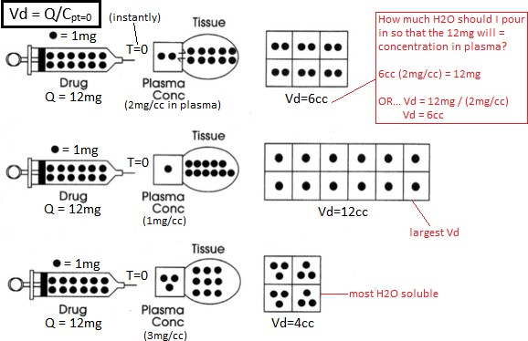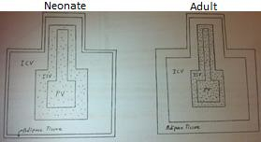 Drugs w/small Vd: muscle relaxants
Drugs w/large Vd: induction agents

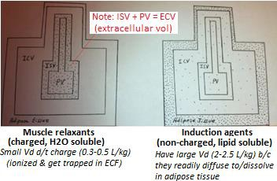
Body compartments

- Comparison of neonate & adult
Neonates/Infants have more H2O/kg (up to twice as much) = >Vd
  - Neonates need more Sux d/t this larger volume & immature neuromuscular jxn
  - Neonates need same NDNMBs b/c, while the volume is larger (requiring more), the neuromuscular jxn is immature (requiring less)
- Zero order kinetics: constant amount of drug is eliminated per unit time
Drugs w/zero order at therapeutic levels: alcohol, phenytoin, ASA
Zero order kinetics occurs when plasma concentration of any drug exceeds capacity of metabolizing enzymes
- First order kinetics: most drugs eliminated this way; constant fraction is eliminated per unit time
These behave as though they distribute into either one compartment or two compartments
Unless told otherwise, assume every drug follows the two compartment model
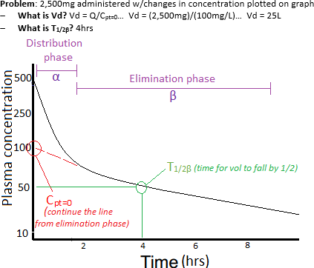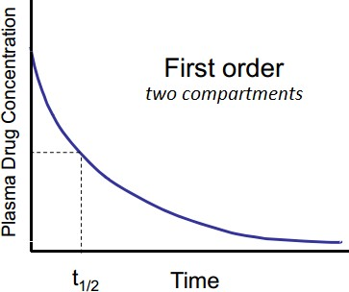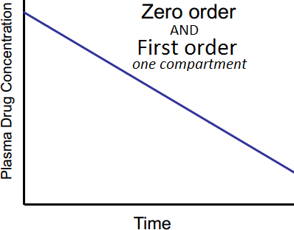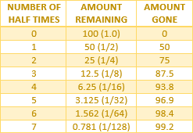 Elimination occurs from the central compartment (liver, kidneys, heart, brain, lungs)

Hepatic metabolism
Phase I reactions: involving chemical biotransformation of a molecule, usually to more H2O soluble & inactive metabolites
  - Types: oxidation, reduction, methylation, hydrolysis
  - Cytochrome P-450: responsible for many of these reactions; found on membranes of hepatic microsomes
Phase II reactions: involve conjugation of drug or its metabolite w/endogenous molecules; makes drugs more H2O sol for excretion by kidneys or biliary system
  - Types: glucuronidation, glutathione conjugation, sulfation, acetylation
    - Acetylation: important for agents such as procainamide, hydralazine, isoniazid (TB drug)
50% of Caucasians are fast acetylators & 50% are slow; 20% of Chinese & 8% of Japanese are fast acetylators

Slow acetylators are more vulnerable to toxicity during amide therapy
Phase III: elimination reactions that involve ATP-binding cassette (ABC) transport proteins
  - Dysfunction of ABC transport proteins hinders bile flow = drug may accumulate in the body

- Protein binding: most drugs bind to plasma proteins; albumin is most abundant
Protein bound drugs do not leave circulation; only free (unbound) drugs diffuse across capillary walls to target cells

Only free (unbound) and non-ionized drugs cross placenta and BBB
Pts w/hypoproteinemia (hypoalbuminemia) are more sensitive to drugs b/c protein binding is ↓ (which = ↑free drug)
  - When protein binding ↓ (w/hypoproteinemia), Vd of a drug will ↑
- Strategy for acid-base problems: to determine whether a drug is mostly ionized or non-ionized, you must know three things…
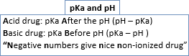
Whether the drug is a weak acid or weak base
The pKa of the drug (pKa is pH at which 50% is ionized & 50% is non-ionized)
The pH of the target solution
- Weak acids (barbiturates, propofol): give up H ions, but not completely

Weak acids unite w/(+) charged ions such as Na⁺, Mg⁺⁺, Ca⁺⁺
  - If you see Na[drug] or calcium[drug] (such as sodium thiopental), you know it is the salt form of a weak acid
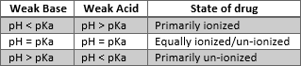
Become more non-ionized as pH ↑ (acid + acid = non-ionized)
Non-ionized crosses BBB & placenta (the more non-ionized, the greater the transfer across these membranes)
The non-ionized form of a weak acid is the acid, & the ionized form is the conjugate base
If you mix a weak acid with a low pH solution, it will become mostly non-ionized & form a precipitate
  - Weak acids are stored in alkaline pHs so that the drug will be highly H2O soluble (ionized) & won’t form a precipitate
- Weak bases (ketamine, opioids, benzodiazepines, LAs): accept H ions, but not completely

Weak bases unite w/(-) charged ions such as Cl⁻, SO42-
  - If you see [drug]chloride or [drug]sulfate (such as morphine sulfate), you know it is the salt form of a weak base
Become more non-ionized as pH ↑ (base + base = non-ionized)
Another way to say a substance has accepted an H ion is that is has become protonated
- Fetal trapping: fetal pH is lower than maternal pH; non-ionized form of a drug crosses the placental barrier
Once in fetus, equilibrium b/w ionized & non-ionized drug is re-established
B/C the pH is lower, a greater amount of drug is ionized, which cannot cross back through the placenta
- Local anesthetics: in general, the lower the pKa of the LA, the greater the proportion of LA in non-ionized form at physiologic pH & the faster the onset of the conduction block
Chloroprocaine is the exception—it has a higher pKa than Lidocaine, but onset is faster d/t large concentration injected
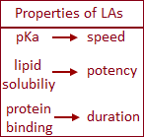
- Determination of LA potency: lipid solubility, measured by the oil:water partition coefficient
The greater the oil:water partition coefficient, the greater the lipid solubility of the agent

Determinants of blood concentration of LAs
Presence of a vasoconstrictor (epi) ↓rate of absorption from injection site = ↑duration (by 75-100%)
Greater tissue blood flow = the faster the agent is absorbed = ↓duration
  - Likelihood of toxicity is ↑when LAs are injected into sites with higher blood flows
    - (fastest to slowest) IV➔tracheal➔intercostal➔caudal➔paracervical➔epidural➔brachial plexus➔subarachnoid/sciatic/femoral➔subQ
Greater concentration injected = ↑duration (also, the number & frequency of injections impact duration)
- 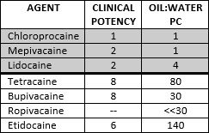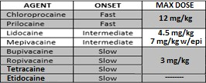Mechanism of action of LAs: block Na channels; non-ionized form diffuses into nerve axon & there the ionized form binds to receptors on the Na channel, locking it in the inactivated state
For myelinated, 2-3 Nodes of Ranvier must be blocked to stop conduction
Conduction block is frequency-dependent: ↑nerve firing = ↑opportunities
for the LA to catch it in the inactivated state
VG-Na channels are found only in the nerve’s axon

Metabolism of LAs
Ester locals are metabolized by plasma pseudocholinesterase
Amides are metabolized by the liver
  - Amides have an “i” before “caine” & are metabolized by liver

- Toxicity of LAs: determined by concentration of LA achieved in the blood
Treatment: airway, breathing, circulation
  - Lipid emulsion (20% Intralipid)
    - 1.5mL/kg bolus, 0.25mL/kg/min infusion
  - Benzos to treat seizures (or propofol, but only if NO CV instability)
  - Avoid vasopressin, CC-blockers, β-blockers, LAs
  - Muscle relaxant to secure airway

CV resuscitation/support

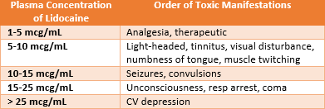
- Random facts
Chronic therapy w/acetylcholinesterase inhibitors (edrophonium, physostigmine, echothiophate) prolongs ester locals
Para-aminobenzoic acid (PABA) is a metabolic end-product of ester metabolism; may mediate hypersensitivity reactions
Cocaine is unique: it’s a vasoconstrictor & naturally occurring
Chloroprocaine is suitable for OB pt b/c it is metabolized rapidly by plasma cholinesterase (less risk to fetus)
Tetracaine is hydrolyzed by plasma cholinesterase much more slowly than procaine/chloroprocaine = ↑risk of toxicity
Dibucaine is a very potent & highly toxic LA (15x as toxic as procaine); not used clinically, but used to test plasma cholinesterase activity (Dibucaine depresses axn of plasma cholinesterase by 70-85%; normal # is 80%)
  - If Dibucaine # is 20, pt is homozygote for atypical pseudocholinesterase (don’t give Sux or ester LA)
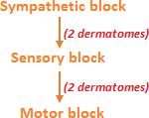
  - If Dibucaine # is 30-70, pt is heterozygote for atypical pseudocholinesterase
Prilocaine & benzocaine may induce the development of methemoglobinemia
  - Methemoglobin has iron in ferric state (Fe⁺⁺⁺) instead of the ferrous state (FE⁺⁺) of normal Hgb
  - O2 carrying capacity of methemoglobin is very poor; treat w/methylene blue, 1-2mg/kg
Ester LAs are derivates of benzoic acid

MODULE 15
Volatile Agents; IV Anesthesia (pg. 288-301)
- Potency: directly r/t lipid solubility (measured by oil:gas partition coefficient)
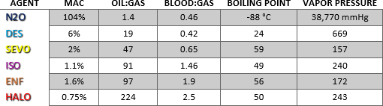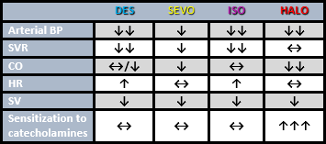 MAC: alveolar concentration at which 50% of pts do not move in response to skin incision (inversely r/t potency)

- Temp & solubility: solubility ↓ as temp ↑
More IA will dissolve in a hypothermic pt, less w/hyperthermic
- Uptake & elimination: brain solubility determines speed at which partial pressure of IAs build up in blood & brain
Blood:gas partition coefficient measures blood solubility
Agents w/high blood solubility diffuse quickly; agents w/low blood solubility prefer to stay in gas space

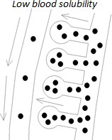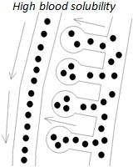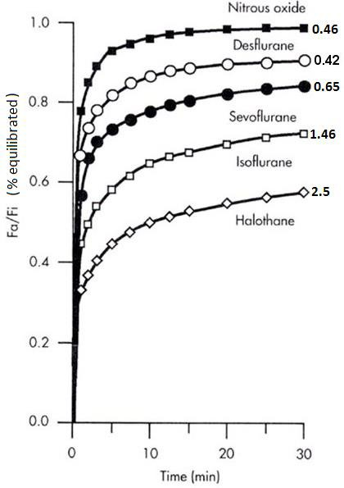Determinants of brain uptake & induction speed
Blood solubility: ↓solubility = faster induction
  - Note: N2O has a faster induction than Des b/c we turn it on at 70% (vs. 6%)
Alveolar ventilation: ↑ventilation = faster induction
CO: ↓CO = faster induction
- Equilibration: estimated by calculating a time constant; 3 time constants = 95% equilibration
Takes IA longer to equilibrate w/fat than any other tissue
N2O equilibrates w/all tissue in about 2.5hrs
- N2O & N2: blood:gas of N2 = 0.014 while N2O = 0.46 (N2 never wants to be in blood)
According to Fick’s law of diffusion, the rate of diffusion of a gas in or out of blood is proportional to its solubility; hence, N2O diffuses 34x faster than N2
When N2O is turned on, distensible gas spaces expand & non-distensible gas spaces ↑in
pressure (middle ear)
When N2O is turned off, distensible gas spaces shrink & non-distensible gas spaces develop subatmospheric (negative) pressure
- Second gas effect: on RA, atmospheric N2 is equilibrated w/body N2
W/N2O admin, N2O diffuses into blood in much greater quantities than N2 leaves blood
Because more N2O leaves alveoli, they shrink in size so N2O concentration remains high
If a second gas is turned on w/N2O, the concentration in the alveoli will be artificially high d/t the shrinking effect of N2O; consequently, the uptake of the second gas will be faster
- Diffusional hypoxia: when N2O is turned off, the quantity of N2O diffusing from blood to alveoli is much greater than the amount of N2 diffusing from alveoli to blood
Consequently, alveoli expand & O2 is diluted

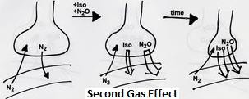
- Barbiturates: thiopental, methohexital, thiamylal (these are short-acting)
Weak acids w/many CNS actions; their depression of RAS = sedation, hypnotic effects
Thiopental: sulfur-containing (thiobarbiturate); anticonvulsant & amnestic
  - Poor analgesia (may ↑reaction to pain in small doses)
  - Resp & myocardial depression
  - ↑cerebral vascular resistance (= ↓CBF & ICP)

Contraindicated w/porphyria
  - Releases histamine
  - Hypoproteinemia intensifies response to thioptental
  - Drugs dissolved in low pH should NOT be mixed w/thiopental b/c precipitate will form
  - Thiopental is lipid soluble & 60% non-ionized at physiologic pH
Methohexital has prominent excitatory effects (hiccups, myoclonus)
- 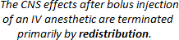Propofol: weak acid; half-time = 0.5-1.5hrs (compared w/11.6hrs for thiopental)
Produces greater ↓in BP than thiopental
More profound resp depression than thiopental
Antiemetic (d/t actions on chemoreceptor trigger zone & vomiting center)
Antipruritic, anticonvulsant
No analgesia
↓CBF & CMRO2
- Benzodiazepines: enhance action of GABA (brain’s inhibitory NT); diazepam, lorazepam, midazolam (these are short-acting)
CNS actions: anxiolytic, amnestic, sedative, hypnotic, anticonvulsant (& some muscle relaxation)

Poor analgesia
Little effect on CV system
Cerebral vasoconstriction (= ↓CBF & ICP)
Because diazepam is poorly H2O soluble, it is dissolved in organic solvent = pain on injection

Diazepam is 98-99% protein bound
Ketamine: weak base w/amnesia + profound analgesia by interacting w/NMDA-R (glutamate-R); can be given IV or IM
  - Cerebral vasodilation (= ↑CBF & ICP); ↑CMRO2

Hypertonus, nystagmus
  - Stimulates SNS (promotes ↑HR, CO, BP)
  - AVOID in cardiac pts, glaucoma pts, & pts w/↑ICP
  - Emergence from ketamine can be terrible (dreams, hallucinations, N/V)

Synthetic opioids: fentanyl, sufentanil, alfentanil, remifentanil, morphine
Profound resp depression, excellent analgesia, CV stability
Cerebral vasoconstriction (= ↓CBF & ICP); w/resp depression, however, CO2 ↑ = dilates cerebral vasculature
Stimulate vagal nerve = brady-c
Produce truncal rigidity
Stimulate CRTZ = N/V
Cause sphincter of Oddi spasm, which ↑pressure in biliary tract (treat w/glucagon 1-2 mg IM)
Morphine is less frequently used d/t histamine release = ↓SVR & BP & may be problematic in asthmatics
- Etomidate: min effects on CV system; causes pain on injection

Poor analgesia
Cerebral vasoconstriction (= ↓CBF & ICP)
Causes myoclonic movements
Adverse effects: depresses immune system, directly depresses cortisol output from adrenal cortex

MODULE 17
Physics, Chemistry, & Math (pg. 302-323)
- Vapor pressure: a function of temp; see chart in last section for specific vapor pressures
Saturated vapor pressure: pressure at which gaseous state is in equilibrium w/liquid or solid state
Boiling point: temp at which saturated vapor pressure is equal to atmospheric pressure

Volatile agent in a flask—Dalton’s Law (PT = P1 + P2 + P3)
When Iso added to an empty flask, the partial pressure of O2 becomes 520 mmHg (760 mmHg—240 mmHg)

Adding volatile agent to wrong vaporizer
If halothane is added to enflurane or Sevo vaporizer, delivered concentration will be higher (d/t halothane’s higher VP)
  - If halothane is added to Iso, delivered concentration will be about the same
“H L H”: if a higher VP agent is placed in a vaporizer for a lower VP agent, the concentration delivered will be higher

“L H L”: if a lower VP agent is placed in a vaporizer for a higher VP agent, the concentration delivered will be lower

- Des vaporizer: heated to 39°C, which ↑VP to 1500 mmHg; this high pressure drives Des to gas outlet where it is diluted
- Bourdon gauges: measure high pressures (cylinders) relative to atmospheric pressure
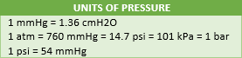
When the gauge = 0, the pressure in the cylinder = atmospheric pressure
- Law of LaPlace: for cylindrical structures, Tension = pressure * radius (T = P * r)
Tension: internal force generated by a structure
As structure expands (↑radius), tension in the wall ↑

Applications
  - For a blood vessel, tension is proportional to radius (larger radius = higher tension = more likely to rupture)
    - Aortic aneurysm is much more likely to rupture than normal aorta d/t larger radius
    - A capillary will withstand a pressure of 100 mmHg far better than a vein b/c it has such a smaller diameter
  - The greater the filling of the left ventricle, the greater the tension in the ventricular wall
    - Since LV has substantial thickness, the formula is modified—T = (P * r )/ h… where h = wall thickness
    - Frank Starling Law states that the greater the tension in the ventricular wall at end diastole, the greater the SV
For spheres, the formula is modified—T = (P * r) / 2 (remember, “TP for the rectum b/w 2 butt cheeks”)

  - Tension-pressure relationship for soap bubbles: the smaller the radius, the greater the pressure inside the bubble
    - If two soap bubbles were connected w/a straw, the smaller would collapse & empty into the larger (b/c the smaller bubble has greater pressure)
  - T-P relationship for normal alveoli: d/t surfactant, tension ↑as radius ↑, so the pressure does NOT change
    - This explains why small alveoli do not collapse & empty into larger alveoli
  - T-P relationship for ARDS: d/t lack of normal surfactant, alveoli w/smaller radii have ↑pressure; this ultimately causes small alveoli to collapse & empty into larger alveoli (where there is less pressure) = atelectasis w/ARDS
- Laminar (“streamlined”) flow: described mathematically by Hagen-Poiseuille’s Law… Q = (πr⁴∆P) / (8ηL)
Q (flow) is directly proportional to r (radius); doubling the radius ↑flow 16x (r is to 4th power)
  - Changing radius most greatly impacts flow
Q is directly proportional to ∆P (hydrostatic pressure gradient, or inflow – outflow)
Q is inversely proportional to η (viscosity); the property that determines flow when the flow is laminar is viscosity
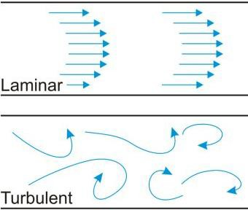
Q is inversely proportional to L (length of tube)
Resistance (R) to flow is defined as: R = ∆P / F… where “F” is flow
  - For laminar flow, R = (8ηL) / (πr⁴)… this implies ↑r = ↓R, ↑η = ↑R, ↑L = ↑R
Poiseuille’s Law explains why…
  - ↓needle gauge on an IV line ↑flow
  - shorter needle = ↑flow
  - ↑height of IV bag on pole = ↑flow
  - Polycythemic pts (high blood viscosity) have reduced flow through vessels
- Turbulent flow: when velocity is high, tube wall is rough, there are kinks/bends/narrowing in tube, fluid flows through an orifice
Laminar flow does not become turbulent when fluid is flowing through an angled tube if the angle is <25°
Resistance to flow ↑ when flow becomes turbulent (ventilating pts is more difficult when flow is turbulent)
Reynolds number (Re) predicts when flow through a cylindrical tube changes from laminar to turbulent… Re = vdρ / η
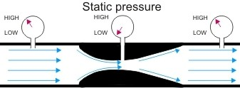
  - Reynolds number is directly proportional to v (velocity), d (diameter), & ρ (density)
  - Reynolds number is inversely proportional to η (viscosity)

When Reynolds number exceeds 1,500-2,000, flow changes from laminar to turbulent
    - The main point is that density (NOT viscosity) determines flow
He has low density (He/O2 mixtures are used for upper airway obstruction)
- Venturi’s effect / Bernoulli’s Principle: as flows through constricted region of a tube (Venturi tube), velocity↑ & lateral pressure↓
Venturi O2 mask, nebulizers, jet ventilators, & injectors are all applications of these principles
- Henry’s Law: amount of gas that dissolves in a liquid is proportional to the partial pressure of the gas in the gas phase
Main application is calculating how much O2 &/or CO2 dissolves in blood

Dissolved O2 = 0.003 * PaO2
    - If only the inspired O2 is given, estimate PaO2 by multiplying FiO2 by 5 (40% FiO2 = PaO2 of 200 mmHg)

Dissolved CO2 = 0.067 * PaCO2
- Gas Laws
Boyle’s Law: P (pressure) is inversely proportional to V (volume) at constant temp (P ∝ 1/V; P1V1 = P2V2)
  - Squeezing the Ambu bag ↑pressure, which ↓volume
Charles’ Law: volume is directly proportional to absolute temp (K) at constant pressure (V ∝ T; V1/T1 = V2/T2)
  - Inflatable cuff of LMA expands when heated (placed in autoclave)
Gay-Lussac’s Law: pressure is directly proportional to absolute temp (K) at constant volume (P ∝ P/T; P1/T1 = P2/T2)

  - When a full cylinder of gas is stored at 0°, then brought into OR where it is 20°, the pressure ↑
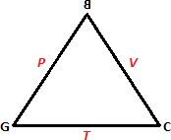
Summary (triangle): “Can These Guys Possibly Be Violinists?”
  - Each law relates the adjacent sides at the constant located on the opposite side
    - Example: Charles law = T & V are directly proportional at a contant P
    - The backwards “B” is a reminder that Boyle’s law states indirect proportionality

Generalized Ideal (Universal) Gas Law: PV = nRT
  - P = pressure, V = volume, n = moles of gas, R = universal gas constant, T = temp
    - One mole is the molecular weight of a substance in grams
  - As gas is released from a cylinder of compressed gas, pressure inside the cylinder ↓ (as “n” ↓, “P” ↓)
van der Waal’s Relationship: deviation from the ideal state; real gases have a finite volume & attract/repel each other (van
der Waal’s accounts for this)… [P + (a/V²) * (V – b) = nRT
Dalton’s Law: the total pressure of a gas mixture is the sum of the pressures of individual gases (PT = P1 + P2 + P3)
  - Dalton’s Law permits the calculation of partial pressures when the % of the gases are known
  - In the atmosphere, total pressure = 760 mmHg; O2 = 160 mmHg (21%) & N2 = 600 mmHg (79%)
  - If O2 was delivered at 30% & N2O at 70%, the partial pressures would be…
    - N2O = 760 mmHg * 0.7 = 532 mmHg
    - O2 = 760 * 0.3 = 228 mmHg
- Avagadro’s Number & Hypothesis: describes the relationship b/w amount of gas & volume of gas
Avagadro’s #: the number of molecules in one mole of a substance is 6.022 * 10²³
Avagadro’s hypothesis: one mole of a gas at standard temp (O°C) & standard pressure (1atm) occupies 22.4 L
  - Two moles of N2O under standard conditions occupy… 22.4 * 2 = 44.8 L
- Critical temp: gases liquefy if sufficient pressure is applied & temp is below critical temp (cannot be liquefied if >critical temp)
The critical temp of N2O is 36.5°C; thus, N2O can be stored as a liquid at room temp
The critical temp of O2 is -119°C; thus, O2 cannot be stored as a liquid at room temp
- Adiabatic (constant heat) process: if a cylinder of compressed gas is opened in a closed space, the pressure will rise rapidly & the temp will also rise rapidly (adiabatic explosion may occur)
- Joule-Thompson effect: when a compressed gas is allowed to escape freely into space, cooling occurs
This explains why the temp of a cylinder of compressed gas (N2O) ↓ as gas is released
- N2O cylinders (1,590 L, 745 psi): as gas escapes, the liquid in the cylinder vaporizes; heat is lost & the temp in the cylinder falls
As the cylinder temp falls, the pressure of the gas ↓modestly
If the cylinder is turned off, the pressure will be restored as the cylinder regains heat from the atmosphere
If the liquid runs out, the pressure in the cylinder will fall rapidly (reads full until it is almost completely empty)
- O2 cylinders (660 L, 2000 psi): at 5L/min, it would take 132 min for the tank to empty (660 / 5 = 132)
- Fick’s Law of Diffusion: diffusion rate (J) = [(P1 – P2) * (area) * (solubility)] / [(membrane thickness) * (√MW)]
This means diffusion rate is directly proportional to partial pressure gradient, membrane area, solubility of gas
  - Diffusion rate is inversely proportional to membrane thickness & the square root of the molecular weight
    - Graham’s Law states the rate of diffusion is inversely proportional to the square root of its molecular weight
Fick’s Law explains concentration effect, 2nd gas effect, diffusion hypoxia, why N2O leads to ↑volume in gas-filled spaces
Graham’s Law explains why smaller substances diffuse in greater quantities (as does Fick’s Law)

Facts to know r/t diffusion
Even though CO2 is larger than O2, CO2 diffuses 20x faster b/c it is much more soluble (20x or more)
Equilibrium of an IA occurs in the body when the partial pressure of the gas is the same everywhere
The process by which the fetus receives O2 & drugs is simple diffusion (across the placental barrier)
Diffusion of a gas from alveoli to the blood (or blood to alveoli) requires a difference in partial pressure (∆P)
- Non-gases: main factors r/t diffusion rate are concentration gradient or electrochemical gradient, lipid solubility, & size
Agents that poorly penetrate BBB or placenta are: lipid insoluble (ionized) &/or large
- Osmosis: requires membrane impermeable to one or more solutes (semi-permeable) & a difference in concentration of solutes
Across capillary walls: most capillaries are permeable to small solutes, so they do not exert an osmotic effect
  - Albumin is a substance in blood that does NOT permeate the capillary wall, which provides osmotic pressure in blood
    - Hypoalbuminemia (as w/liver dz) is the cause of ascites
- Beer-Lambert’s Law: intensity of light is altered (↓dramatically) as it is transmitted through a liquid; basis for POX
- Heat loss: core temp refers to intrathoracic & intracranial contents (where vital organs live); measured in lower esophagus/ear
Routes of heat loss: radiation (60%), convection (15-30%), evaporation (20%), conduction (<5%)

Humidification
Absolute humidity: the mass of water vapor in a given volume of air
Relative humidity: ratio of actual water vapor in air at a given temp to the max amount of water vapor the air can hold
  - Relative humidity (%) = (actual vapor pressure / saturated vapor pressure) * 100

  - Relative humidity ↑ as temp ↓ b/c saturated vapor pressure falls
  - Inspired gas is quickly humidified to 100% (relative humidity) when breathing through the nose
    - The partial pressure of water vapor at 37°C is 47 mmHg

CO2 absorber
Soda lime: 94% Ca(OH)2, 5% NaOH, 1% KOH
  - Small amounts of silica ↑hardness & reduce dust
  - Uses 4-8 mesh size granules—ideal b/c surface area is adequate but resistance to flow is not too high
  - Chemical reactions… CO2 + H2O ➔ H2CO3
    - H2CO3 + 2NaOH (2KOH) ➔ Na2CO3 (K2CO3) + 2H2O + heat
    - Na2CO3 (K2CO3) + Ca(OH)2 ➔ CaCO3 + NaOH (2KOH)
Baralyme: 80% Ca(OH)2, 20% Ba(OH)2; NO silica

Other laws
Ohm’s Law: basis for SVR calculation… SVR = [(MAP – CVP) / CO] * 80
LaChatelier’s Principle: a change in any factors determining equilibrium causes system to adjust (to counter the change)
  - Solubility of a salt in H2O ↑the temp; solubility of gas ↑ w/↓temp
Inverse Square Law: explains that the distance from source determines the amount of exposure to X-rays
Law of mass action: when the concentration of a reaction is ↑, reaction is driven toward the production of more products

MODULE 18
Co-existing (pg. 513-522)
- Mediastinoscopy: done via transverse incision just above suprasternal notch or in 2nd or 3rd rib interspace
Considerations: useful for R lung tumors, tracheal deviation, myasthenic syndrome, thoracic inlet obstruction, may vagal
Anesthesia: a-line in R radial & POX on R hand to monitor compression of innominate artery, BP on L arm
Contraindications: previous mediastinoscopy, SVC obstruction, tracheal deviation, aneurysm of thoracic aorta
Complications: hemorrhage (#1), pneumo (#2), air embolus, nerve injury, esophageal injury, thoracic duct injury
- Pheochromocytoma: tumor of adrenal medullary or chromaffin tissue of paravertebral sympathetic chain
↑catecholamine secretion (usually NE); originates in adrenal medulla 90% of time; found in abdomen 95% of time
S/S: diagnostic triad = diaphoresis, tachy-c, HA; also paroxysmal HTN, tremulousness
If not diagnosed/treated, pt may die from CHF, MI, intracerebral hemorrhage
Treatment: α-blocker (phenoxybenzamine—20mg/day then ↑to 250mg/day, prazosin), β-blocker (primarily for tachy-c)
Anesthesia: do NOT stimulate SNS; control tachy-c
- One lung ventilation: the goal is to optimize arterial oxygenation
Absolute indications = prevent contamination of healthy lung, control ventilation distribution; relative = surgical exposure

Types of tubes
  - Carlens: L-sided DLT w/carinal hook (White is a R-sided Carlens tube)
  - Robertshaw: DLT available for R or L; does NOT have carinal hook; concave curve of tube is anterior
    - After tip passes through cords, turn 90° to left and advance until resistance is met
Verifying placement: inflate tracheal/bronchial cuffs & confirm BBB; confirm one lung by clamping each lumen
- Muscular dystrophy: hereditary; painless degeneration & atrophy of skeletal muscles; associated w/mental retardation
Pseudohypertrophic MD: CHF, recurrent pneumonia, kyphoscoliosis, hyper-K w/Sux, may be susceptible to MH
Other: Limb-girdle (fairly benign), Facioscapulohumeral (heart not involved), Nemaline rod (micrognathia, Bulbar palsy)
Duchenne’s MD: most common/severe; x-linked recessive; kyphoscoliosis & hip/knee contractures; ↑MH incidence
  - ECG changes: prolonged PR & ORS, ST segment abnormalities, BBB, Q waves, tall R waves
  - ↓TLC & RV; recurrent pulm infections
  - Neuromuscular monitoring is mandatory
- Multiple sclerosis: randome & multiple sites of demyelination of corticospinal tract neurons in brain & SC, exclusive of peripheral neurons
S/S: visual disturbance, ataxia, limb paresthesia/weakness, spastic paresis of skeletal muscles, exacerbations & remissions
Diagnosis: SSEPs, CT, immersion in hot water, examination of CSF
Treatment (palliative): corticosteroids, avoid stress, avoid marked temp changes, dantrolene, carbamazepine
Anesthesia: subarachnoid block is questionable, hyper-K w/Sux, prevent ↑temp
- Myasthenia gravis: chronic autoimmune dz invovling neuromuscular jxn; weakness & rapid exhaustion of muscles w/repetitive use (some recovery w/rest)
S/S: ptosis & diplopia (most common initial S/S), weakness of pharyngeal muscles (aspiration risk), asymmetric extremity skeletal muscle weakness (atrophy absent), cardiomyopathy, hypothyroidism
Treatment: anticholinesterase meds, corticosteroids, cyclosporine, plasmapheresis, thymectomy
Anesthesia: possible vent postop, altered response to NMBs, tracheal intubation w/o muscle relaxants

- Parkinson’s: degenerative dx of CNS; loss of dopaminergic fibers in basal ganglia (dopamine is an inhibitory NT acting on extrapyramidal motor system)
S/S: skeletal muscle rigidity, tremors, diaphragmatic spasms, mental depression
Treatment: levodopa (combines w/decarboxy inhibitor to offset SE), anticholinergics, antihistamine
Anesthesia: continue levodopa, labile BP & dysrhythmias common, avoid meds w/antidopaminergic effects (droperidol, reglan, possibly opioids)
- Rheumatoid arthritis: chronic inflammatory dz; symmetric polyarthropathy & systemic involvement; often females 30-50yrs
Cervical vertebral involvement but no sacroiliac involvement
Anesthesia: cricoarytenoid involvement, pericardial effusion, aortic regurg, cardiac conduction abnormalities, cardiac valve fibrosis, pulm fibrosis, pleural effusion, anemia, keratoconjunctivitis sicca
Treatment: ASA, corticosteroids, gold therapy, surgery
Airway evaluation (restrictive dz): head mvmnt, hoarseness/stridor (cricoarytenoid involvement), PFTs, postop ventilation
- Osteoarthritis: degenerative process affecting articular cartilage; d/t lack of (or min) inflammatory reaction (vs. rheumatoid)
Primarily in middle to lower C-spine & in lower lumbar area
Treatment: ASA, reconstructive joint surgery, NO corticosteroids
- Scoliosis: lateral curvature of spine; idiopathic is most common type; restrictive breathing w/thoracic; chest wall deformity
VC, TLC, IRV, FRC, IC, & ERV all ↓; RV may be normal; FEV1/FVC is normal; arterial desat but normal PaCO2/PaO2
CV: may develop ↑PVR & pulm HTN leading to R heart failure; mitral prolapse is most common abnormality associated
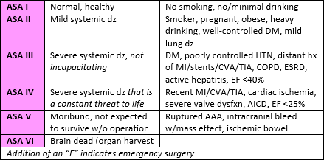
Anesthesia: avoid Sux, prepare for blood loss (15-75 mL/kg), deliberate hypo-t (don’t want to compromise SC)
Extubation parameters: VC >10 mL/kg, VT > 3mL/kg, RR < 30/min, negative inspiratory force > -30 cm H2O
Complications: pneumo, atelectasis, pleural effusion, hemothorax, neurologic injury
Obesity (pg. 455-471)
- Overweight: body weight above standard r/t height
- Obesity: abnormally high % of body weight as fat
- Ideal body wt (IBW): associated w/lowest mortality rate for a given height & gender (defined by insurance companies)
Female = ht (cm) – 105… male = ht (cm) – 100
- Lean body wt (LBW): NOT synonymous w/IBW; TBW – adipose tissue; estimated as IBW + (20-40%)
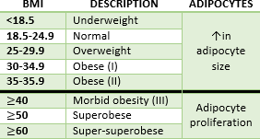
- Body mass index = (body wt in kg) / (ht in m²)… OR [(wt in lbs) * (703)] / (in²)
- # of adipocytes is determined during childhood (“fluffy kids make fluffy adults”)
Children get obese from proliferation (hyperplasia) of adipocytes; adults from
hypertrophy of adipocytes
Fxn of fat: insulation (thermal) & storage of energy

Anatomic distribution of body fat
Android (central, truncal, Cushingoid): Apple-shaped; adipose tissue mainly in upper body; associated w/↑O2 consumption & incidence of CV dz
Gynecoid (peripheral, gluteal): pear-shaped; adipose tissue mainly in thighs, hips, buttocks; less metabolically active (= less association w/CV dz)
Waist circumference > 102cm (40.2in) in men & 88cm (34.6in) in women = ↑risk for heart dz, DM, HTN, death
- Respiratory system: obese pts have ↓lung volumes, ↑WOB, alterations in control of ventilation, & altered gas exchange
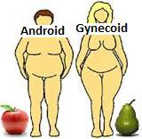
Airway changes include ↓pharyngeal area, excess hypopharyngeal tissue acting as a ball valve, posteriorly displaced hyoid bone, & pharyngeal long-axis oriented in the antero-posterior direction (instead of transverse)
Fat on thorax/abdomen ↓chest wall & lung compliance to 35% of norm (pulm compliance ↓vastly w/↑BMI)
↓ERV, exponentially ↓FRC, ↓TLC; VT, RV, & CC are typically unchanged
  - ↓FRC is explained primarily by the ↓ERV; eventually FRC falls below CC
  - When CC > FRC, a V/Q mismatch = CO2 retention (acidosis), R➔L shunting, & arterial hypoxemia
  - In response, breathing is rapid & shallow (like restrictive dz), which ↑WOB & dead space
Anesthesia ↓FRC in obese by 50% (vs. 20% in nonobese)

Obstructive sleep apnea (OSA)
Obstructive sleep hypopnea: milder precursor to OSA; partial ↓airflow (>50% reduction) lasting 10sec, >15x/hr of sleep, w/≥4% reduction in arterial oxygenation
Risk factors for OSA: male, middle-aged, BMI>30, evening alcohol consumption
  - Risk factors in nonobese: craniofacial dystoses, tonsillar hypertrophy, trisomy 21
Hallmark of OSA is snoring; definitive diagnosis by polysomnography in sleep lab
Apnea: airflow cessation >10sec, ≥5x/hr of sleep, w/≥4% reduction in arterial oxygenation

  - Hyperventilation follows apnea in compensation for hypercarbia
Physiologic alterations from OSA: arterial hypoxemia, hypercarbia, pulm/systemic vaso-c, secondary polycythemia
  - These combine to ↑risk of ischemic heart dz & cerebrovascular dz
STOP-BANG questionnaire for preop: Snore loudly? Tired during daytime? StOp breathing during sleep? High BP?
BMI>35kg/m²? Age >50yrs? Neck circumference >40cm? Male Gender?
Definitive treatment is positive airway pressure (IPAP, EPAP, CPAP)
- Obesity hypoventilation syndrome (Pickwickian): complication of extreme obesity—OSA, hypercapnia, daytime hypersomnolence, arterial hypoxemia, cyanosis-induced polycythemia, resp acidosis, pulm HTN, R-sided heart failure
OHS can lead to central apnea, which is apnea w/o respiratory effort
Prevalence of OHS in pts w/OSA is 4%; the prevalence of OSA in pts w/OHS is 90%
- Cardiovascular alterations: reflect progressive compensatory changes necessary to meet ↑metabolic demands of the fat organ
CO ↑ by 20-30 mL/kg of excess body fat (100 mL/min for each kg of fat); total volume ↑ (but less volume to weight ratio)
↑blood volume places > demands on myocardium, specifically LV wall stress = hypertrophy (concentric + eccentric)
  - This leads to ↓LV compliance/diastolic filling, ↑LV pressures, pulm edema, systolic dysfxn, biventricular failure
Obesity accelerates atherosclerosis; obese pts also have a 2x greater risk of DVT
Cardiac dysrhythmias result from fatty infiltration of conduction system = low QRS voltage, flattened T waves, prolonged QT
Adipose tissue releases bioactive mediators (cytokines, chemokines, hormones) = chronic, sub-clinical inflammatory state
High factor VIII levels are associated w/↑CV mortality
- Gastrointestinal: gastric volume & acidity are ↑, hepatic fxn is altered, & drug metabolism is adversely affected
90% of fasting obese pts have a gastric volume >0.35 mL/kg & pH <2.5 (Mendleson’s criteria) = aspiration risk
  - Also, ↑risk of hiatal hernia, GERD, & delayed gastric emptying b/c of ↑in abdominal mass
Associated w/nonalcoholic fatty liver dz, inflammation, focal necrosis, cirrhosis (1.5-2.5x greater than nonobese)
  - Abnormal LFTs in up to 1/3 of obese pts; ↑ALT (SGPT, ALAT) is most frequent
Gallstones are 30% more common (women)
Both males & females have ↑risk of esophageal & colorectal CA; obese females have ↑risk of gallbladder CA
Type II DM is more prevalent (several fold) d/t impaired glucose tolerance
Subclinical hypothyroidism occurs in 25%; also ↑risk of adenocarcinoma of thyroid gland in males
Females are at ↑risk of breast CA
- Metabolic syndrome (pre-diabetes): abdominal obesity, glucose intolerance, HTN, dyslipidemia (~50 million people in US)
Associated w/↑risk of vascular events
Diagnosis: android (apple-shaped) obesity, plus at least two of the following: ↑triglycerides, ↓HDL, HTN, ↑fasting BS
- Genitourinary: ↑RBF/GFR (d/t ↑CO/MAP); wt gain ↑renal tubular reabsorption & impairs natriuresis
Prolonged obesity = loss of nephron fxn
Males & females have ↑risk of renal CA; males have ↑risk of prostate CA; females have ↑risk of endometrial/cervical CA
- Muskuloskeletal: osteoarthritis from stress on wt-bearing joints, bone resorption secondary to limited mobility
- Bariatric surgery: alteration of small intestine or stomach
Restrictive (old): reduce pt’s capacity for intake; vertical band gastoplasty has been replaced by lap gastric band, which has the advantage of avoidance of permanent alteration
  - Another restrictive procedure is lap sleeve gastrectomy
Combined restriction/malabsorption (new): Roux-en-Y gastric bypass is most effective procedure to produce safe short & long-term w loss; pts lose an average of 50-60% of excess body wt; Type II DM resolves in majority of pts
  - Risk of anastomotic leaks (biggest risk associated w/bariatric surgery)
- Rhabdomyolysis: suspect if unexplained ↑in creatinine & creatinine kinase or complaints of butt, hip, shoulder pain postop
More common in obese pts undergoing lap procedures compared to open procedures
Prevention: proper positioning, ↓operative time, aggressive hydration, stimulate diuresis, alkalization of urine
- Pharmacology: drugs distributed to lean tissues should be dosed on LBW, while drugs equally distributed b/w lean & adipose tissue should be dosed on TOB
Clearance: for a drug w/similar clearance values in obese/nonobese, maintenance dosing should be based on LBW; a drug
whose clearance ↑w/obesity should be based on TBW
  - Dose Sux on TBW d/t ↑plasma cholinesterase levels
Vd is altered by: ↓body H2O, ↑fat, ↑lean body mass, ↑blood volume, ↑CO, ↑free fatty acids, ↑triglycerides,
↑cholesterol, ↑blood alpha-1-glycoprotein, lipophilicity of the drug, organomegaly, altered protein binding
Highly lipophilic drugs (barbs, benzos) show significant ↑in Vd; exceptions are digoxin, procainamide, remifentanil
Fat has low blood flow; drugs based on TBW could lead to excessive plasma concentrations

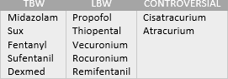
- Preop eval: pay special attention to CV, resp, & hepatic fxn
CV: S/S of L & R ventricular failure = ↑jugular venous pressure, added
heart sounds, crackles, peripheral edema, tall precordial R waves (R failure)
  - Systemic HTN, pulm HTN (tricuspid regurg on echo), ischemic heart dz
Resp: smoking hx, exercise tolerance, PFTs, OSA, ABGS
Hepatic: ALT, AST, albumin, bilirubin, cholesterol, alkaline phosphate
For bariatric surgery, be suspicious of nutritional & metabolic abnormalities (commonly ↓ are Vit B12, iron, Ca, folate)
  - These can lead to polyneuropathy known as acute postgastric reduction surgery neuropathy
- Concurrent & prophylactic meds: concurrent meds should be continued, w/possible exception of insulin & oral hypoglycemic
Abx prophylaxis d/t risk of wound infection
Dexmed b/c of minimal resp depression
Sub-Q heparin (5,000 units) b/f surgery & every 8-12hrs until pt is fully mobile d/t risk of DVT
Phenylephrine for reversing low BP
- Airway eval: suspect a potentially difficult airway; anatomic changes include limited mvmnt of atlantoaxial joint & C-spine, excessive tissue folds, short/thick neck, suprasternal/presternal/posterior cervical fat, double chin (submental fat)
Difficult airway does NOT always correlate w/BMI; instead, it most closely correlates w/↑age, male, temporomandibular
joint pathology, Mallampati III or IV, hx of OSA, pt’s neck circumference
  - Neck >40cm = ~5% probability; >60cm = ~35% probability
- OR equipment: regular OR tables have max wt of 200kg, but special tables that support up to 455kg w/↑width are available
- Positioning: ulnar, brachial plexus, radial, peroneal, & sphenoid injuries are frequent
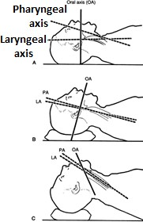
Supine causes ventilator impairment (FRC & oxygenation are ↓); T-burg makes this even worse
Carpal tunnel is most common mononeuropathy after bariatric surgery
- Monitoring: BP may be falsely elevated if cuff is too small; forearm BP measurements overestimate
- Induction & intubation: adequate preoxygenation is vital—4 breaths w/100% within 30sec
Position by stacking or HELP (Head Elevated Laryngoscopy Position)
- Intraop & maintenance: can include MAC, GA, regional, or combo
Short acting opioids combined w/low solubility IA = more rapid emergence
Cis is favorable b/c it is eliminated via Hofmann; vec & roc are also okay
Dexmed b/c it has no adverse effects on resp
PEEP is the only ventilatory parameter shown to improve resp fxn in obese pts
Blood loss is usually greater; replace w/crystalloids 3:1
Regional: may be more technically difficult LA requirements are 20% lower d/t compressed space
- Emergence & extubation: risk of airway obstruction is ↑; recovery in a head-up position is ideal (↑s FRC)
Extubation criteria: neuro intact, head-lift, hemodynamically stable, normothermic, TOF >0.9, 10<RR<30, SpO2 ≥95% w/FiO2 0.4, VT >5 mL/kg IBW, VC>10-15 mL/kg, acceptable pain control
- Postop pain mgmt: regional ↓resp complications postop; epidural>spinal d/t ↓DVT risk, improved analgesia, earlier GI motility
PCA dose based on IBW (morphine 20mcg/kg, hydromorphone 4-5mcg/kg, fentanyl 1mcg/kg, methadone 20mcg/kg)
- Complications: major preop risk of death correlates w/BMI, pre-existing HTN, PE, & anastomotic leak
Most severe postop complications are anastomotic leaks & strictures, PE, sepsis, gastric prolapse, & bleeding
  - S/S of anastomotic leak: tachy-c, fever, abdominal pain (tachypnea & ↓SAT are early signs of sepsis)

MODULE 19
Geriatric Anesthesia (pg. 436-454)
- Anesthesia risks: preop comorbid dz is a greater determinant of postop complications than anesthetic mgmt
Most common postop complications w/elderly are cardiac, pulmonary, & neurologic
Surgical risk/outcome w/elderly based on 4 factors: age, pt’s status (coexisting dz), elective vs. emergent, type of surgery
  - Highest risk = thoracic, intraperitoneal, major vascular (d/t ↑blood loss & ↑risk of postop vent)

Physiologic & cellular changes
Progressive loss of functional reserve in all organ systems; 1% decline/yr in organ function after 30yrs
After a max # of cell divisions, cells fail to grow & may undergo programmed death (apoptosis)
Elderly become increasingly less able to restore hemostasis when subjected to trauma, dz, or drugs
Protein catabolism (breakdown) along w/nutritional deficiencies = ↓intracellular H2O & K levels
Contracted state of vasculature may result in higher than expected plasma concentrations of drugs

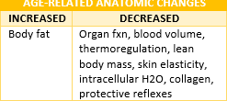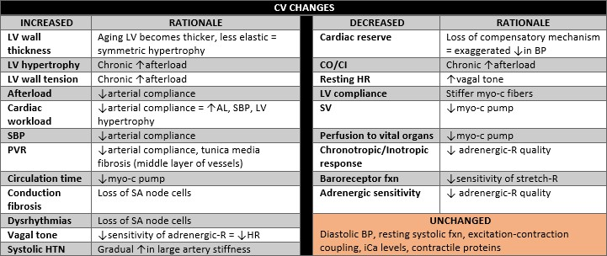
↑lipid storage sites = greater reservoir for lipid soluble drugs
Thermoregulation is impaired, making body heat conservation important
- Young pts shiver at 36.1°C; >80yrs shiver at 35°C; shivering ↑O2 consumption up
to 400%, which leads to hypoxia, acidosis, & cardiopulmonary compromise
Positioning requires extra attention d/t fragile skin, ↓subQ fat, & poor skin turgor

CV changes—additional
Cardiac fxn declines 50% (b/w 20-80yrs)
Elderly are more dependent on EDV than ↑HR to produce an ↑in CO (prone to CHF w/fluid overload w/anesthesia)
Elastic tissue of coronaries & myo-c fibers are replaced by connective tissue & adipocytes
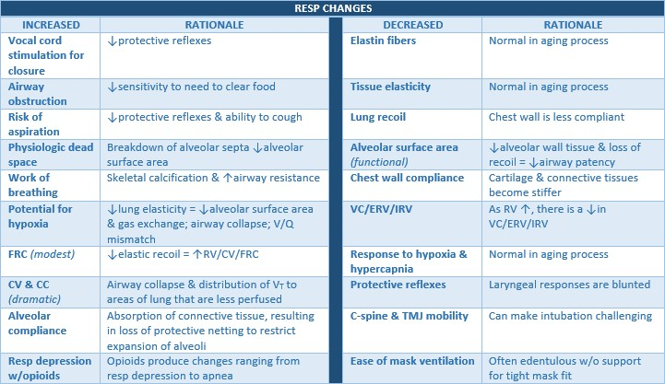
Atrial contraction (kick) accounts for 20% of LVEDV (loss of kick = ↓BP)

Resp changes—additional
15% reduction in functional alveolar surface area by 70yrs
Changes in chest wall & lung compliance = V/Q mismatching (shunt is ↑ & O2 exchange is ↓)
Progressive ↓in FEV1 & FVC is caused by loss of elastic tissue around alveoli & alveolar ducts = air trapping

CC>FRC in anesthetized elderly pt = dependent airways are collapsed (more VT to underperfused areas)

TLC ↓by 10% by 70yrs
Alveolar-arterial O2 difference ↑from 8 mmHg (20yrs) to 20 mmHg (70yrs)
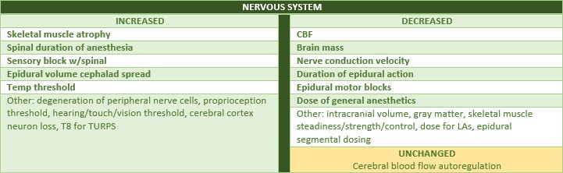
PaO2 ↓0.5 mmHg/yr after 20yrs

Nervous system—additional
CBF & brain mass ↓20-30%, w/neuronal loss prominent in cerebral cortex (especially frontal lobes)

Intracranial volume ↓from 92-82%
Conduction velocity of peripheral nerves slows by 0.15 m/s per year

Skeletal muscle steadiness/strength/control ↓by 20-50%
MAC ↓, as does dosing w/LAs, opioids, barbs, benzos, & many other agents
- Postop delirium: most common complication in older pts (15-53%); more common in pts having ortho & cardiac procedures
Characterized by: disruption of perception, psychomotor behavior, thinking/memory, consciousness, attention
Risk factors: old age, male, duration of anesthesia, metabolic dz, dementia, Parkinson’s, CV dz, dehydration, alcohol abuse
Believed to be r/t anesthesia-stimulated vaso-d w/resultant hypermetabolic state in brain; leads to oxidative stress & irregularities in cholinergic, dopaminergic, histaminergic, noradrenergic neuronal systems (may ↓synthesis/release of ACh)
- Postop cognitive dysfunction: NOT synonymous w/delirium; subtle onset & may not present for weeks/months after surgery
Results in inability to work, decline in ADLs, need for assistive care
Characterized by: memory deficits, difficultly concentrating, impaired comprehension, delayed psychomotor speed
No universally accepted diagnostic activity, no definition, no known cause, no cure, & no proven treatment
Recommendations: keep anesthesia/surgery as short as possible, use short-acting & neuro-protective meds (Ketamine)
- Comorbidities: HTN is most common in elderly; others are DM, arthritis, CHF
CHF, COPD, &/or malignancy are the strongest predictors of mortality in older pts

Endocrine—additional
Pancreatic fxn ↓ & DM ↑ (glucose metabolism is impaired)
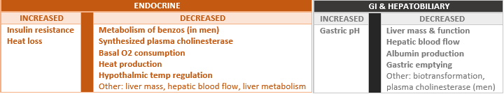
Mechanisms responsible for ↑ BS are sluggish response to insulin for hyperglycemia & resistance to insulin at peripheral-R

GI & hepatobiliary—additional
Reduced hepatic flow & a potential ↓in P450 enzyme fxn impairs ability to metabolize anesthetics & NDNMBs
- Renal—additional
RBF ↓~50% (10%/decade)
GFR ↓6-8%/decade
Combo of ↓renal fxn & ↓cardiac function = prone to fluid overload

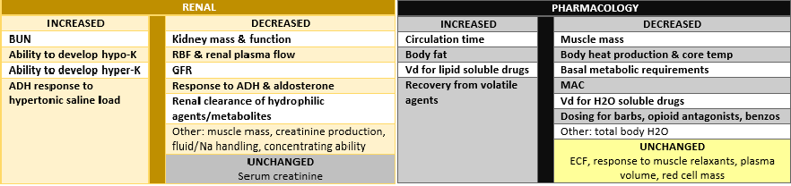
Prone to acute kidney injury postop d/t ↓RBF & ↓renal mass

Pharmacology—additional
↓protein binding➔↑free drug➔more BBB crossing of drug
↓MAC by 4-6%/decade beyond 40yrs
Recovery from anesthesia is prolonged d/t ↑Vd, ↓hepatic fxn, & ↓pulm gas exchange
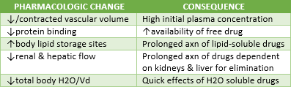
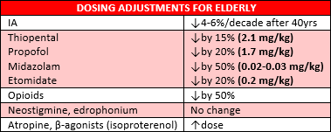
Response to Sux & NDNMBs is unaltered w/aging (though IV administration may be prolonged d/t ↓circulation time)

MODULE 21
Obstetric Anesthesia (pg. 388-412)
- C/S should be started within 30min once the need is identified; most deaths occur during/after C/S (~2x that of any surgeries)
- Always be ready for blood loss—have blood sent for type & screen; all pts are full stomach & risk for aspiration (RSI)
- A preanesthesia assessment must include a fetal assessment (FHR monitoring)

Materal resp changes
Diaphragm is displaced cephalad 4cm by expanding uterus = ↓FRC by 20%; may lead to airway closure
  - TLC, VC, & IC are NOT changed d/t compensatory ↑in thoracic antero-posterior diameter (*this differs from chart)
Vent changes produce resp alkalosis (PaCO2 = 30 mmHg), yet compensation by met acidosis keeps pH normal
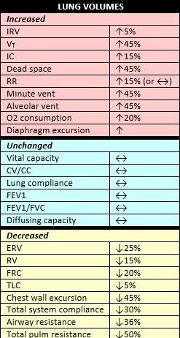
  - PaO2 will be higher in the pregnant pt, but PaCO2 will be lower
The ↑in O2 consumption produces a 70% ↑ in alveolar ventilation at term; VT
↑40% & RR ↑15%
  - ↑alveolar ventilation + ↓FRC + ↓MAC = ↑risk of overdose with IAs
Airway edema d/t engorgement is most evident during 3rd TM (need smaller ETT)
↓FRC may allow rapidly ↓O2; assess alkalemia b/c hyopcarbia will = uterine vaso-
c, which results in ↓placental perfusion

Anesthesia
Airway mgmt is more challenging (wt gain, edema)
↓MAC, ↓FRC = faster induction w/insoluble, ↑Vm = faster induction w/soluble
Greater risk of hypoxemia (less O2 reserve, ↑consumption, airway obstruction)
  - Maternal/Fetal hypoxemia are associated w/pain-induced hyper & hypo- ventilation (can be avoided w/effective analgesia)

Excessive mechanical ventilation may ↓CO & uterine blood flow
- Maternal CV changes
CO ↑30-40% during 1st TM d/t ↑HR & ↓AL while SV remains the same
  - CO is greatest after delivery & for the next couple of weeks
After delivery, blood volume ↑when uterus no longer obstructs VC & aorta
Blood volume ↑33-40%, RBCs ↑to 30 mL/kg, & plasma volume ↑70 mL/kg
↑blood volume does NOT ↑BP d/t ↓PVR (this doesn’t apply to labor/delivery)
Near term, blood volume ↑~1000 mL (40%) probably d/t peripheral vaso-d

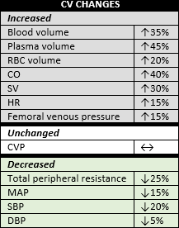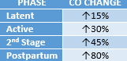

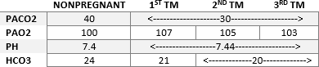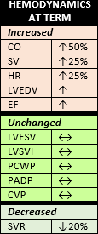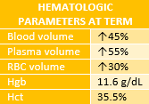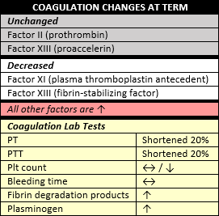 CO to uterine vasculature is ~700-800 mL/min
Anesthesia
  - Venodilation may ↑incidence of accidental epidural vein puncture
  - Healthy parturients will tolerate up to 1500 mL blood loss
  - High Hgb (>14) indicates low volume state caused by preeclampsia, HTN, or inappropriate diuretics
  - Maternal SBP <90 mmHg during regional should be of concern b/c it may be associated w/proportional ↓in UBF
  - Always avoid aortocaval compression; 70-80% of supine parturients w/T4 sympathectomy develop hypo-t
Supine hypo-t syndrome: compression of IVC = ↓VR/SV; maternal response is tachy-c & vasoc-c of LE; LUD to treat

Maternal GI changes
Prolonged gastric emptying & ↓LES tone d/t ↑progesterone
Elevated gastrin from placenta ↑s intragastric pressure & ↓normal oblique angle of gastroesophageal jxn

ALWAYS considered full stomachs
Narcotics, valium, atropine all ↓LES tone & ↑gastric emptying time; narcotics & valium also cause fetal depression
Metoclopramide ↑LES tone & ↑gastric emptying

Maternal renal changes
Normal ↓s in BUN & creatinine are d/t ↑s in RBF & GFR
RBF & GFR ↑up to 50-60% by 4th month & slowly return to normal during 3rd TM
24 hr creatinine clearance ↑ by 8th wk until deliver

Factors causing ↓UBF
↓perfusion pressure
  - ↓uterine arterial pressure: supine position, hemorrhage, hypo-t/drug-induced hypo-t
  - ↑uterine venous pressure: uterine contractions, drug-induced hypertonus, vena caval compression

↑uterine vascular resistance
  - Endogenous vasoconstrictors: catecholamines, vasopressin (response to hypovolemia)
  - Exogenous vasoconstrictors: epinephrine, vasopressors (neo>ephedrine), LAs (in high concentrations)
- Factors affecting O2 transfer from mother to fetus: intervillous/fetal-placenta blood flow, maternal/fetal PaO2, maternal/fetal O2 affinity, maternal/fetal Hgb, maternal/fetal pH, placental diffusing capacity, placental vascular geometry, ratio of maternal to fetal blood in exchanging areas, shunting around exchange tissues, placental O2 consumption
- Drugs that cross placenta: low molecular wt, lipid soluble, non-ionizing drgus

Uterine & placental blood flow
Blood to uterus/placenta via uterine artery; uterine artery pressure determined by maternal systemic artery pressure
Uterine arteries➔blood spurted into intervillous space➔passes to fetal villi b/f draining back into veins of uterine wall
Tissue layers in placental membrane: fetal trophoplasts, fetal connective tissue, endothelium of fetal capillaries

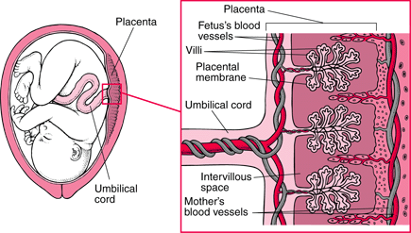
Anesthesia during pregnancy—summary
IAs: MAC ↓ (15-40%), rate of induction ↑
Induction agents: ED50 of thiopental ↓35%, elimination half-life of thiopental prolonged, elimination half-life of propofol unaltered
Meperidine: elimination half-life unaltered
Sux: duration of block unaltered (or ↓), sensitivity ↓
NDNMB: ↑sensitivity to vec/roc, elimination half-life of vec/panc ↓,
atracurium/cisatracurium unaltered

Chronotropic agents: response diminished
ETT: smaller tube required, ↑risk of trauam w/nasal tube, ↑aspiration risk
Maternal oxygenation: ↑physiologic shunt when supine, ↑rate of decline in PaO2 during apnea, ↑rate of denitrogenation
Maternal ventilation: ↑Vm required
Regional considerations: lumbar lordosis ↑, head-down tilt in lateral position
  - Hydration: ↑fluid requirements to prevent hypo-t

Subarachnoid/Epidural dose: ↓
- Regional effects on uterine flow
↑flow from: pain relief, ↓sympathetic activity, ↓maternal hyperventilation
↓flow from: hypo-t, unintentional IV injection of LAs and/or epi, absorbed LAs

Stages of labor & pain
1st stage: begins at onset of contractions, results in complete dilation of cervix
  - Latent = little dilation of cervix, but it becomes softer; active = regular cervical dilation d/t contractions
  - Pain is initially at T11-12, then progresses to T10-L1 during active labor
2nd stage: begins at full cervical dilation & ends w/delivery of infant; onset of perineal pain at the end of the 1st stage is the signal of fetal descent & beginning of 2nd stage
  - Sensory to perineum by pudendal nerve (S2-4), therefore 2nd stage pain involves T10-S4 (“Second goes to Sacrum”)
3rd stage: delivery of placenta

Pain pathways & labor
1st stage pain is primarily d/t uterine contractions; visceral pain
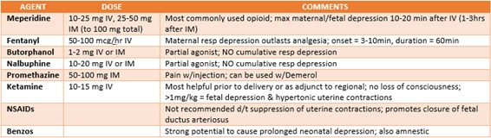
Late 1st stage – 2nd stage pain: caused by distention of lower vagina, vulva, perineum; somatic pain
- Regional: synergistic interaction b/w spinal opioids & LAs produce few maternal SE & little to no neonatal depression
Spinal opioids: preservative free, do not impair mom from pushing baby out; SE—pruritus, N/V, sedation, resp depression

Complications
  - Hypo-t: 20-30%↓ in BP; most common SE; treat w/LUD, ephedrine/neo
  - Unintentional IV injection: place supine w/LUD; may produce seizures; treat w/lipid emulsion (20% Intralipid) 1.2-2 mL/kg bolus w/0.25-0.5 mL/kg infusion; may need to intubate/ventilate
  - Unintentional intrathecal injection: may produce high spinal (intubate/ventilate)
  - Postdural puncture HA: d/t dural puncture (↑ICP w/compensatory vaso-d); treat w/bed rest, hydration, oral analgesics, epidural saline (50-100mL), caffeine sodium benzoate (500mg), blood patch (10-30mL)
- Umbilical cord prolapse: may lead to fetal hypoxia; caused by excessive cord length, malpresentation, low birth wt, graviparity (>5 pregnancies), multiple gestations, artificial ROM, polyhydramniosis
Diagnosis: sudden fetal brady-c or profound decels (variable, then late); confirmed by physical exam
Treatment: steep T-burg, & manual pushing of presenting fetus back up into pelvis until immediate C/S is commenced

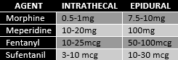
Signs of fetal distress
  - Nonreassuring fetal HR: late decels, loss of beat-to-beat variability, HR <80
  - Fetal scalp pH <7.2
  - Meconium stained amniotic fluid
  - Oligohydramnios
  - IUGR
- Placenta previa: Painless Preterm bleeding, Planned (will have for wks), Pass on pushing (C/S)
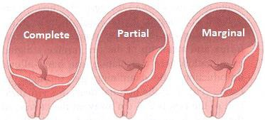
Previa risk ↑dramatically w/# of past C/S (placenta grows into scar tissue)
First episode of bleeding is typically preterm & there are no contractions
  - Onset of bleeding is not related to any particular event
  - Painless bleeding during 2nd or 3rd TM
Risk factors: multiparity, advanced maternal age, accreta, large, disturbed placenta
Fetal distress/demise is uncommon w/1st episode of bleeding
Mgmt

  - Goal is to delay delivery until fetus is mature
    - C/S if: active labor, documented lung maturity, gest age = 37wks, excessive bleeding, another OB complication

Ultrasound for confirmation
  - AVOID vaginal exams
  - Fetus at risk if: progressive or sudden placental separation, preterm delivery < 37wks

Prematurity is the most common cause of neonatal morbidity/mortality
    - ↑incidence of asymmetric IUGR is greatest in women w/placental previa
  - Get H/H & have blood available (positive antibody screen may mean it takes longer to get blood)
  - May choose regional or GA
  - Emergency bleeding: treat w/VOLUME
    - 2 large bore IVs, (4) PRBCs ready, fluid/blood warmers, non-dextrose IV fluid, RSI, ketamine, etomidate, Pitocin
- Placental abruption: separation of placenta from deciduas basilis b/f delivery of fetus; bleeding is often hidden
Fetal distress results from loss of area for maternal-fetal gas exchange
Etiology unknown but results in: occult bleeding, abdominal pain, uterine irritability, fetal distress, DIC, death
Risk factors: HTN, advanced age, parity, tobacco use, cocaine use, hx of previous abruption, trauma
Fetal distress signals C/S
May require massive blood transfusion, replacement of coags/plts (FV, FVIII, fibrin split products, & plts are ↓)

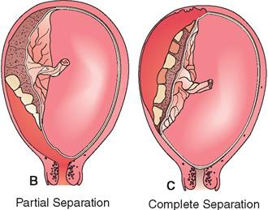
Diagnosis
  - Classic S/S: painful vaginal bleeding, ↑uterine activity/tenderness, atypical presentation

Volume deficit
  - Large retroplacental hematoma: uterus may contain 2500 mL of blood
Complications: hemorrhagic shock, ARF, coagulopathy (DIC), fetal distress
Mgmt: FHR monitoring, H/H/coags, blood typed/crossed, LUD

Delivery of fetus is definitive treatment
  - Induction is necessary when there is no evidence of fetal distress OR vaginal delivery is choice for dead fetus
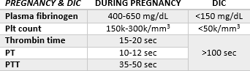
    - Epidural if mom has normal coags & no intravascular volume deficit (any concerns w/either = NO epidural)
    - Note: regional is generally NOT indicated d/t coagulopathy & uncertain uteroplacental blood flow
  - C/S hazardous in unstable mom w/severe hypovolemia or coagulopathy
    - GA is preferred in most cases
    - Aggressive volume resuscitation, CVP, a-line, Pitocin after delivery

Abnormal placental implantation
Placenta accreta: Adheres to myometrium w/o invasion
Placenta increta: Invades & is confined to myometrium
Placenta percreta: invades & Penetrates myometrium, uterine serosa, or other pelvic structures
Risk factors: placenta previa, uterine trauma, previous C/S (risk ↑s w/↑# of C/S)
Diagnosis: if placenta extends anteriorly into old uterine scar, high likelihood of accreta is expected
  - MRI & ultrasound have poor predictive capability
Mgmt: most cases require C/S; have lots of blood products ready & give VOLUME
  - Placenta accreta is most common indication for obstetric hysterectomy
- Amniotic fluid embolism: rare; mortality ~86%; occurs when amniotic fluid gets into maternal circulation
S/S: chills, shivering, anxiety, cough, dyspnea, cyanosis, tachypnea, pulm edema, CV collapse
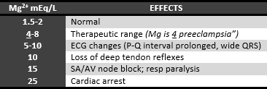
Treatment: aggressive CV resuscitation, stabilization, & supportive care
- Uterine rupture: rare; ↑incidence w/TOLAC (trial of labor after C/S)
S/S: continuous abdominal pain & hypo-t
Treatment: volume resuscitation & laparotomy w/GA; clamp hypogastric arteries or internal iliac arteries to save uterus

Maternal heart dz
Group I: mitral valve dz, aortic insufficiency, congenital lesions w/L➔R shunting
  - Anesthesia: regional ok; will cause ↓PL/AL/pulm congestion (which might ↑CO)
Group II: aortic stenosis, primary pulmonary HTN, congenital lesions w/R➔L shunting
  - Anesthesia: regional is contraindicated; use intraspinal opioids, systemic meds, pudendal block, GA
- Preeclampsia: syndrome of HTN, proteinuria, generalized edema after 20th wk gestation (usually fades within 48hrs of delivery)
- Eclampsia: occurrence of seizures superimposed on preeclampsia
Mg sulfate: attenuates SM contraction by competing w/CA

  - Axns: anticonvulsant, vasodilaion, ↑UBF, ↑RBF, ↓ACE, ↓renin, bronchodilation, tocolysis (↓uterine activity), ↓plt
aggregation, attenuation of vascular response to pressor substances, ↑prostacyclin release by endothelial cells
  - SE: hypo-t, ↓FHR variability, muscle weakness, ↑sensitivity to NMBs, ↓APGAR (w/OD), ↑postpartum hemorrhage
- Preventing pulm aspiration: regional anesthesia, fasting guidelines, gastric prophylaxis, RSI w/cricoid pressure, sxn b/f PPV
- Early decels: head compression or stretching of neck; HR ↓10-14 bpm
Mirror patterns of uterine contractions (start & end w/contraction)
- Late decels: uteroplacental insufficiency; at or following peak of contraction; HR ↓ >45bpm
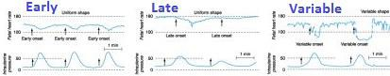
- 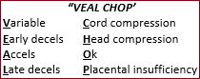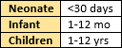Variable decels: cord compression; nonuniform; most common; severe if FHR ↓by 60bpm (or to <60bpm) or if decel >60 sec

MODULE 22
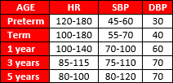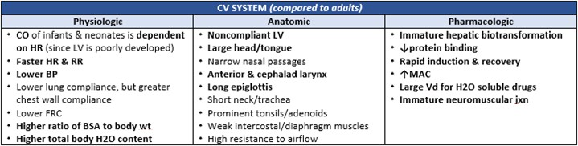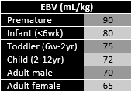Pediatric Anesthesia (pg. 413-435)

Respiratory system
Airway: narrow nares (resistant 12x adult), large tongue, high glottis, slanting VC, narrow subglottic cricoid ring
ETT size = (age + 16) / 4… ETT length = 3x tube size
Small FRC = more rapid induction w/IA
↑CV & ↓FRC = more prone to atelectasis & hypoxia during anesthesia
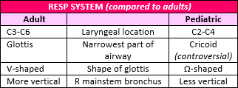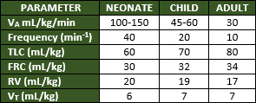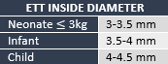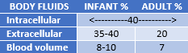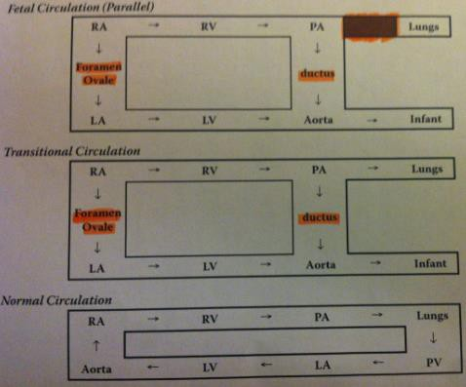 Neonates are diaphragmatic breathers b/c: intercostal muscles are underdeveloped, diaphragm is high, chest cavity is small

- Fluid management
4-2-1: 4 mL/kg for 1st 10kg, 2 mL/kg for 10-20 kg, 1 mL/kg for each kg >20
- Total body H2O: preterm = 90%, term = 80%, 6-12mo = 60%
- Hypoglycemia: infants w/diabetic mothers are prone to hypoglycemia b/c the infant will produce insulin in response to mom’s BS; after delivery, this insulin will ↓infant’s BS level
- Most commonly used LA infants is 0.25% Bupivacaine (0.125% for infusion)
Max dose for kids = 4 m/kg; max dose for infants = 2 mg/kg
- Prematurity: born b/f 37wks
SGA (small gestational age) = full or preterm infant whose age-adjusted wt is <5th percentile
Postconceptual age = gestational age + postmaternal age
Anesthesia concerns: airway control, fluid mgmt, temp regulation,
retinopathy of prematurity, ↑risk of postop apnea

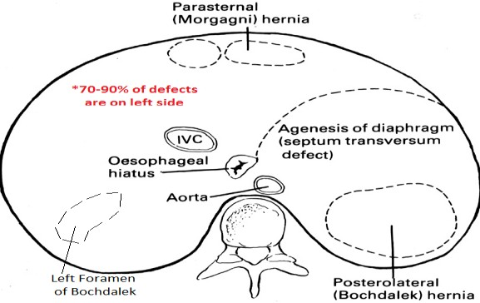
  - <60wks posctonceptual age have greatest risk of experiencing postanesthetic complications
- Congenital diaphragmatic hernia: usually associated w/pulmonary hypoplasia
Occurs at 5-10wks of life; ultrasound or MRI for diagnosis
Gut herniates into thorax; left-sided is most common
High incidence of congenital heart dz & intestinal malrotation
Mortality 44-66%; 1 minute APGAR may be normal (placental oxygenation)

S/S: profound arterial hypoxemia (R➔L shunt), barrel-shaped chest, severe retractions
Causes of poor prenatal prognosis: polyhydramnios, stomach above diaphragm, diagnosis made b/f 20wks gestation
Treatment:
  - Maintain preductal SAT >85% using peak inspiratory pressure <25cm H2O (allowing PCO2 to rise to 45-55 mmHg)
  - Decompress stomach & O2 supplementation (NO N2O)
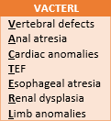
  - Immediate stabilization w/sedation, paralysis, & moderate hypercapnia
  - ECMO (extracorpeal membrane oxygenation) is useful, but NOT proven as 1st line treatment

Anesthesia
  - Ensure adequate oxygenation while avoiding barotrauma (place POXs pre & postductally)
  - Right-sided pneumo is a concern (↓lung compliance/BP/O2 SAT)
  - Avoid hypothermia, hypoxia, acidosis
- Tracheoesophageal fistula: occurs b/w 4th & 5th weeks of intrauterine life; med emergency
Most common is form that ends in blind pouch & a lower esophagus that connects to trachea (85%)
S/S: gastric distention w/resp, aspiration pneumonia, dehydration; feeding leads to choking, coughing, cyanosis (3Cs)
Diagnosis: failure to pass catheter into stomach & confirmed by visualization of catheter coiled in a blind pouch
50% have associated congenital anomalies (VACTERL)

Anesthesia
  - Copious pharyngeal secretions
  - No PPV b/f intubation (& awake intubation w/o NMBs); ETT below fistula but above carina
  - Neonates are dehydrated/malnourished

No neck distention
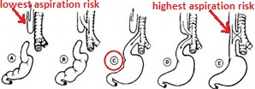
  - Avoid instrumentation of esophagus
Complications: resp distress, feeding exacerbates S/S, gastric reflux (distal TEF), pneumonia, pneumo, atelectasis, subQ emphysema, RLN damage, anastamotic leak, esophageal stricture
Mgmt: patent airway, stop feedings, prevent aspiration, head up position
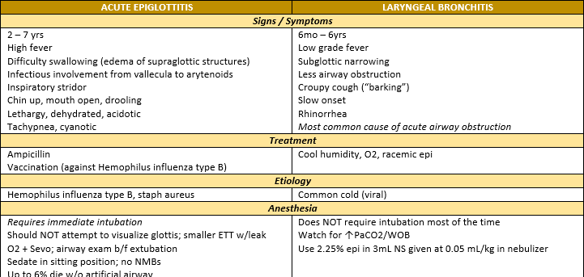

- Pyloric stenosis: idiopathic hypertrophy of smooth muscle of pylorus resulting in compression & narrowing of pyloric channel
S/S: nonbilious projectile vomiting (dehydration), jaundice, hypo-K, hyochloremic met alkalosis w/secondary resp acidosis
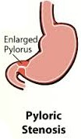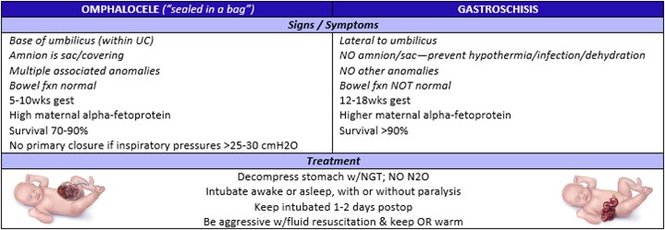 Diagnosis: olive-like mass can be palpated in epigastrium, confirmation w/ultrasound
Treatment: med mgmt 1st (must treat hypo-K & resp acidosis), pyloromyotomy, fluid/electrolyte replacement
Anesthesia: avoid pulm aspiration (sxn in 3 positions gets 98% of contents), hypo-Ca/hypoglycemia may occur, apnea monitoring for 12hrs postop, feeding 4-6hrs after surgery
Note: though alkalosis is classic met disturbance, severe dehydration may lead to ↓renal/hepatic perfusion,
which could = met acidosis w/compensatory hyperventilation (key point = hydration status is crucial)

- Intestinal malrotation/volvulus: spontaneous abnormal rotation of midgut around mesentery (sup mesenteric artery involved)
S/S: those associated w/acute or chronic bowel obstruction (bilious vomiting, abdominal distention, met acidosis)
Most serious complication is volvulus d/t rapid compromise of intestinal blood supply (true surgical emergency)
Diagnosis: confirmed by abdominal ultrasound or upper GI imaging; mortality rate up to 25%
Anesthesia: NGT for decompression, broad-spectrum abx, F/E replacement, blood products, ketamine (poorly tolerate GA)
  - Pts w/volvulus are hypovolemic & acidotic (replace fluids aggressively & may need bicarb)
  - May develop bowel compartment syndrome (hinders ventilation/VR, produces renal compromise)
- Trisomy 21 (Down’s Syndrom): extra chromosome 21
S/S: mental retardation, short neck, flat occiput, micrognathia, macroglossia, atlantoaxial instability, irregular dentition, high/arched palate, dysplastic ears, mongoloid slanting, strabismus, hypotonia, brachycephaly, Brushfield spots on iris
Associated anomalies: congenital heart dz, subglottic stenosis, OSA, ASD, VSD, PDA, TOF, TEF, floppy/soft palate, seizures, bowel atresia, recurrent pulm infections, enlarged tonsils, endocardial cushion defect
Diagnosis: amniocentesis, based on typical clinical features, karyotyping (chromosome analysis)
Prognosis: risk of leukemia, Alzheimer’s, conductive hearing loss, hypothyroidism
Anesthesia: difficult airway (use smaller ETT d/t subglottic stenosis), postop apnea/stridor common, caution w/neck stability, watch for brady-c, avoid air bubbles in line (R➔L shunt present)
- Cystic fibrosis: hereditary dz of exocrine glands of pulm & GI systems
Thick, viscous secretions & ↓ciliary activity = pneumonia, wheezing, bronchiectasis
Malabsorption syndrome leads to dehydration & electrolyte imbalance
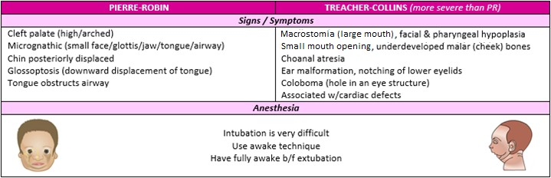
↑RV & airway resistance w/↓VC & expiratory flow rate (obstructive dz)

Anesthesia: deep intubation, aggressive sxn, avoid hyperventilation, aggressive resp therapy (broncho-d, spirometry, abx)
- Scoliosis: lateral rotation & curvature of spine; may alter cardiac & pulm fxn (↓lung volumes, ↓chest wall compliance)
↓PaO2 as a result of V/Q mismatch; ↑PaCO2 signals severe dz
↑PVR from chronic hypoxia causes pulm HTN & right ventricular hypertrophy
Anesthesia: PFTs, watch for major blood loss, may be predisposed to MH/cardiac dysrhythmias/untoward effects of Sux
- Tonsillectomy/Adenoidectomy: consider pts at ↑risk for perioperative airway probs
Waldeyer’s Ring: lymphoid tissues in naso/oropharynx; consists of palantine/lingual/nasopharyngeal tonsils (adenoids)
Anesthesi a: preop anticholinergic (to ↓secretions), reinforced ETT, PONV, RSI + NGT if bleeding
  - Flexible LMA catches secretions on emergence = ↓stridor
- Myringotomy & insertion of tympanotomy tubes: pts have long hx of upper resp infections
Hemophilus influenza, streptococcus, pneumococcus, & mycoplasma pneumonia are common causes of otitis media
Anesthesia: short procedures, inhalation induction w/N2O, may use mask only or LMA
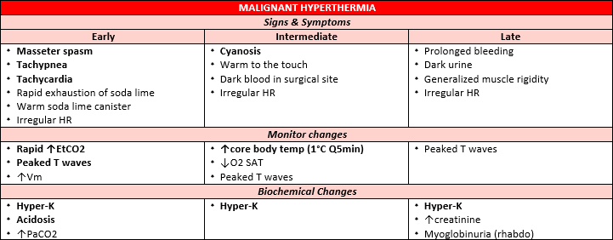
- Malignant hyperthermia: triggers are sux, halogenated agents; if untreated, death from v-fib, ARF, DIC
Treatment: (“Some Hot Dude Better Give Iced Fluids Fast”)

  - Stop triggers
  - Hyperventilate w/100% O2
  - Dantrolene 2-3 mg/kg, repeated Q5-10min (max dose = 10mg/kg)
  - Bicarb (1-2 mEq/kg, based on arterial pH)
  - Glucose + insulin: to treat hyper-K
  - IV fluids & cooling blanket

  - Fluid output: lasix, mannitol
  - Fast heart (tachy-c, be prepared for v-tach)
Genetic testing: muscle biopsy (caffeine halothane contracture test)

Airway difficulties
Pediatric: congenital abnormalities, inflammation, foreign bodies, neoplasms, trauma
  - Mgmt: 100%O2, inhalation induction, assess brady-c (atropine), NMBs are last resort
Signs of difficult airway: inability to open mouth, poor C-spine mobility, receding chin, prominent incisors, morbid obesity, short/muscular neck, injuries to face/jaw/neck
Upper airway obstruction: tongue occluding airway, intercostal/suprasternal retractions, abdominal wall motion, laryngospasm, airway edema
  - Treatment: elevate head, warm/humidified O2, racemic epi, corticosteroids, fluid restriction/diuresis

Neonate
Place in radiant warmer in slight T-burg position
Suction nares, mouth, pharynx & dry neonate w/sterile towel

Resp should be 30-60/min & HR 120-160/min
1 min APGAR correlates w/survival, 5min r/t neurologic outcome
  - APGAR 0-2 = intubate + chest compressions; 3-4 = temporary assisted ventilation; 5-7 = stimulation, O2 blow-by
If meconium is aspirated, sxn (but no more than 3x)
Most common cause of resp depression is intrauterine asphyxia

Hypovolemia: early cord clamping, premature, maternal hemorrhage, twin-to-twin transfusion, sepsis, placental transection
Indication for PPV: apnea, HR <100, persistent central cyanosis
Chest compressions if: HR <60 or HR <80 & doesn’t ↑ w/adequate ventilation
  - Cardiac compression at rate of 120/min & depth of 1/2-3/4 in
Vascular access via cannulation of umbilical vein w/3.5-5 F umbilical catheter
Umbilical artery cannulation allows for BP measurement & ABGs
Volume resuscitation indicators: pallor that persists after oxygenation, faint pulse, poor response to resuscitation
  - Volume expansion may be w/type O-neg blood or 10mL/kg of either 5% albumin or LR
Neonatal BP generally correlates w/intravascular volume
  - Normal BP… 1-2kg = 50/25; >3kg = 70/40
Drugs
  - Epi: 0.01-0.03mg/kg; give is asystole or HR<80; can give IV or endotracheal
    - 0.1-1 mcg/kg/min for persistent brady-c, hypo-t, & signs of low CO
  - Atropine: 0.03mg/kg; give for reflex brady-c
  - Ca: 30mg/kg of CaCl or 100mg/kg of Ca glutamate; give for suspected Mg toxicity (S/S = hypo-t & vaso-d)
  - Naloxone: 0.01mg/kg IV or 0.02mg/kg IM; used to reverse resp depression from narcotics to mom
  - Glucose: 4mL/kg of 10% solution; give for hypoglycemia
- Miscellaneous facts (from Q & A on pg. 433)
Pediatric laryngospasm can usually be avoided by extubating deep or fully awake
Sevo is the preferred induction agent for peds
5 concerns for hypothermia: delayed wakening, cardiac irritability, resp depression, ↑PVR, altered drug responses
In neonates & infants, SV is fixed by noncompliant & poorly developed LV (CO is dependent on HR)
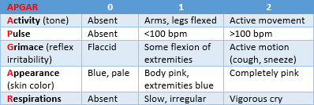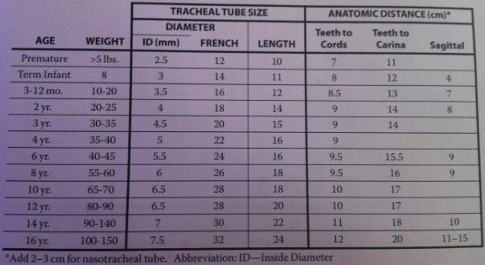 Unexpected cardiac arrest after Sux administration could be caused by hyper-K

